**A Project Report on**

**APP-MAKER**

***In partial fulfilment for the award of the degree***

***Of***

**BACHELOR OF ENGINEERING**

**In**

**COMPUTER ENGINEERING**

**Submitted By**

**Group ID: GIT_CE_14_12**

**Nishit Gopani (110120107039)**

**Kunjal Trivedi (110120107066)**

**Guided By**

**Prof. Sonali Virparia**

**Assistant Professor**



**Department of Computer Engineering**

**GANDHINAGAR INSTITUTE OF TECHNOLOGY**

**Moti-Bhoyan, Gandhinagar**

**2014-2015**

**Acknowledgement**

We have taken efforts in this project. However, it would not have been possible without the kind support and help of many individuals and organizations. We would like to extend my sincere thanks to all of them.

We are highly indebted to **Prof. Sonali virparia** for their guidance and constant supervision as well as for providing necessary information regarding the project. We take this opportunity to thank all my friends who started us out on the topic and provided extremely useful review feedback and for their all-time support and help in each and every aspect of the course of my project preparation. We are grateful to our college Gandhinagar Institute of Technology, Gandhinagar for providing us all required resources and good working environment.

We would like to express my gratitude towards Head of Department, **Prof Kinjal Adhvaryu** and Director, **Dr N M Bhatt** for their kind co-operation and encouragement which help us in this project.

**Nishit Gopani (110120107039)**

**Kunjal Trivedi (110120107066)**

**Abstract**

***App-Maker*** *can make the mobile app of existing web app as well as non-existing web app, it creates the mobile app then market it and updates all changes. For many businesses, the logical next step after a website is a mobile app. But, until very recently, developing the mobile application was time-consuming and expensive. To solve that problem,* ***App-Maker*** *developed a concept called "Do-it-yourself", mobile-app authoring platform, which lets anyone build their own app, without having to hire coders, programmers, or anyone else. An* ***App-Maker is*** *a app-making platform, helping small businesses around the world thrive in the mobile age. In existing system, if we have to make an android app then we have to go to andriod developer, Similarly for i-phone application we have to go to i-phone developer, But* ***App-Maker*** *overcome this disadvantage of existing system. GOAL of* ***App-Maker*** *is to create an application which makes mobile app of andriod as well i-phone on a single platform.* ***App-Maker*** *provides facility to user of NO requirement of CODING and knowledge of any mobile application development. It is USER FRIENDLY and FULLY CUSTOMIZE. With a commitment to meeting the needs of today’s small businesses, the* ***App-Maker*** *offers a variety of e-commerce solutions and other monetization options designed to raise profits.****App-Maker*** *provides a wide range of features, styles, backgrounds, and color themes to match the look and feel to your application.* ***App-Maker*** *allows to Create, publish, promote, and manage your Mobile application from one control panel. It Also Provides View analytics and keep track of your performance. As millions of consumers today turn to their smartphones and tablets to shop, search, order, and pay, even the smallest businesses need to reach their customers on mobile devices* ***App-Maker*** *provide solution to them.*

|  |  |
| --- | --- |
|  | PLATINUM FOUNDATION MANAGED  **GANDHINAGAR INSTITUTE OF TECHNOLOGY**  **(Affiliated to Gujarat Technological University)**  Khatraj-Kalol Road, At: Moti Bhoyan, Tal: Kalol, Dist: Gandhinagar  Website: [www.git.org.in](http://www.git.org.in) |

**CERTIFICATE**

This is to certify that the work of Industrial Project entitled **“APP-MAKER*”*** has been carried out by ***Nishit Gopani (110120107039)*** under my guidance in partial fulfilment for the degree of Bachelor of Engineering in ***Computer Engineering*** 8th Semester at the Department of Computer Engineering, ***Gandhinagar Institute of Technology***, Moti-Bhoyan, Gandhinagar, Gujarat, during the academic year 2014-2015 and his work is satisfactory. This student has successfully completed all the activity under my guidance related to Industrial Project for 8th semester.

|  |  |
| --- | --- |
| **Internal Guide,**  Prof. Sonali Virparia,  Assistant Professor,  Computer Engineering Department. | **External Guide,**  Uresh Patel,  Senior Web Developer,  Hyperlink InfoSystem. |

**Prof. Kinjal Adhvaryu,**

Head of Department,

Computer Engineering,

Gandhinagar Institute of Technology

|  |  |
| --- | --- |
|  | PLATINUM FOUNDATION MANAGED  **GANDHINAGAR INSTITUTE OF TECHNOLOGY**  **(Affiliated to Gujarat Technological University)**  Khatraj-Kalol Road, At: Moti Bhoyan, Tal: Kalol, Dist: Gandhinagar  Website: [www.git.org.in](http://www.git.org.in) |

**CERTIFICATE**

This is to certify that the work of Industrial Project entitled **“APP-MAKER*”*** has been carried out by ***Kunjal Trivedi (110120107066)*** under my guidance in partial fulfilment for the degree of Bachelor of Engineering in ***Computer Engineering*** 8th Semester at the Department of Computer Engineering, ***Gandhinagar Institute of Technology***, Moti-Bhoyan, Gandhinagar, Gujarat, during the academic year 2014-2015 and her work is satisfactory. This student has successfully completed all the activity under my guidance related to Industrial Project for 8th semester.

|  |  |
| --- | --- |
| **Internal Guide,**  Prof. Sonali Virparia,  Assistant Professor,  Computer Engineering Department. | **External Guide,**  Uresh Patel,  Senior Web Developer,  Hyperlink InfoSystem. |

**Prof. Kinjal Adhvaryu,**

Head of Department,

Computer Engineering,

Gandhinagar Institute of Technology

**Contents**

|  |  |  |  |  |  |  |
| --- | --- | --- | --- | --- | --- | --- |
|  | Acknowledgement | | | | | I |
|  | Abstract | | | | | II |
|  | Certificate | | | | | III |
|  | Contents | | | | | V |
|  | List of Figures | | | | | VII |
|  | List of Tables | | | | | IX |
|  | Symbols And Abbreviations | | | | | X |
|  | | | | | | |
| **Chapter 1** | **Introduction** | | | | |  |
|  | 1.1 | | Organization Profile | | | 1 |
|  | 1.2 | | Project Detail | | | 3 |
|  |  | | 1.2.1 | | Project Profile | 3 |
|  |  | | 1.2.2 | | Project Definition | 3 |
|  | 1.3 | | Purpose | | | 4 |
|  | 1.4 | | Scope | | | 4 |
|  | 1.5 | | Objective | | | 5 |
|  | 1.4 | | Technology And Literature Review | | | 5 |
|  | | | | | | |
| **Chapter 2** | **About The System** | | | | |  |
|  | 2.1 | | System Requirement Specification | | | 8 |
|  | 2.2 | | Feasibility Study | | | 26 |
|  | 2.3 | | Project Planning | | | 28 |
|  |  | | 2.3.1 | | Project Development Approach | 28 |
|  |  | | 2.3.2 | | Project Plan | 29 |
|  | | | | | | |
| **Chapter 3** | **Analysis** | | | | |  |
|  | 3.1 | | E-R Diagram | | | 30 |
|  | 3.2 | | Data Flow Diagram | | | 31 |
|  | 3.3 | | Use Case Diagram | | | 32 |
|  | 3.4 | | Sequence Diagram | | | 35 |
|  | 3.5 | | Activity Diagram | | | 37 |
|  | 3.6 | | Class Diagram | | | 39 |
|  | | | | | | |
| **Chapter 4** | **Design** | | | | |  |
|  | 4.1 | | System Flow Diagram | | | 40 |
|  | 4.2 | | Data Dictionary | | | 42 |
|  | 4.3 | | Relationship Of Table | | | 47 |
|  | 4.4 | | User Interface | | | 48 |
|  | 4.5 | | Application Navigation | | | 50 |
|  | | | | | | |
| **Chapter 5** | | **Implementation** | | | |  |
|  | | 5.1 | | Implementation Environment | | 51 |
|  | | 5.2 | | Security Feature | | 51 |
|  | | 5.3 | | Coding Standard | | 52 |
|  | | 5.4 | | Stored Procedure | | 54 |
|  | | 5.5 | | Data Access Layer | | 55 |
|  | | 5.6 | | Business Logic Layer | | 56 |
|  | | | | | | |
| **Chapter 6** | **Testing** | | | | |  |
|  | 6.1 | | Testing Plan | | | 57 |
|  | 6.2 | | Testing Strategy | | | 58 |
|  | 6.3 | | Testing Methods | | | 58 |
|  | 6.4 | | Test Cases | | | 60 |

|  |  |  |  |
| --- | --- | --- | --- |
|  |  | |  |
| **Chapter 7** | **Application Screenshot** | | 65 |
|  |  | |  |
| **Chapter 8** | **Conclusion & Future Work** | |  |
|  | 8.1 | Conclusion | 89 |
|  | 8.2 | Future Work | 89 |
|  | | | |
| **Appendix A** | **PSAR Report** | | 94 |
| **Appendix B** | **Document of Canvas (BMC)** | | 133 |
|  | | | |
|  | **References** | |  |

|  |  |  |
| --- | --- | --- |
| **LIST OF FIGURES** | | |
| **Figure No** | **Description** | **Page No** |
| **Figure 1.1** | Cordova | 6 |
| **Figure 2.1** | Iterative Waterfall Model | 28 |
| **Figure 2.2** | Gantt chart | 29 |
| **Figure 3.1** | E-R Diagram | 30 |
| **Figure 3.2** | Dfd Level-0 Diagram | 31 |
| **Figure 3.3** | Dfd Level-1 Diagram | 31 |
| **Figure 3.4** | Use case Diagram for Admin | 32 |
| **Figure 3.5** | Use case Diagram for Visitor | 33 |
| **Figure 3.6** | Use case Diagram for Registered User | 34 |
| **Figure 3.7** | Admin/User Sequence Diagram | 35 |
| **Figure 3.8** | System Sequence Diagram | 36 |
| **Figure 3.9** | User Activity Diagram | 37 |
| **Figure 3.10** | Admin Activity Diagram | 38 |
| **Figure 3.11** | Class Diagram | 39 |
| **Figure 3.12** | User Flow Diagram | 40 |
| **Figure 3.13** | Admin Flow Diagram | 41 |
| **Figure 4.1** | Relation of table | 47 |
| **Figure 5.1** | User Home | 48 |
| **Figure 5.2** | Admin Home | 49 |
| **Figure 6.1** | Application Navigation | 50 |
| **Figure 7.1** | Testing Plan | 57 |
| **Figure 8.1** | User Login | 65 |
| **Figure 8.2** | User Registration | 65 |
| **Figure 8.3** | Registration with validation | 66 |
| **Figure 8.4** | Invalid Login | 66 |
| **Figure 8.5** | About Us | 67 |
| **Figure 8.6** | Features | 67 |
| **Figure 8.7** | Feature Flip | 68 |
| **Figure 8.8** | Pricing Plan | 68 |
| **Figure 8.9** | User Screen After Login | 69 |
| **Figure 8.10** | Create App | 69 |
| **Figure 8.11** | Layout Selection | 70 |
| **Figure 8.12** | Create Application | 70 |
| **Figure 8.13** | App Page 1 | 71 |
| **Figure 8.14** | App Page 2 | 71 |
| **Figure 8.15** | App Page 3 | 72 |
| **Figure 8.16** | App Page 4 | 72 |
| **Figure 8.17** | App Page 5 | 73 |
| **Figure 8.18** | My app | 73 |
| **Figure 8.19** | Application Dashboard | 74 |
| **Figure 8.20** | Analytical Report | 74 |
| **Figure 8.21** | User Profile | 75 |
| **Figure 8.22** | Edit Profile | 75 |
| **Figure 8.23** | User Plan | 76 |

|  |  |  |
| --- | --- | --- |
| **LIST OF FIGURES** | | |
| **Figure No** | **Description** | **Page No** |
| **Figure 8.24** | Plan Selection | 76 |
| **Figure 8.25** | Admin Login | 77 |
| **Figure 8.26** | Admin Home | 77 |
| **Figure 8.27** | Charts & Table | 78 |
| **Figure 8.28** | Manage Features | 79 |
| **Figure 8.29** | Add New Features | 79 |
| **Figure 8.30** | Feature Added | 80 |
| **Figure 8.31** | Edit Features | 80 |
| **Figure 8.32** | Updated Features | 80 |
| **Figure 8.33** | Delete Features | 81 |
| **Figure 8.34** | Feature Deleted | 81 |
| **Figure 8.35** | Manage Platform | 82 |
| **Figure 8.36** | Edit Platform | 82 |
| **Figure 8.37** | Update Platform | 83 |
| **Figure 8.38** | Add Platform | 83 |
| **Figure 8.39** | Update Platform | 84 |
| **Figure 8.40** | Delete Platform | 84 |
| **Figure 8.41** | Platform Deleted | 84 |
| **Figure 8.42** | Manage Pricing Plan | 85 |
| **Figure 8.43** | Add New Plan | 85 |
| **Figure 8.44** | Plan Added | 85 |
| **Figure 8.45** | Manage Payment Gateway | 86 |
| **Figure 8.46** | User Report | 86 |
| **Figure 8.47** | Apps Report | 87 |
| **Figure 8.48** | User Wise App Report | 87 |
| **Figure 8.49** | Specific User | 88 |
| **Figure 8.50** | User Payment Report | 88 |

**LIST OF TABLES**

|  |  |  |
| --- | --- | --- |
| **Figure No** | **Description** | **Page No** |
| **Table 1.1** | Project profile | 3 |
| **Table 2.1** | References | 9 |
| **Table 2.2** | Login | 15 |
| **Table 2.3** | Logout | 15 |
| **Table 2.4** | Create App | 16 |
| **Table 2.5** | Manage Plan | 16 |
| **Table 2.6** | Manage Offer | 17 |
| **Table 2.7** | Manage Template | 17 |
| **Table 2.8** | Manage Platforms | 18 |
| **Table 2.9** | Show Plans | 18 |
| **Table 2.10** | Manage Payment | 19 |
| **Table 2.11** | Report Generation | 19 |
| **Table 4.1** | User | 42 |
| **Table 4.2** | Categories | 42 |
| **Table 4.3** | Templates | 42 |
| **Table 4.4** | Page-Templates | 42 |
| **Table 4.5** | App-Created Data | 43 |
| **Table 4.6** | App-Build | 43 |
| **Table 4.7** | App-Publish | 43 |
| **Table 4.8** | Plan | 43 |
| **Table 4.9** | User Plan | 44 |
| **Table 4.10** | Build Server | 44 |
| **Table 4.11** | Server Platform | 44 |
| **Table 4.12** | Offer | 44 |
| **Table 4.13** | App-pages | 45 |
| **Table 4.14** | Market Places | 45 |
| **Table 4.15** | Price | 45 |
| **Table 4.16** | Payment Method | 45 |
| **Table 4.17** | Payment Gateway | 46 |
| **Table 5.1** | Testcase For Login Validation | 68 |
| **Table 5.2** | Testcase For User Type | 68 |
| **Table 5.3** | Testcase For Forgot Password | 69 |
| **Table 5.4** | Testcase For Email Validation | 69 |
| **Table 5.5** | Testcase For Null Validation | 70 |
| **Table 5.6** | Testcase For User Name Validation | 70 |
| **Table 5.7** | Testcase For Password Validation | 71 |
| **Table 5.8** | Testcase For After Logout Validation | 71 |
| **Table 5.9** | Testcase For User Right | 72 |

**Symbols and Abbreviations**

|  |  |
| --- | --- |
| PIN | Personal Identification Number |
| FAQ | Frequently Asked Questions |
| J2EE | Java Enterprise Edition |
| HTML | Hypertext Mark Up Language |
| SQL | Structured Query Language |
| IE | Internet Explorer |
| RAM | Random Access Memory |
| MB | Mega Bytes |
| HDD | Hard Disk Drive |
| GB | Giga Byte |
| APP | Application |
| ER Diagram | Entity Relationship Diagram |
| DFD | Data Flow Diagram |
| GUI | Graphical User Interface |
| SDLC | Software Development Life Cycle |

**Chapter 1**

**Introduction**

* 1. **Project Details**



|  |  |
| --- | --- |
| **Company Name:** | Hyperlink InfoSystem |
| **Address:** | Block C, 106/B Ganesh Meridian,  Near Sola Bridge,  Opp Gujarat High Court,  S.G. Highway,  Ahmedabad- 380061  Gujarat, India |
| **Email:** | [info@hyperlinkinfosystem.com](mailto:info@hyperlinkinfosystem.com) |
| **About Us:** | Ahmedabad-based Hyperlink InfoSystem is believed to be one of the popular providers of IT services. The professional company is closely structured in such a way to offer more acquirable results and solutions for use in a variety of businesses, encountering problems in information and technology sector. We have a good and proper coordinating partnership between the company's intramural internal environments and emerging external IT surrounding. Hyperlink InfoSystem has been developing mobile applications since many years. We have worked with iPhone/iPad and Android Mobile. We also built and deploy mobile websites using JAVA, HTML 4.0 or HTML 5.0, depending on the campaign and target audience. |
|  |  |

|  |  |
| --- | --- |
| **Professionalism:** | We commit to delivering on our promises and work hard to never miss a deadline.  We are responsive with each other and with our clients.  We are accountable. We take responsibility for our deliverables.  We take responsibility for our mistakes and actively work to fix and learn from them. |

|  |  |
| --- | --- |
| **Innovation :** | We continually challenge and improve our processes.  We are agile and adapt quickly to changing situations or ways of working with our clients.  We actively perform research and development.  We aim to create products that innovate, add value and push the boundaries of what has been done before. |
| **Excellence:** | We take care to always produce high-quality work.  We produce work that we are proud to show off.  We follow repeatable processes to deliver quality work.  We make use of our experience to produce high-quality work efficiently. |

* 1. **Project Detail**

**1.2.1 Project Definition**

The definition of our project is to create an ***App-Maker****,* as the word itself suggests that App-Maker will provide a platform to create a mobile application based on various configurations. **App-Maker** developed a concept called "Do-it-yourself" a mobile-app authoring platform, which lets anyone build their own app, without having to hire coders, programmers, or anyone else.

**1.2.2 Project Profile**

|  |  |
| --- | --- |
| **Project Title** | App-Maker |
|  |  |
| **Project Definition** | Creating a mobile application on multiple platform(Android/I-phone) |
|  |  |
| **Developers** | Nishit Gopani (110120107039) |
|  | Kunjal Trivedi (110120107066) |
|  |  |
| **Time Duration** | 12 months |
|  |  |
| **Mentors** | Prof. Sonali Virparia (Internal Guide) |
|  | Mr Uresh Patel (External Guide) |
|  |  |
| **Programming** | Eclipse IDE with JDK , Apache Tomcat , JQuery Mobile, MySQL |
| **Environment** |  |
|  |  |
| **Basic** | A desktop computer/Laptop, Internet connection. |
| **Requirements** |  |
|  |  |

TABLE 1.1 Project profile

* 1. **Purpose**

For many businesses, the logical next step after a website is a mobile app. But, until very recently, developing the mobile application was time-consuming and expensive. To solve that problem, **App**-**Maker** developed a concept called "Do-it-yourself", mobile-app authoring platform, which lets anyone build their own app, without having to hire coders, programmers, or anyone else**.** An **App-Maker** is a app-making platform, helping small businesses around the world thrive in the mobile age. **App-Maker** makes it easier than ever before for small businesses to create apps for engaging customers, building loyalty, and succeeding in today’s increasingly mobile business environment.

* 1. **Scope**

**User:**

* User can register by filling Signup form and can create their account on the website.
* User can search for plans and Offer.
* User selects categories.
* User can use predefined templates provided by the system and make their mobile applications.
* User can edit their profile.
* User can ask for report generation.

**Admin:**

* The administrator can login to the server using their Id and password.
* Admin can manage all user’s profile, can delete user and can manage own profile.
* Admin can manage templates for mobile application.
* Admin can manage category.
* Admin manage plans and offers.
* Admin generates various reports.

**1.5 Objective**

The main Goal of this Site is that people can make their own mobile application. People can create and share business or work using mobile application, Easy and instant app creation, Moreover does require the knowledge of coding and does not require to go to developer for creating mobile application. It’s User friendly it includes create mobile app, sharing mobile app via social media, providing offers and coupons, Available on different platform and also include report generation.

* 1. **Technology and Literature Review**
     1. **JSP:**
* Java server page is the J2EE technology for generating dynamic web content. JSP

Specification is provided by sun micro systems for vendors to implement. JSP specification is based on the functionality provided by Servlet specification. JSP specification provides more convenient web page authoring framework than Servlet and simplifies the creation and management of dynamic web content.

* + 1. **Apache Cordova**
* Apache Cordova is a set of device APIs that allow a mobile app developer to access native device function such as the camera or accelerometer from JavaScript. Combined with a UI framework such as jQuery Mobile or Dojo Mobile or Sencha Touch, this allows a Smartphone app to be developed with just HTML, CSS, and JavaScript.
* The application itself is implemented as a web page, named index.html by default, that references whatever CSS, JavaScript, images, media files, or other resources are necessary for it to run. The app executes as a Web View within the native application wrapper, which you distribute to app stores.
* The Cordova-enabled Web View may provide the application with its entire user interface. On some platforms, it can also be a component within a larger, hybrid application that mixes the Web View with native application components. (See Embedding Web Views for details.).
* A plugin interface is available for Cordova and native components to communicate with each other. This enables you to invoke native code from JavaScript. As of version 3.0, plugins provide bindings to standard device APIs
  + 1. **Cordova architecture**

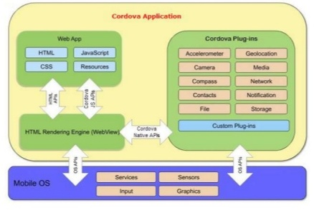

**Fig 1.1 Apache Cordova**

* + 1. **Introduction to Java EE**

Java Platform, Enterprise Edition or Java EE is Oracle's enterprise Java computing platform. The platform provides an API and runtime environment for developing and running enterprise software, including network and web services, and other large-scale, multi-tiered, scalable, reliable, and secure network applications. Java EE extends the Java Platform, Standard Edition (Java SE), providing an API for object-relational mapping, distributed and multi-tier architectures, and web services. The platform incorporates a design based largely on modular components running on an application server. Software for Java EE is primarily developed in the Java programming language

* + 1. **Introduction to Apache Tomcat server**

Apache Tomcat (or simply Tomcat, formerly also Jakarta Tomcat) is an open source web server and servlet container developed by the Apache Software Foundation (ASF). Tomcat implements the Java Servlet and the JavaServer Pages (JSP) specifications from Oracle, and provides a "pure Java" HTTP web server environment for Java code to run in. In the simplest config Tomcat runs in a single operating system process. The process runs a Java virtual machine (JVM). Every single HTTP request from a browser to Tomcat is processed in the Tomcat process in a separate thread.

* + 1. **Servlets:**

Servlets are Java technology's answer to CGI programming. They are programs that run on a Web server and build Web pages. Building Web pages on the fly is useful (and commonly done) for a number of reasons:

1. The Web page is based on data submitted by the user. For example the results pages from search engines are generated this way and programs that process orders for e-commerce sites do this as well.
2. .The data changes frequently. For example, a weather-report or news headlines page might build the page dynamically, perhaps returning a previously built page if it is still up to date.
3. The web pages use information from corporate databases or other such sources. For example, you would use this for making a Web page at an on-line store that lists current prices and number of times in stock.
   * 1. **Hibernate:**

Hibernate is an object-relational mapping (ORM) library for the Java language, providing a framework for mapping an object-oriented domain model to a traditional relational database. Hibernate solves object-relational impedance mismatch problems by replacing direct persistence-related database accesses with high-level object handling functions.

* Hibernate Query Language
* Hibernate Criteria Query
* Support for Query in native SQL dialect

Take less development time. Support Automatic key Generation and XML Binding and has Eclipse support.

Advantages over JDBC:-

* Relational Persistence for Java.
* Database independent code.
* Support for Query language.
* Optimize performance with caching.
* Easily scalable
  + 1. **MY SQl:**

MySQL is a popular choice of database for use in web applications, and is a central component of the widely used LAMP web application software stack—LAMP is an acronym for "Linux, Apache, MySQL and Perl/PHP/Python

**Chapter 2**

**About the System**

* 1. **System Requirement Specification**

**2.1.1 Introduction**

* **App-Maker**-For many businesses, the logical next step after a website is a mobile application. But until very recently, developing the mobile application was time-consuming and expensive. To solve that problem, **App Maker** developed a concept called "Do-it-yourself", mobile-app authoring platform, which lets anyone

Build their own app, without having to hire coders, programmers, or anyone else.

* The application **App-Maker** can make the mobile app of existing web app as well as non existing web application it creates the mobile app then market it and updates all changes.
* **Purpose**
* In existing system, if we have to make an android app then we have to go to android developer, similarly for i-phone app we have to go to i-phone developer. But **App-Maker** overcome this disadvantage of existing system, GOAL of APP-maker is to create an application which makes mobile app of andriod as well i-phone on a single platform.
* **App-Maker** provides facility to user of NO requirement of CODING and knowledge of any mobile application development.
* **Scope**

**App-Maker** unique auto-discovery technology grabs your existing online content and builds your app in seconds.

* It provides a wide range of features, styles, backgrounds, and colour themes to match the look and feel of your brand. Create, publish, promote, and manage your app from one control panel. View analytics and keep track of your performance.
* Increase app installs and boost brand awareness with our complete set of promotional and social sharing tools.
* Quickly and easily customize your app (no coding required).
* **App-Maker** Offer users an app for all major mobile platforms (Android, i-Phone).
* Use integrated social media features to build your mobile community

## **References**

The SRS document uses the following documents as references:

|  |  |
| --- | --- |
| Roger S. Pressman | Software Engineering , McGraw-Hill, 2001 |
| Rajib Mall | Fundamentals of Software Engineering, 3rd Edition, PHI Learning Pvt. Ltd. |
| Phone Gap | It enables software programmers to build applications for mobile devices using JavaScript, HTML5, and CSS3. It enables wrapping up of HTML, CSS and JavaScript code depending upon the platform of the device. It extends the features of HTML and JavaScript to work with the device. |
| APP-Builder | website [ www.apps-builder.com] |
| Apps-geyser | website [http://www.appsgeyser.com] |
| jQuery | Reference on api.jquery.com |
| W3School | Website[http://www.w3schools.com/] |

TABLE 2.1 References

* **Overview:**

The SRS will provide a detailed description of the **App-Maker**. This document will provide the outline of the requirements, overview of the characteristics and constraints of the system.

* An APP-MAKER is a app-making platform, helping small businesses around the world thrive in the mobile age.
* From creating an app to marketing it and driving sales, APP-MAKER offers a complete app solution.
* No coding or technical expertise required!
* APP-MAKER makes it easier than ever before for small businesses to create apps for engaging customers, building loyalty, and succeeding in today’s increasingly mobile business environment
* Its user-friendly platform simplifies app creation, while allowing publishers to build unique, feature-filled apps.
* With a commitment to meeting the needs of today’s small businesses, the APP-MAKER app maker offers a variety of e-commerce solutions and other monetization options designed to raise profit
* To round out its complete app-management solution, APP-MAKER offers marketing and promotional tools to help publishers get their apps downloaded and used.
  + 1. **Overall Description**

The APP-MAKER is a package to be used by different user who wants to make mobile application that does not have knowledge of coding can make the mobile application by registering on App-maker website. The App-maker to be developed benefits greatly the user who having small business and cannot afford making android or i-phone application by going with their developer. The User can keep their application updated all the time so that the members (End-user) get the updated information all the time

* As millions of consumers today turn to their smartphones and tablets to shop, search, order, and pay, even the smallest businesses need to reach their customers on mobile devices.
* The apps are actually universal: app maker's platform creates them in HTML5, a programming language supported by most smartphones.
* In addition, the Console keeps track of app activities: It provides businesses with information about how the app is being used, such as which offers the customers are taking advantage of and their favourite feature of the app.
* It provides a wide range of features, styles, backgrounds, and colour themes to match the look and feel of your brand. Create, publish, promote, and manage your app from one control panel. View analytics and keep track of your performance.
* Increase app installs and boost brand awareness with our complete set of promotional and social sharing tools.
* **Product Description**
* **App-Maker** is a web based application intended to serve the user to create a mobile application. User can build mobile application without the knowledge of coding. It provides easy and instant mobile application building.
* It has various type users who can build their mobile application of different categories. Capability includes Plans, which are of three types Free Plans, Starter plans and Premium Plans from these plans user can select any one of them according to their convenience.
* It includes **Monetization** that is company’s revenue increase by selecting paid plans, coupons and e-commerce generating app features. It also has the functionality of Monitor and track app performance, staying informed on what's working.
* **Product Functions**
* There are various flows of the application the manner it works all the operation of the application relies on the user visits the website views the plans and features.
* The user registers and then selects the plan for creating the mobile application**.** If user selects the free plan then the user redirects to the page which includes categories. If user selects the paid plan then the user redirects to the payment gateway which is supported by the PayPal. After payment user will redirects to the page which includes categories.
* User select the platform on which they wish to create mobile application then choose the category then give the name of the mobile application and then fills the data into predefined templates provided by **App-Maker.** Mobile application is created and ready for publish
* If the User other than the registered user like Visitor, Visitor user visits the websites views plans and features provided by the **App-Maker**. Visitor user can also view the app-gallery which contains the created mobile application of other users.
* Registered user signup selects the mobile application created by them. If user decides to launch that created application in another platform then they choose the platform and publish the created application.
* The administrator has the ability to manage newly developed application. Administrator keeps track of all release applications in time-span for all platforms. Administrator can create PIE-CHART according to platform specific applications, mobile application, release mobile application, number of mobile application developed by categories, platform as well as categories and can view them.
* Administrator generates user report according to the categories and also generates user report based on release date with the platform and on which it has been released.
* Administrator generates Analytical data of completed mobile applications and release pending mobile application. Also generate the error report.

## **Product User**

* The categories of the users of Undefined QA System roles as defined in the system are as follows :-
* Administrator :

Administrator is the overall in-charge of the system. His job is to maintain the system, its data and monitoring the system with the help of the reports. Manage various API platforms for application development. He manages categories and application templates and also manages users. He can configure Plans and Features as well as Offers and generate reports.

* Register User :

Registered users are a normal registered user who has the normal permission to create the mobile application. Based on pricing plans features will be display to the users. If the register users select the Free Plans few features compared to paid plans are provided and user can build maximum five applications in terms of one year in only one platform. If the user selects the paid plans then all the features will be available to them and they can build thousands of applications in terms of one year in various platforms.

* Visitor Users :

Visitors are those users who are not registered with the web application. They can just navigate through App Gallery and view created application of different users. They can also view the Plans and Features of the **APP-Maker.**

## **Assumptions and dependencies**

The assumptions made while designing the **App-Maker** are as follows:-

* At the base of the role hierarchy there will be only one administrator account provided which will have all the functionalities accessible.
* All the system level feature permissions are fixed and no changes can be made to it. However, the administrators are allowed to create roles with specific system permissions so only expected features are accessible to the user of that role as intended.
* The database configurations are provided as a part of configuration files.
* The users have sufficient knowledge of computers.
* User must have Internet Connection.
* The users can access App-maker from any computer that has Internet browsing capabilities and an Internet connection.

# **Specific Requirements**

**2.1.3.1 External Interface Requirements**

* Hardware Requirements:

**App-Maker** is required to be installed on a Web Server having the following minimum hardware specifications:

- Intel® Dual Xeon® 5000 series Dual Core processor having clock speed

Of 2.33 GHz or more.

- 8 GB DDR RAM

- 2 x RAID-1 SATA-2 Hard Disk Drives having capacity of 250 GB each.

- At least 5 GB free space for installing Apache Tomcat, JAVA, MySQL

and the App-Maker WAR files deployment.

- USBs for back purposes.

- Required to be housed in at least a Tier-3 Data Centre as per TIA-942;

Data Centre Standards Overview which provides detailed specifications

for UPS, firewalls, routers, switches, IDS and redundancy.

On the **client** side, any personal computer capable of browsing the Internet will suffice. However, it is recommended that at least a personal computer with Pentium-IV processor with a resolution support of 1024x768 screen resolution along with a minimum of 512kbps of internet connection.

For **development**, a personal computer with Intel® Core i5 processor, 3 GB DDR3 RAM, 320 GB Hard drive, a monitor with 1024x768 of screen resolution support, and an Internet connection of 1 mbps was used.

* Software Requirements:

On the Web Server side, **App-Maker** will require the below mentioned software platforms:-

- MySQL 5.6.17 RDMS or later

- Java 7 Runtime Environment

- Apache Tomcat 7.0 or later

- Any server capable of running Java Runtime Environment.

On Client Side, only a Web Browser is required supporting HTML 4.0 such as Internet Explorer, Firefox, or Chrome on any of its supported operating system.

The below mentioned tools were used while developing the application:-

- Eclipse Kepler

- JDK 1.7

- Notepad++

- Chrome, IE and Firefox

- Apache Tomcat 7.0

- MySQL 5.6.17

- Windows 7 Operating System

**App-Maker** is platform independent due to wide availability of Java, MySQL and Apache Tomcat for various platforms.

**2.1.3.2 Functional Requirement**

The system was studied thoroughly and the following functional requirements could be identified:

|  |  |
| --- | --- |
| **Id-2.2** | |
| **Functions** | Login |
| **Descriptions** | Users of Undefined Logs into the system. |
| **Inputs** | Email Address & Password. |
| **Source** | Users of system i.e. Administrators and Registered Users |
| **Destination** | Home Page of the web application is reloaded. |
| **Output** | Bad Credentials message or redirects the user to the home page on successful login. |
| **Action** | The combination of the email address and password as entered by the user is checked in the database, if it exists the user is redirected to the home page of the web application or else a Bad Credentials message is shown. |

TABLE 2.2

|  |  |
| --- | --- |
| **Id-2.3** | |
| **Functions** | Logout |
| **Descriptions** | Users of Undefined Logs out of the system. |
| **Inputs** | Click on the logout link. |
| **Source** | Users of system i.e. Administrators and Registered Users. |
| **Destination** | Home Page of the web application is reloaded. |
| **Ouput** | Redirects the user to the home page on successful login, clearing any persistent login information stored in the database. |
| **Action** | The logout link is shown to the user when the user logs in, inside the menu on the top-right corner of the screen. |

TABLE 2.3

|  |  |
| --- | --- |
| **Id-2.4** | |
| **Functions** | Create App |
| **Descriptions** | Registered User will provide with option for creating application. |
| **Inputs** | Registered User will give the name of the mobile application and selects the category. |
| **Source** | Registered Users. |
| **Destination** | Redirects the user to the Create application page on successful login, their by providing option for creating the mobile application. |
| **Output** | Generate mobile application. |
| **Action** | On successful login User will redirects to the Create application page, selects the category and start building his mobile application |

TABLE 2.4

|  |  |
| --- | --- |
| **Id-2.5** | |
| **Functions** | Manage plans. |
| **Descriptions** | Administrator provides various plans to the user for creating mobile application. |
| **Inputs** | Add/remove plan, change duration of plan and update pricing of plan. |
| **Source** | Administrator. |
| **Destination** | Plans will be update to the Screen which include show plan. |
| **Output** | Shows “New plans added successfully” message on success or else it shows “Failure in creating new plans on failure” |
| **Action** | On successful management plan provided plans will be updated. |

TABLE 2.5

|  |  |
| --- | --- |
| **Id-2.6** | |
| **Functions** | Manage Offer |
| **Descriptions** | Administrator provides various offers to the user for creating mobile application |
| **Inputs** | Add/remove offer, change duration of offer and update offer. |
| **Source** | Administrators |
| **Destination** | Plans will be update to the Screen which include show offer. |
| **Output** | Shows “New offer added successfully” message on success or else it shows “Failure in creating new offer on failure” |
| **Action** | On successful management of offer provided offer will be updated. |

TABLE 2.6

|  |  |
| --- | --- |
| **Id-2.7** | |
| **Functions** | Manage template |
| **Descriptions** | Administrator provides various templates to the user for creating mobile application. |
| **Inputs** | Add/remove pages of templates, Update templates and provide customize template. |
| **Source** | Administrators. |
| **Destination** | Template will be update to the page which include template for creating mobile application. |
| **Output** | Shows “New template added successfully” message on success or else it shows “Failure in creating new Template on failure” |
| **Action** | On successful management of template provided templates will be updated. |

TABLE 2.7

|  |  |
| --- | --- |
| **Id-2.8** | |
| **Functions** | Manage Platform |
| **Descriptions** | Administrator provides various platform to the user on which they can create their mobile application |
| **Inputs** | Add/remove platform |
| **Source** | Administrators. |
| **Destination** | Platform will be update to the page which include platform for creating mobile application. |
| **Output** | Shows “New Platform added successfully” message on success or else it shows “Failure in creating new platform on failure” |
| **Action** | On successful management of template provided templates will be updated. |

TABLE 2.8

|  |  |
| --- | --- |
| **Id-2.9** | |
| **Functions** | Show plans |
| **Descriptions** | User selects various plans provided administrator. By selecting any one plan from them they can create their mobile application |
| **Inputs** | Select/Views plans provided by the Administrator |
| **Source** | User |
| **Destination** | By selection plans from the plans Screen redirects according to the selection |
| **Output** | User selects free plans then it will redirects to the website or else if user selects the paid plan they will redirects to payment Gateway provide by the system. |
| **Action** | On successful purchase of plan User will redirects to the screen according to the selection of plans. |

TABLE 2.9

|  |  |
| --- | --- |
| **Id-2.10** | |
| **Functions** | Manage Payment. |
| **Descriptions** | If User select paid plans then administrator will provide payment service supported by the website |
| **Inputs** | Select plan |
| **Source** | User |
| **Destination** | Payment gateway |
| **Output** | User selects the paid plan they will redirects to payment Gateway provide by the system. |
| **Action** | On successful payment of plan payment receipt will given to the user for the payment done and redirects to the App-Creation Screen. |

TABLE 2.10

|  |  |
| --- | --- |
| **Id-2.11** | |
| **Functions** | Report Generation |
| **Descriptions** | Report will be generated by administrator based on different categories, platform, plan selection etc |
| **Inputs** | Data |
| **Source** | Administrator |
| **Destination** | Report Generation Screen. |
| **Output** | User can view report according to their requirement. |
| **Action** | User clicks on the “Report Generation” button in the Report Generation screen, and once completes app creation report will be generated. |

TABLE 2.11

* **Non-Functional Requirements:**

The system was studied thoroughly and the following functional requirements could be identified they are:

* QrCode Generation: Quick Response Code is the trademark for a type of

Matrix barcode. From this user can download mobile

Application by scanning the Qrcode.

* Social media promotion: Social media promotion is facilities provide to

the user who selects paid plan to share their

Application on social media or can add

Connectivity to social media in their application.

## **Usability**

* **App-Maker** does not require the knowledge of coding.
* The system shall allow the users to access the system from the Internet using HTML or its derivative technologies. The system uses a web browser as an interface.
* Since all users are familiar with the general usage of browsers, no specific training is required.
* The system is user friendly and self-explanatory.

## **Reliability**

The system must be highly reliable as it manages a massive data of the community and the damages incorrect or incomplete data can do.

### **Availability**

The system is available 100% for the user and is used 24 hrs a day and 365 days a year. The system shall be operational 24 hours a day and 7 days a week.

### **Mean Time between Failures (MTBF)**

The system will be developed in such a way that it ***may*** fail once in a year.

### **Mean Time to Repair (MTTR)**

Even if the system fails, the system will be recovered back up within an h our or less.

### **Accuracy**

The accuracy of the system is limited by the accuracy of the speed at which the employees of the library and users of the library use the system.

### **Maximum Bugs or Defect Rate**

Not specified.

### **Access Reliability**

The system shall provide 100% access reliability Performance

* **Performance**

### **Response Time**

The Information page should be able to be downloaded within a minute using a 56K modem. The information is refreshed every two minutes. The access time for a mobile device should be less than a minute. The system shall respond to the user in not less than two seconds from the time of the request submittal. The system shall be allowed to take more time when doing large processing jobs.

### **Administrator/User**

The system shall take as less time as possible to provide service to the user

or to the Administrator.

### **Throughput**

The number of transactions of developing App may increase with increase in number of users. There are provisions to set up different server with web service App which is just responsible of performing App developing based on App platform.

### **Capacity**

The system is capable of handling 250 users at a time.

### **Resource Utilization**

The resources are modified according the user requirements and also according to the App-Created by the user.

## **Supportability**

The system designers shall take in to considerations the following supportability and technical limitations.

### **Internet Protocols**

The system shall be comply with the HTTP and TCP/IP protocol standards and shall be designed accordingly.

### **Information Security Requirement**

The system shall support the UHCL information security requirements and use the same standard as the UHCL information security requirements.

### **Billing System Data Compatibility**

The User billing amount will be calculated on the basis of the pricing plan selected by the user and the receipt will be generated by the billing system the data in the receipt will be compatible for the data types and design constraints of the billing system

### **Maintenance**

**App-Maker** is designed to be flexible, maintenance of the system will be easy without any changes in the code. Changing configurations in the database will be enough to change the control of the system.

### Standards

The coding standards and naming conventions will be as per the java code conventions designed by sun microsystem for java.

## **Design Constraints**

### **Software Language Used**

The languages that shall be used for coding the **App-Maker** are Java Servlets, Java Server Pages (JSP), HTML, JavaScript and jQuery Mobile. For working on the coding phase of the **App-Maker**, the Apache Tomcat Server needs to be installed, along with it MySQL Server is also required for handling database operations.

### **Development Tools**

Will make use of the available Java Development Tool kits for working with Java Beans and Java Server Pages. Also will make use of the online references available for developing programs in ASP, HTML and JavaScript.

* + - ***Class Libraries***

Will make use of the existing Java libraries available for JSP and Servlets. Also we need to develop some new libraries for the web-based application. Also we will develop new designs for various categories of application and library for communicating with the hardware of mobile device using Phone Gap.

## **Interfaces**

### User Interfaces:

* + - The GUI should adhere to industry standards so that the GUI will look the same on a variety of web browsers such as Internet Explorer, Firefox, Opera, and Safari etc.
    - Common Components for rendering pages based on pricing plans.
    - The system must have a free flowing interface to keep the usability of it to simple and easy.
    - The system will use buttons to select materials, users etc. The system will use grid based layouts and CSS framework like bootstrap to maintain uniformity components of looks.

### **Hardware Interfaces:**

* Any hardware with the specifications equal to or higher than that determined in Hardware Specifications may be used. There might be problems in operating system with a lower specification.

### **Software Interfaces:**

### Only W3C Compliant Web Browser must be installed on the system.

### JavaScript must be enabled on the user’s web browser.

### System must interface with MySQL Database.

### **Communications Interfaces**

* Communication between different servers using Http protocol.

Communication happens when data exchange format JSON will be used between application development and application server

.

.

## **Legal, Copyright, and Other Notices**

* **App-Maker** is a trademark of Hyperlink Info System and cannot be used without its consent.

## **Applicable Standards**

* The ISO/IEC 6592 guidelines for the documentation of computer based application systems will be followed.

**Appendix A: Glossary**

SSL: Secure Socket Layer encryption

SRS: Software Requirements Specification

GUI: Graphical User Interface

.Net: A Microsoft platform for software development.

Microsoft SQL server: A database system and is multithreaded/multiuser databaseserver.

Microsoft Visual Studio: An Integrated Development Environment

Microsoft IIS: An application server for .net applications

Microsoft Visio: A Microsoft platform for creating various UML and Flow Diagrams.

Mozilla Firefox: A web browser of mozilla foundation

Microsoft Internet Explorer: A web browser of Microsoft corporation.

Photoshop: The designing software for designing of different elements of website.

Processor: It allows the processing of numeric data, meaning information entered in binary form, and the execution of instructions stored in memory.

SOAP: A standard for exchanging XML messages over a network.

SMTP: A standard text based method for transferring email.

Windows: An Operating System by Microsoft Corporation.

SDLC: Software Development Lifecycle.

**2.2 Feasibility Study**

The feasibility study of the **App-Maker** was conducted using the “TELOS” model which stands for Technical, Economic, Legal, Operational and Scheduler feasibility.

**2.2.1 Operational Feasibility**

The system has been developed for any user who wants to use this system. The users must find the system friendly and easy to use. The interoperability with the existing system is also to be checked after uploading the website. So they may face certain problems in using the user interfaces. So keeping this consideration in mind we have provided field for each and every field on the forms. The administrator also may be non-technical, so the user interface is designed in such a way that it gets comfortable for the non-technical person to operate easily.

**2.2.2 Technical Feasibility**

It is a measure of practically of a specific technical solution and the availability of technical resource and expertise. The analyst must find out whether current technical resources, which are available in the system is capable of handling the job. If not, then the analyst with the help of developers should confirm whether the technology is available and capable or not.

Factors considered:

* + Here we have to consider those tools, which are required for developing the project.
  + As far as basic knowledge is concerned we have studied basics of PHP, SQL HTML &CSS.
  + Dealing with database is the main issues in our system. Using My SQL as backend this functionality is provided.

**2.2.3 Schedule Feasibility**

Schedule feasibility corresponds to whether sufficient time is available to complete the project.

Factors considered:-

* Schedule of the project.
* Time by which the project has to be completed.
* Reporting period.

Considering all above factors it was decided that we have sufficient time and then we decided to start the project.

**2.2.4 Economical Feasibility**

Economical feasibility is a measure of cost effectiveness of a project or solution. For declaring that the system is economically feasible, the benefits from the project should exceed or at least be equal to the cost of development.

The cost spent in the making of the project is categorized into two parts:

**Direct cost:** This is in terms of money. In our project it is the estimated cost of:

* Hardware (Computer).
* Software (if any licensed version tool we purchase to use).
* Report generation cost.

**Indirect cost:**

* Time spent in system analysis
* Managing time
* Referring other sources like the Internet.

The benefits from the project can also be categorized into two parts:

**Tangible benefit:** This is in terms of money. In our project this is not valid since it‟s the first time we are learning to make the web application and developing the project for ourselves as a part of our curricular studies.

**Intangible benefit**: This is in terms of position and satisfaction.

* The project can be used in Government Organization.
* We would make the first individual and own handwork project that would give us confidence and also knowledge about the field.
* It would also create the impression on our faculties and leave an impact on others depending on the quality of the project.

**2.3 Project Planning**

**2.3.1 Project Development Approach**

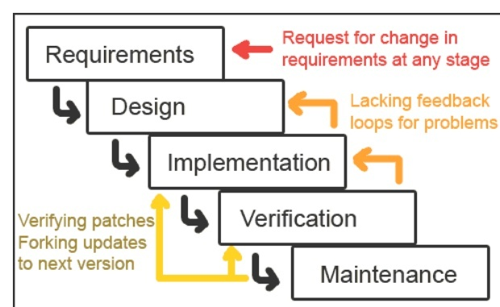

**Fig 2.1 Iterative Waterfall Model**

We will use Iterative waterfall model to develop our project. Iterative waterfall model is a model which can be easily modified and extensible according to requirements.

Steps performed in Iterative waterfall model are:

* Requirement gathering.
* Analysis.
* Implementation.
* Verification.
* Maintenance.

Why Iterative Waterfall model:

* Oldest software lifecycle model and best understood by upper management
* Used when requirements are well understood and risk is low
* Work flow is in a linear (i.e., sequential) fashion with backtracking
* We use iterative waterfall model because requirement are clear cut and well-defined
* This model is easy to understand
* Problems can be somewhat alleviated in the model through the addition of feedback loops
* We can also use waterfall model but problem with this model is waterfall model is that the linearity of the development results in a failure to provide early feedback on the development .

**2.3.2 Project Plan**

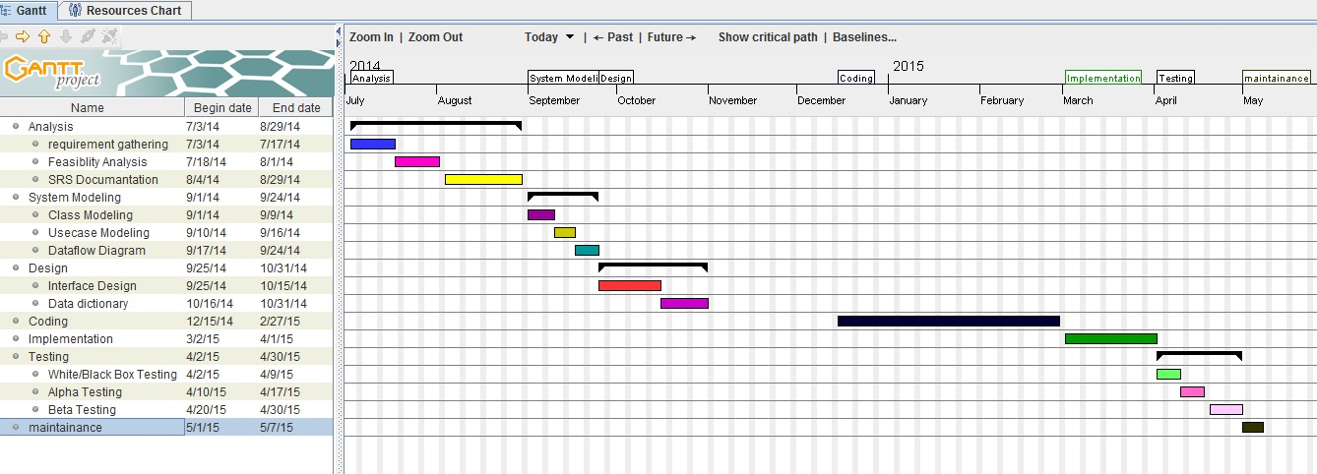

**Fig 2.2 Gantt chart**

**Chapter 3**

**Analysis**

**3.1 E-R Diagram**

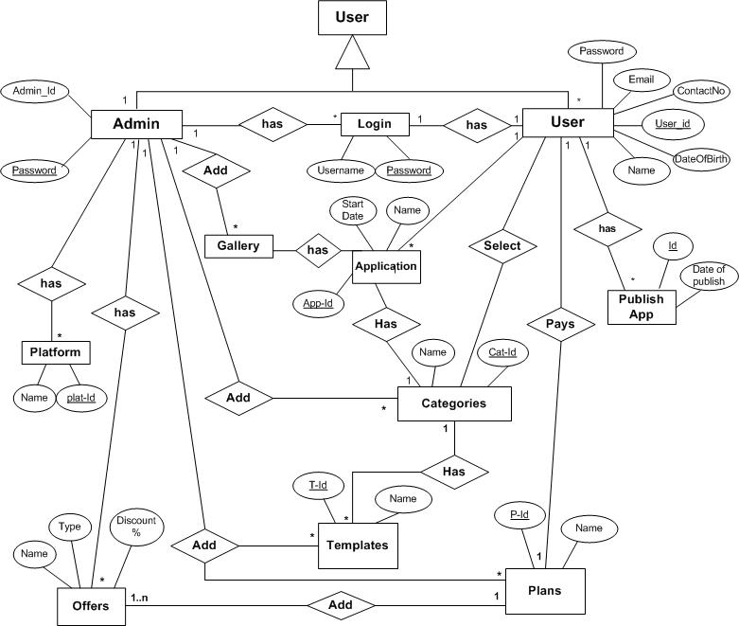

**Fig 3.1 Entity relationship diagram**

**3.2 Data Flow Diagram**

**Dfd level-0**

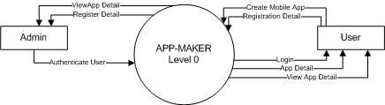

**Fig 3.2 Dataflow Diagram level-0**

**Dfd level-1**

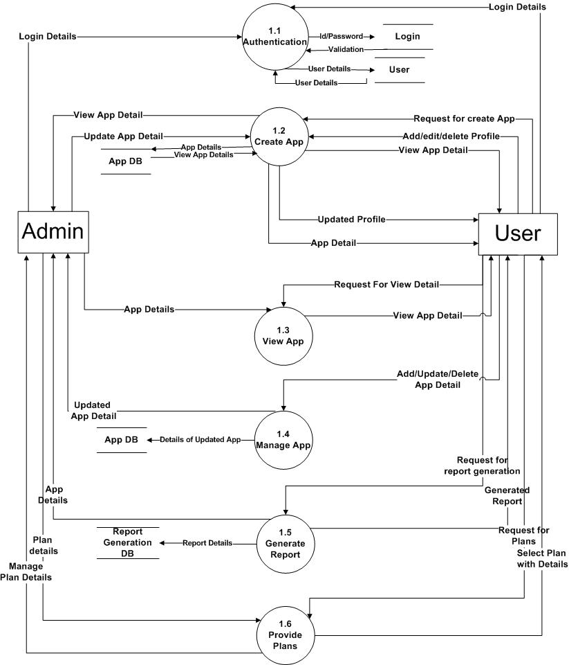

**Fig 3.3 Dataflow Diagram level-1**

**3.3 Use Case Diagram**

**Use case diagram for Admin:**

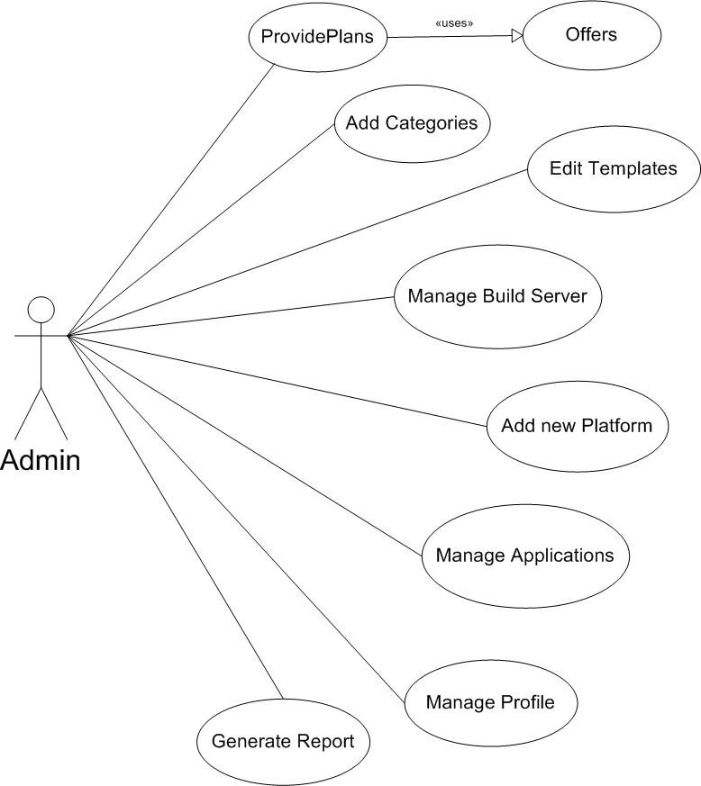

**Fig 3.4 Use Case Diagram for Admin**

Use case Diagram for **visitor user**:

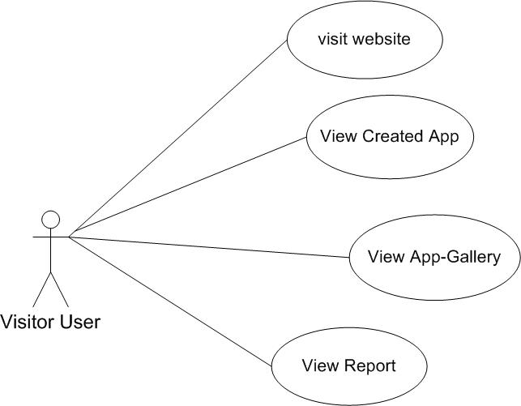

**Fig 3.5 Use Case Diagram for Visitor**

Use Case Diagram for **Registered User:**

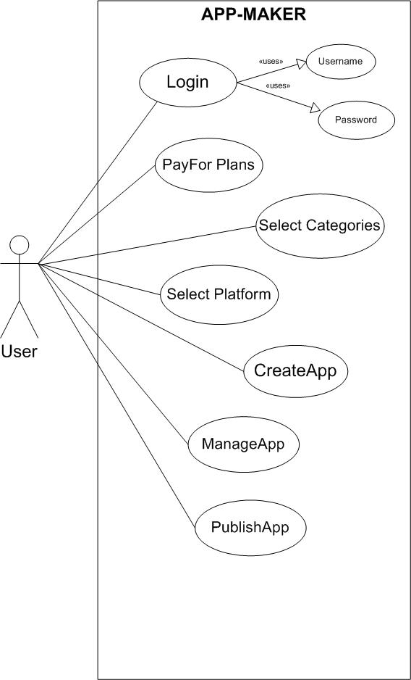

**Fig 3.6 Use Case diagram for Registered User**

**3.4 Sequence Diagram**

**Sequence Diagram for Admin/User**

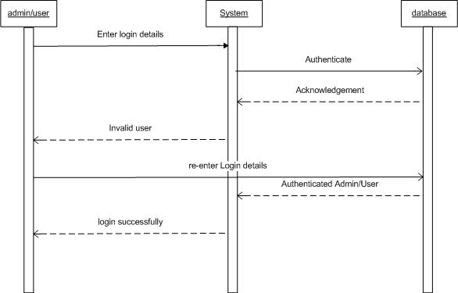

**Fig 3.7 Admin/User Sequence diagram**

Sequence Diagram for **System**

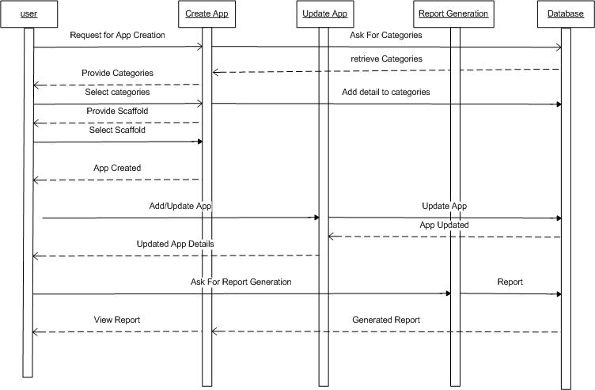

**Fig 3.8 System Sequence diagram**

**3.5 Activity Diagram**

**User Activity Diagram**

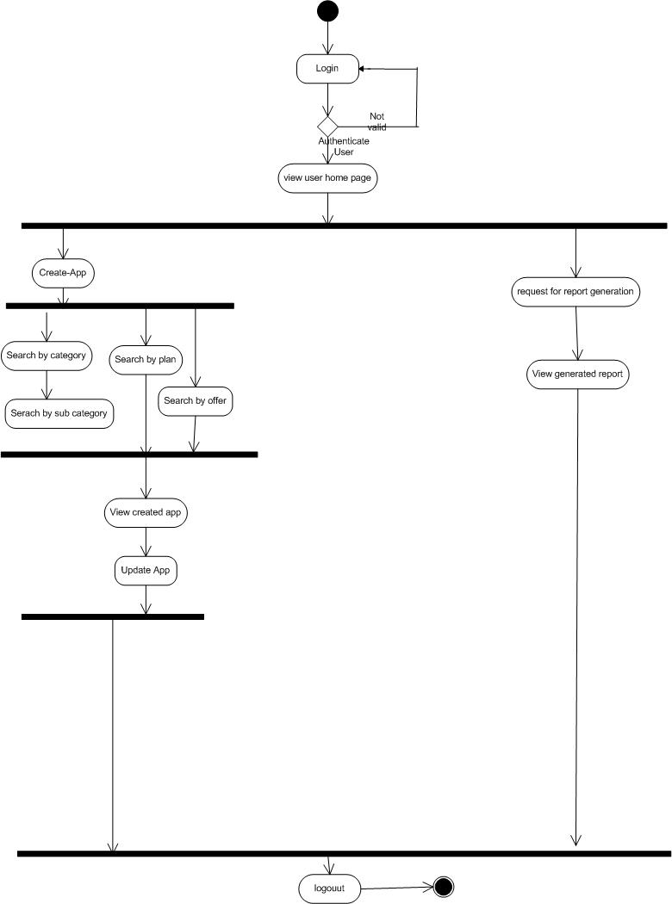

**Fig 3.9 User Activity diagram**

**Admin Activity Diagram**

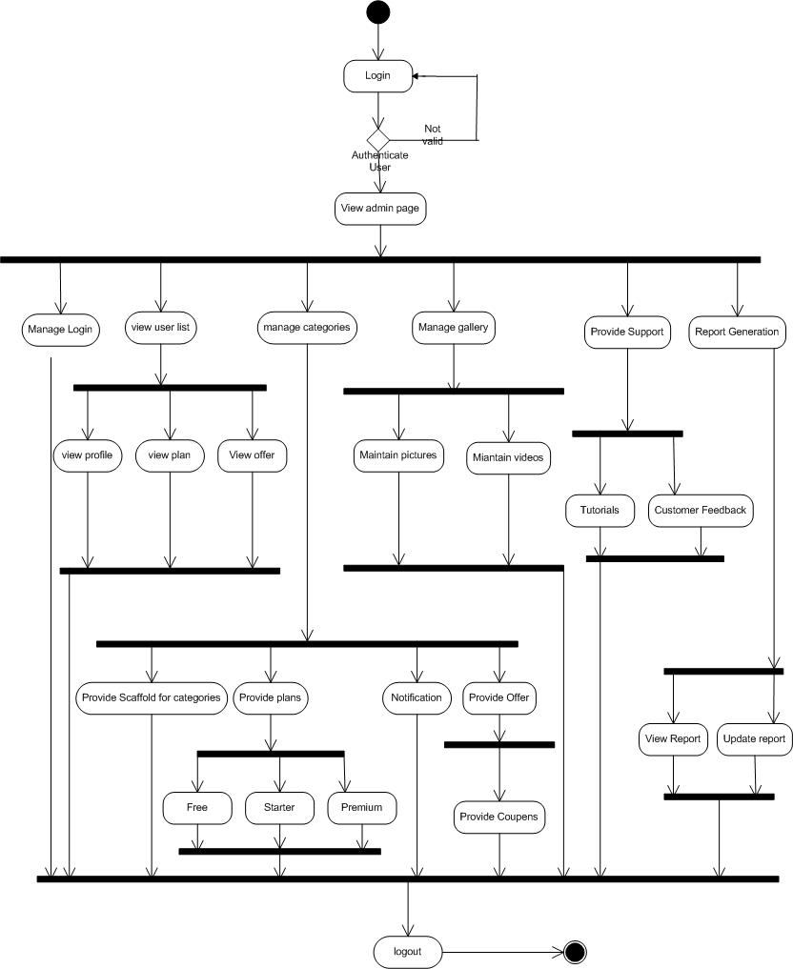

**Fig 3.10 Admin activity diagram**

**3.6 Class Diagram**

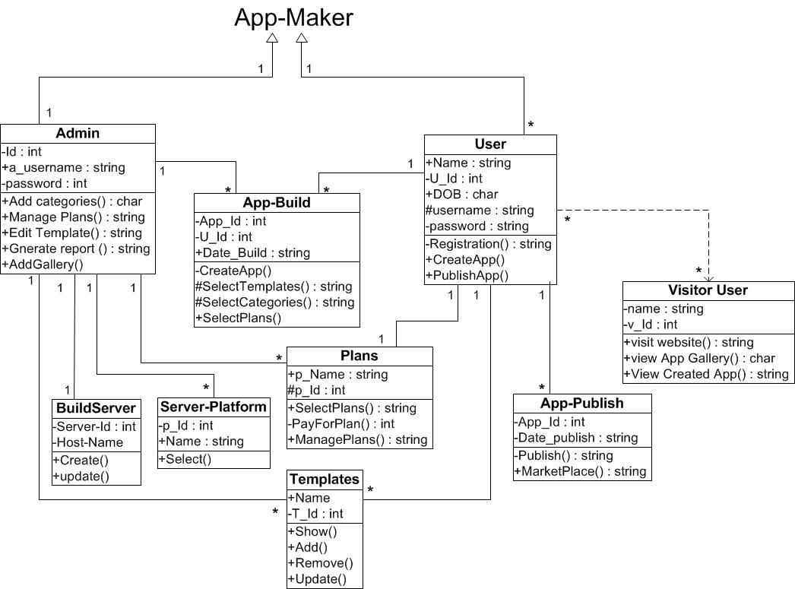

**Fig 3.11 Class diagram**

**Chapter 4**

**Design**

**4.1 System Flow Diagram**

**User**

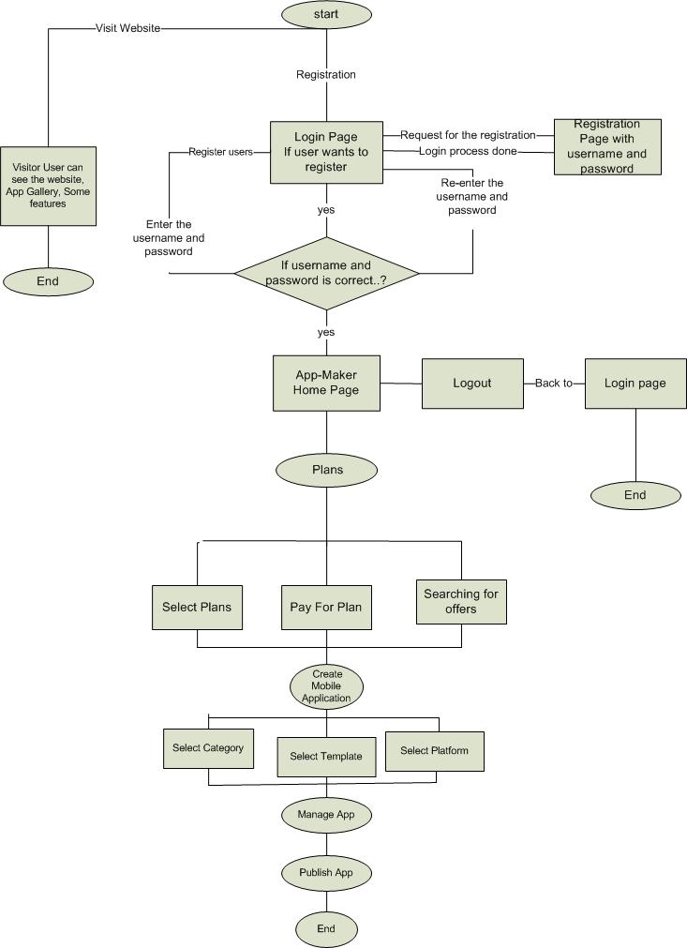

**Fig 3.12 User Flow diagram**

**Admin**

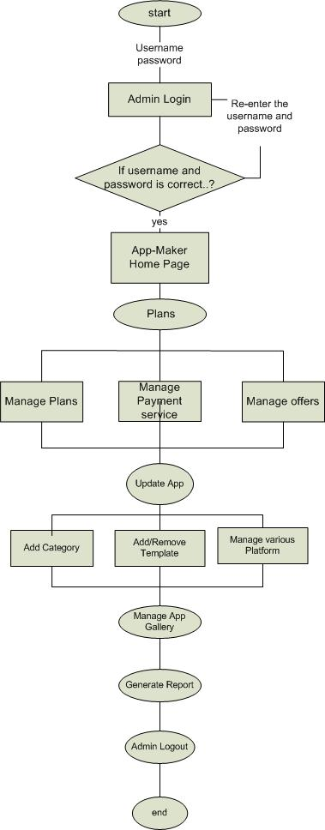

**Fig 3.13 Admin Flow diagram**

**4.2 Data Dictionary**

|  |  |
| --- | --- |
| **Table Name:** | **User** |
| **Description :** | **Provide information about User.** |
| |  |  |  |  |  |  | | --- | --- | --- | --- | --- | --- | | **Sr no** | **Column** | **Data Type** | **Size** | **Constraints** | **Description** | | 1 | Id | Number | 10 | Primary key | Assign Unique Id to Offer. | | 2 | User_Name | Varchar2 | 30 | NOT NULL | Assign Name to User. | | 3 | Email_Id | Varchar2 | 25 | NOT NULL | Defines unique Email_Id | | 4 | Password | Password | 25 | Length of password  Should contain at least  6 characters. | Define password of the user | | 5 | Address | Varchar2 | 30 | NOT NULL | Defines the address of the user | | 6 | Contact_No | Number | 20 | NOT NULL | Defines contact no of user | | 7 | DoB | Varchar2 | 20 | NOTNULL | Defines date of birth of user | | |
| **Table 4.1 User** | |

|  |  |
| --- | --- |
| **Table Name:** | **Categories** |
| **Description :** | **Table has information about Categories.** |
| |  |  |  |  |  |  | | --- | --- | --- | --- | --- | --- | | **Sr no** | **Column** | **Data Type** | **Size** | **Constraints** | **Description** | | 1 | Category_Id | NUMBER | 11 | Primary Key | Assign Unique Id to categories. | | 2 | Category_name | Varchar2 | 20 | NOT NULL | Name of Category. | | 3 | Description | Varchar2 | 40 |  | Detail of Category. | | |
| **Table 4.2 Categories** | |

|  |  |
| --- | --- |
| **Table Name:** | **Templates** |
| **Description :** | **Table has information about template.** |
| |  |  |  |  |  |  | | --- | --- | --- | --- | --- | --- | | **Sr no** | **Column** | **Data Type** | **Size** | **Constraints** | **Description** | | 1 | Template_Id | NUMBER | 10 | Primary Key | Assign Unique Id to Template. | | 2 | Template_name | Varchar2 | 15 | NOT NULL | Name of Template. | | |
| **Table 4.3 Templates** | |

|  |  |
| --- | --- |
| **Table Name:** | **Page-Templates** |
| **Description :** | **Table has information about Categories.** |
| |  |  |  |  |  |  | | --- | --- | --- | --- | --- | --- | | **Sr no** | **Column** | **Data Type** | **Size** | **Constraints** | **Description** | | 1 | Pt_Id | NUMBER | 10 | Primary Key | Assign Unique Id to Page of Template. | | 2 | Title | Varchar2 | 20 | NOT NULL | Name of Page of Templates. | | 3 | body | Varchar2 | 40 |  | User fill data in this. | | 4 | url | Varchar2 | 15 | NOT NULL | Provide Navigation. | | 5 | Tab_name | Varchar2 | 15 | NOT NULL | Provide table name | | |
| **Table 4.4 Page-Templates** | |

|  |  |
| --- | --- |
| **Table Name:** | **App-Created Data** |
| **Description :** | **Provide information about date on which application is created.** |
| |  |  |  |  |  |  | | --- | --- | --- | --- | --- | --- | | **Sr no** | **Column** | **Data Type** | **Size** | **Constraints** | **Description** | | 1 | Page_Id | NUMBER | 10 | Primary Key | Assign Unique Id to Page of App. | | 2 | Name | Varchar2 | 20 | NOT NULL | Name of Page of App. | | 3 | Category_Id | NUMBER | 11 | NOT NULL | Category unique Id required. | | 4 | User_Id | NUMBER | 15 | Foreign Key | User id required here. | | 5 | Last updatedOn | Varchar2 | 15 | NOTNULL | Date on which App last updated. | | |
| **Table 4.5 App-created data** | |

|  |  |  |  |  |  |  |  |  |  |  |  |  |  |  |  |  |  |  |  |  |  |  |  |  |  |  |  |  |  |  |  |  |  |  |  |  |  |  |  |  |  |  |  |  |  |  |  |  |  |  |
| --- | --- | --- | --- | --- | --- | --- | --- | --- | --- | --- | --- | --- | --- | --- | --- | --- | --- | --- | --- | --- | --- | --- | --- | --- | --- | --- | --- | --- | --- | --- | --- | --- | --- | --- | --- | --- | --- | --- | --- | --- | --- | --- | --- | --- | --- | --- | --- | --- | --- | --- |
| |  |  | | --- | --- | | **Table Name:** | **App-Build** | | **Description :** | **Create mobile App.** | | |  |  |  |  |  |  | | --- | --- | --- | --- | --- | --- | | **Sr no** | **Column** | **Data Type** | **Size** | **Constraints** | **Description** | | 1 | Build_Id | NUMBER | 10 | Primary key | Assign Unique Id to build of App. | | 2 | App_Id | NUMBER | 20 | Primary Key | Name of Page of App. | | 3 | Category_Id | NUMBER | 11 | NOT NULL | Category unique Id required. | | 4 | User_Id | NUMBER | 15 | Foreign Key | User id required here. | | 5 | Server platform_id | NUMBER | 25 | NOTNULL | Platform Id must be required. | | 6 | Date_build | VARCHAR2 | 20 |  | Date of creation of App. |   **Table 4.6 App-build** | | |  | | |

|  |  |
| --- | --- |
| **Table Name:** | **App-Publish** |
| **Description :** | **Publishing the Application.** |
| |  |  |  |  |  |  | | --- | --- | --- | --- | --- | --- | | **Sr no** | **Column** | **Data Type** | **Size** | **Constraints** | **Description** | | 1 | App_publish_Id | NUMBER | 10 | NOT NULL | Assign Unique Id to Plan. | | 2 | App_Build_Id | NUMBER | 10 | NOT NULL | Assign Unique Id to build of App. | | 3 | Date_publish | Varchar2 | 20 |  | Date of publish of App. | | 4 | Marketplace_Id | NUMBER | 15 | Foreign key | App has unique Id in Market place. | | |
| **Table 4.7 App-publish** | |

|  |  |
| --- | --- |
| **Table Name:** | **Plan** |
| **Description :** | **Provide information about plans.** |
| |  |  |  |  |  |  | | --- | --- | --- | --- | --- | --- | | **Sr no** | **Column** | **Data Type** | **Size** | **Constraints** | **Description** | | 1 | Plan_Id | NUMBER | 10 | Primary Key | Assign Unique Id to Plan. | | 2 | Name | Varchar2 | 20 | NOT NULL | Name of Plan. | | |
| **Table 4.8 plan** | |

|  |  |
| --- | --- |
| **Table Name:** | **User Plans** |
| **Description :** | **User select the plans** |
| |  |  |  |  |  |  | | --- | --- | --- | --- | --- | --- | | **Sr no** | **Column** | **Data Type** | **Size** | **Constraints** | **Description** | | 1 | UserPlan_Id | NUMBER | 11 | Primary Key | Assign Unique Id to Plans. | | 2 | plan_id | NUMBER | 15 | Foreign key | Assign plan id | | 3 | User_Id | NUMBER | 10 | Foreign key | Assign Unique Id to User. | | 4 | Date | Varchar2 | 20 |  | Date of starting plan. | | 5 | Start_Date | Varchar2 | 20 | NOT NULL | Date of plan begins. | | 6 | End_Date | Varchar2 | 15 | NOT NULL | Date of plan ends. | | 7 | TAX | NUMBER | 15 | NOT NULL | TAX including in pricing. | | 8 | Discount | NUMBER | 10 | NOT NULL | Discount percentage. | | |
| **Table 4.9 User plans** | |

|  |
| --- |
|  |

|  |  |  |  |  |  |  |  |  |  |  |  |  |  |  |  |  |  |  |  |  |  |  |  |  |  |  |
| --- | --- | --- | --- | --- | --- | --- | --- | --- | --- | --- | --- | --- | --- | --- | --- | --- | --- | --- | --- | --- | --- | --- | --- | --- | --- | --- |
| |  |  | | --- | --- | | **Table Name:** | **Build server** | | **Description :** | **Provide information about sever.** | | |  |  |  |  |  |  | | --- | --- | --- | --- | --- | --- | | **Sr no** | **Column** | **Data Type** | **Size** | **Constraints** | **Description** | | 1 | Server_Id | NUMBER | 10 | Primary Key | Assign Unique Id to server. | | 2 | Host_Name | Varchar2 | 20 | NOT NULL | Name of host. | | | | **Table 4.10 Build server** | | |

|  |  |  |  |  |  |  |  |  |  |  |  |  |  |  |  |  |  |  |  |  |  |  |  |  |  |  |  |  |
| --- | --- | --- | --- | --- | --- | --- | --- | --- | --- | --- | --- | --- | --- | --- | --- | --- | --- | --- | --- | --- | --- | --- | --- | --- | --- | --- | --- | --- |
| |  |  | | --- | --- | | **Table Name:** | **Server platform** | | **Description :** | **Information about which server provide which platform.** | | |  |  |  |  |  |  | | --- | --- | --- | --- | --- | --- | | **Sr no** | **Column** | **Data Type** | **Size** | **Constraints** | **Description** | | 1 | Build_Server_Id | NUMBER | 10 | Primary Key | Assign Unique Id to build server. | | 2 | Platform_Id | Varchar2 | 20 | NOT NULL | Assign Id to platform. | | | | | **Table 4.11 Server Platform** | | | |

|  |  |
| --- | --- |
| **Table Name:** | **Offer** |
| **Description :** | **Provide information about Offer.** |
| |  |  |  |  |  |  | | --- | --- | --- | --- | --- | --- | | **Sr no** | **Column** | **Data Type** | **Size** | **Constraints** | **Description** | | 1 | Offer_Id | Number | 10 | NOT NULL | Assign Unique Id to Offer. | | 2 | Offer_Name | Varchar2 | 10 | NOT NULL | Assign name to Offer. | | 3 | Offer_Discount | Number | 10 | NOT NULL | Provide discount. | | |
| **Table 4.12 Offer** | |

|  |  |
| --- | --- |
| **Table Name:** | **App-Pages** |
| **Description :** | **Table has information about Application pages.** |
| |  |  |  |  |  |  | | --- | --- | --- | --- | --- | --- | | **Sr no** | **Column** | **Data Type** | **Size** | **Constraints** | **Description** | | 1 | App_page_Id | Number | 15 | Primary Key | Assign unique Id to application pages | | 2 | Pt_Id | Varchar2 | 20 | Foreign key | Id of Page of Templates. | | 3 | Page_body | Varchar2 | 40 |  | User fill data in this. | | 4 | Cust_title | Varchar2 | 15 | NOT NULL | Provide customize title. | | 5 | Cust _tab_name | Varchar2 | 15 | NOT NULL | Provide customize table name | | 6 | Date | Varchar2 | 12 | NOT NULL | Date |   **Table 4.13 App-pages** | |
| |  |  | | --- | --- | | **Table Name:** | **Market Places** | | **Description :** | **Provide information about platform.** | | |  |  |  |  |  |  | | --- | --- | --- | --- | --- | --- | | **Sr no** | **Column** | **Data Type** | **Size** | **Constraints** | **Description** | | 1 | MarketPlace_Id | NUMBER | 10 | Primary Key | Assign Unique Id to Market Place. | | 2 | Platform_Id | NUMBER | 10 | Foreign Key | Assign Id to platform. | | 3 | Marketplace_Name | Varchar2 | 20 | NOT NULL | Assign name to market Place. | | | | **Table 4.14 Market places** | | | |

|  |  |
| --- | --- |
|  |  |
|  |  |
|  | |
|  | |

|  |  |
| --- | --- |
| **Table Name:** | **Price** |
| **Description :** | **Provide information about pricing.** |
| |  |  |  |  |  |  | | --- | --- | --- | --- | --- | --- | | **Sr no** | **Column** | **Data Type** | **Size** | **Constraints** | **Description** | | 1 | plan_Id | Number | 10 | Foreign Key |  | | 2 | Allowed_Platform | Number | 10 | NOT NULL | Decribes no of platform allowed | | 3 | Allowed_Adv | Varchar2 | 20 | NOT NULL | Decribes Ads allowed or not | | 4 | No_Of_App | Number | 10 | NOT NULL | Decribes no of App can be made | | 5 | Duration | Number | 10 | NOT NULL | Decribes duration of pricing | | |
| **Table 4.15 Price** | |

|  |  |
| --- | --- |
| **Table Name:** | **Payment Method** |
| **Description :** | **Provide information about Method for payment.** |
| |  |  |  |  |  |  | | --- | --- | --- | --- | --- | --- | | **Sr no** | **Column** | **Data Type** | **Size** | **Constraints** | **Description** | | 1 | Payment_Id | Number | 10 | Primary Key | Assign Unique Id to payment. | | 2 | Payment_name | Varchar2 | 20 | NOTNULL | Name payment gateway (paypal). | | |
| **Table 4.16 Payment Method** | |

|  |  |
| --- | --- |
| **Table Name:** | **Payment Gateway** |
| **Description :** | **Provide information about payment Gateway.** |
| |  |  |  |  |  |  | | --- | --- | --- | --- | --- | --- | | **Sr no** | **Column** | **Data Type** | **Size** | **Constraints** | **Description** | | 1 | Payment_Id | Number | 10 | Foreign Key | Uses payment Id. | | 2 | Pay_method_Id | Number | 10 | NOTNULL | Assign Unique Id to Pay Method. | | 3 | App_Id | Number | 10 | Foreign Key | Uses App Id | | 4 | User_Name | Varchar2 | 20 | NOT NULL | Gives User name | | 5 | Password | Password | 20 | NOT NULL | Password of the user | | 6 | Signature | Varchar2 | 20 | NOT NULL | Provide sign for authentication. | | |
| **Table 4.17 Payment Gateway** | |

**4.3 Relationship of Tables**

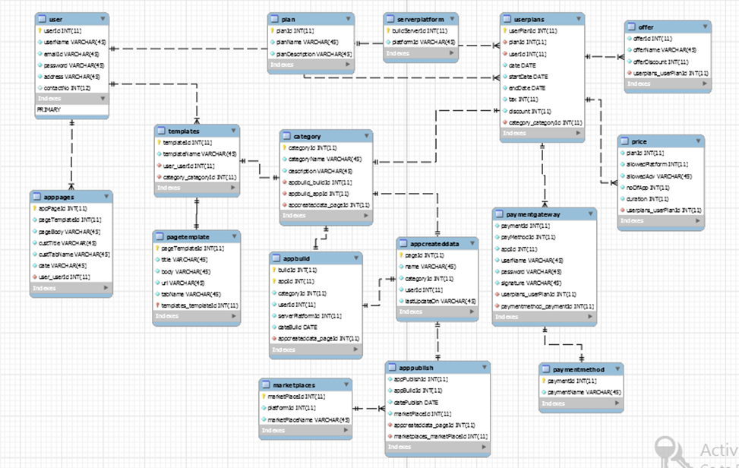

**Fig 6.1 Admin login**

**Fig 4.1 Relationship of table**

**4.4 User Interface**

User of the system will be provided with the Graphical user interface, there is no command line

interface for any functions of the product.

1. All the details in the webpage should be arranged systematically.
2. Login page followed by Password.
3. Users can easily Build their Application of their own kind via different and various feature of the website.
4. Users can update their profile by login into their account they can also view their created app.
5. Users can also edit their created app via application dashboard.
6. Pop-up boxes are used at various places in the website for creating website more interactive to users.

**User Home**

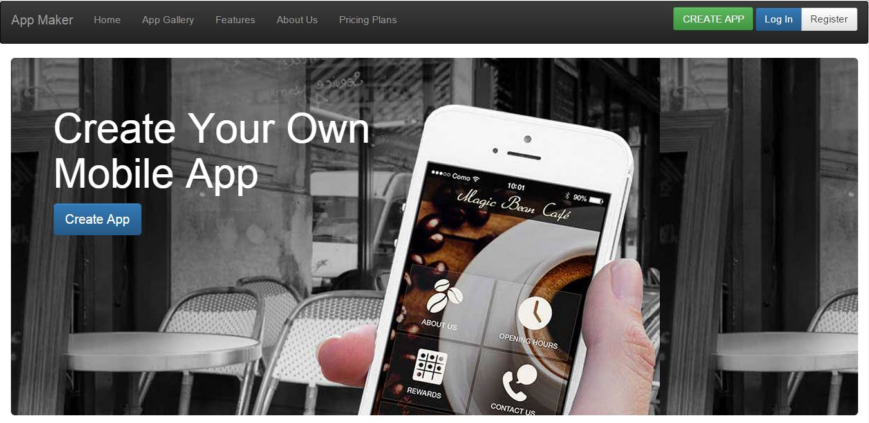

**Fig 5.1 User Home Page**

**Description**:-Above Screenshot Display the Home Screen of App-Maker

**Admin:**

Role of the Administrator is to handle all the activity of user from their login to login out.

Administrator authenticates the user, add or remove different functionality or they can edit them.

**Admin Home**

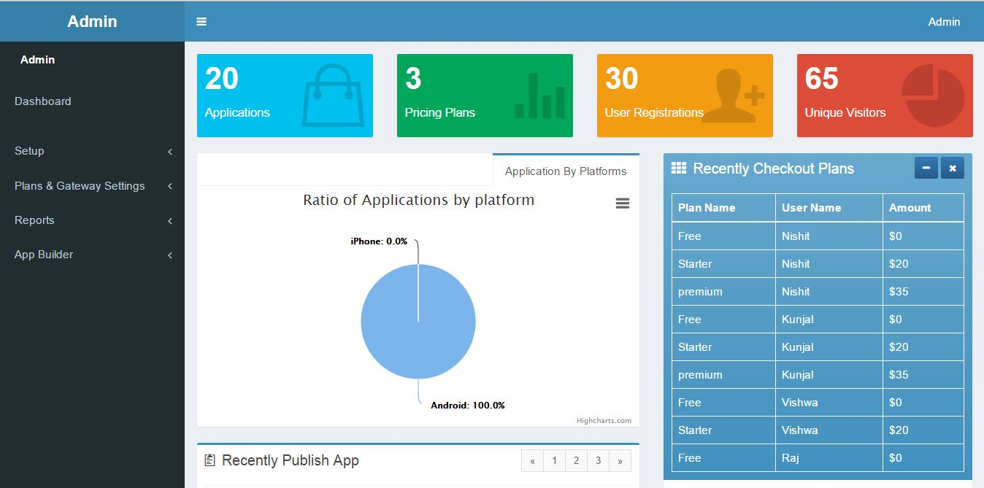

**Fig 5.2 Admin Home**

Description:- Above Screenshot Display the Administrator Screen of App-Maker

**4.5 Application Navigation**

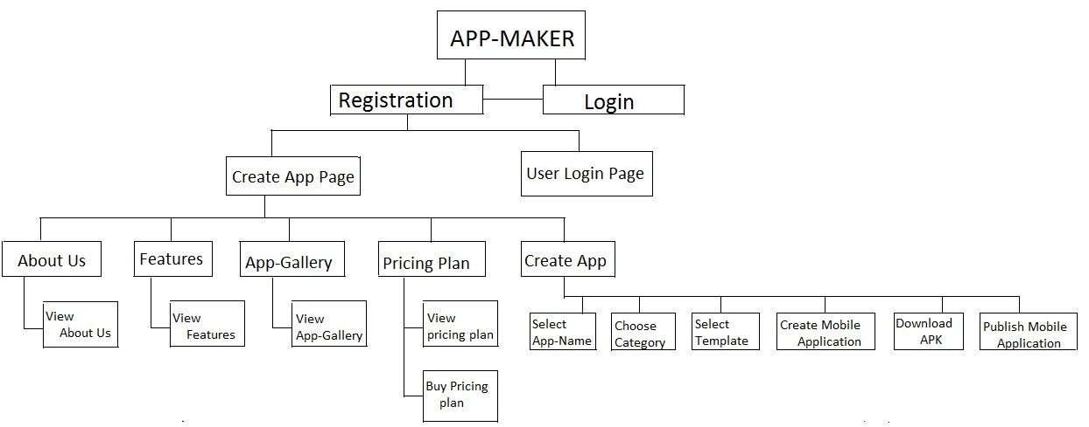

**Fig 6.1 Application Navigation**

**Chapter 5**

**Implementation**

**5.1 Implementation Environment**

The system has a very friendly user interface. The system can be used by User and Admin. The user will use its unique username and password to log into the system. The plugin extension will work according to the user type. Admin will manage the user. The user will able to access the system according to its rights.

**Admin:**

The admin will access the system with its username and password. The admin will have full access to the system. Admin will be able to access all forms and will have full rights to the system. Admin will be able to manage the use. Admin will manage message templates he can add the template and delete or edit it. Admin can give the notifications to the user. So the admin will manage all users.

**User:**

User can make the accounts on our websites. After registration user can login into our application they will redirect to user page where there will information of user. It will also have information about application created by user. There user will find create app button by clicking them they will be redirected to create app page where they can create their application. After creating application they can download it by app name given by them.

* 1. **Security Features**

The interfaces provided to the firm are web based. Hence security is one of the primary questions involved. In order to establish privacy of accounts and information, the team has provided login facilities for the application. This is mainly because any important information which needs to be given only to the firm remains secured. The username and the password are stored safely in the database. The password is stored in an encrypted format in the database so as to enhance the system’s security. Similar kind of mechanism has been provided for the other interface as well. Hence the issue of security has been resolved using the mechanism of username and password.

* Authentication is necessary to enter into the system. This is required to prevent unauthorized access to the system
* A Session is maintained throughout the system when a particular user enters into the system. The Session is regularly checked whenever it is required.
* The Input to the system is always validated before saving it into the database.
* Only Administrator has all the privileges. He/She can allot the rights to users for Access of the system. He/She can view reports of entire system

**5.3 Coding Standards**

The Software needs to be updated from time to time according the changing needs of Users. So some standards are to be maintained in implementation and Coding, so that if the software needs to be modified due to some changes in User needs or some enhancements to be done, then it’s easy for the person to find some specific modules, pages, functions, variables or even the tables or stored procedures in the database.

This type of naming standards is called as "Naming Conventions". It is very useful to reduce user errors and ease the search process to find required information like variable, procedure, etc.

**General:**

|  |  |
| --- | --- |
| No. | Standard |
| 1 | Web site is partitioned into restricted areas (protected using SSL) and public areas |
| 2 | Code-behind files are used rather than inline server-side script blocks |
| 3 | Code-behind files are not used as a container for Business Logic and/or Data Access Logic |
| 4 | Master Pages are used as a means to create a consistent layout for web applications |
| 5 | Commonly used page elements are separated into Web User Controls and/or Web Custom Controls |
| 6 | Web site is fully-functional when JavaScript is disabled in the browser |

**Input Validation:**

|  |  |
| --- | --- |
| No. | Standard |
| 7 | Server-side validation is performed on all user inputs from sources such as HTML controls, Query String, and Cookies |
| 8 | Input from field values are retained when form is redisplayed to the user after input validation fails |

**Data Access**

|  |  |
| --- | --- |
| No. | Standard |
| 9 | Data paging is used for unbounded or long lists of data |

**Caching**

|  |  |
| --- | --- |
| No. | Standard |
| 10 | Data that is frequently used but changes infrequently is cached using web-browser Caching |
| 11 | Pooled resources (e.g. Database connections) are not cached |
| 12 | Sensitive data is not cached using web browser caching or Application state |

**State Management**

|  |  |
| --- | --- |
| No. | Standard |
| 13 | Sensitive information such as passwords and query strings are not stored in any client-side state |
| 14 | Web site is fully-functional when cookies are disabled in the browser |
| 15 | Session State is disabled for web applications and only enabled for individual pages that require it |
| 16 | View State is disabled for web applications and only enabled for individual controls that require it |
| 17 | View State is not enabled for data bound controls such as drop-down lists, check box lists, grid views, repeaters, etc |
| 18 | The Data Grid server control is not used |
| 19 | Objects are not stored in the session state |
| 20 | Application state is only used for sharing application-wide read-only data for all clients |

**Exception Handling**

|  |  |
| --- | --- |
| No. | Standard |
| 21 | HTTP error codes are handled using custom error reporting pages |
| 22 | Unhandled exceptions are caught using an application-level global error handler |

**Configuration**

|  |  |
| --- | --- |
| No. | Standard |
| 23 | Configurable application settings are stored in the web application's Web.xml file |
| 24 | Request validation is enabled to prevent scripting attacks |
| 25 | Page output buffering is enabled |
| 26 | Java tracing and debugging are disabled |
| 27 | Database query string are encrypted |

**5.4 Stored Procedure**

Astored procedure is a precompiled executable object that contains one or more SQL statements. Using stored procedures, database operations can be encapsulated in a single command, optimized for best performance, and enhanced with additional security.

We have made stored procedure for these functions:

* Insert

• Delete

• Update

• Select

These stored procedures are made for all forms. The variables used in the stored procedure are in accordance to the naming convention. Thus we have implemented 3-tier architecture with stored procedure. There are in all 30 stored procedures

**5.4 Data Access Layer**

* A data access layer can be an important part of a software application. Business applications almost always need access to data from relational or object databases.
* The Java platform offers many techniques for accessing this data, regardless of whether a data access layer is used. The oldest, and most mature and reliable technique, is to use the Java Database Connectivity – JDBC API, which provides the capability to execute SQL queries against a database and then fetch the results, one column at a time. Although this API provides everything a developer needs to access data and to persist application state.
*  DAO(Data access object) might return a reference to an object (in terms of object-oriented programming) complete with its attributes instead of a row of fields from a database table. This allows the client (or user) modules to be created with a higher level of abstraction. This kind of model could be implemented by creating a class of data access methods that directly reference a corresponding set of database stored procedures. Another implementation could potentially retrieve or write records to or from a file system. The DAO hides this complexity of the underlying data store from the external world.
* For example, instead of using commands such as insert, delete, and update to access a specific table in a database, a class and a few stored procedures could be created in the database. The procedures would be called from a method inside the class, which would return an object containing the requested values. Or, the insert, delete and update commands could be executed within simple functions like registeruser or loginuser stored within the data access layer.
* A Data Access object can be an important part of a software application. Business applications almost always need access to data from relational or object databases and the Java platform offers many techniques for accessing this data, regardless of whether a data access layer is used.
*  Data Access object concerns with taking the request from the user interface and according to the logic, this layer provides the necessary data from the database.
  1. **Business Logic Layer**
* Business Logic Layer enforces the methods by which business objects are accessed and Updated. To implement business logic layer we have defined properties of different fields. In this layer main logic of the system is implemented. Dataset or Data table stores the data fetched to show the data in the forms.
* The task of the business logic layer is to provide an interface to the business methods of the system. The business layer applies the facade pattern and is split among different managers, each one providing functionality needed for a specific module of the system. Thus there exists one manager for user authorization and one manager for cost analysis. Common functionality used in these managers is either encapsulated internal helper-classes or provided by an abstract base class called the BaseManager, from which every manager derives.
* Within a BLL objects can further be partitioned into business processes (business activities) and business entities. Business process objects typically implement the controller pattern, i.e. they contain no data elements but have methods that orchestrate interaction among business entities. Business entities typically correspond to entities in the logical domain model, rather than the physical database model.
* Business Logic Layer concerns with performing the logic on input request from the interface and pass this logic to the data tier.
* This layer is very important because it has to handle logic of request.

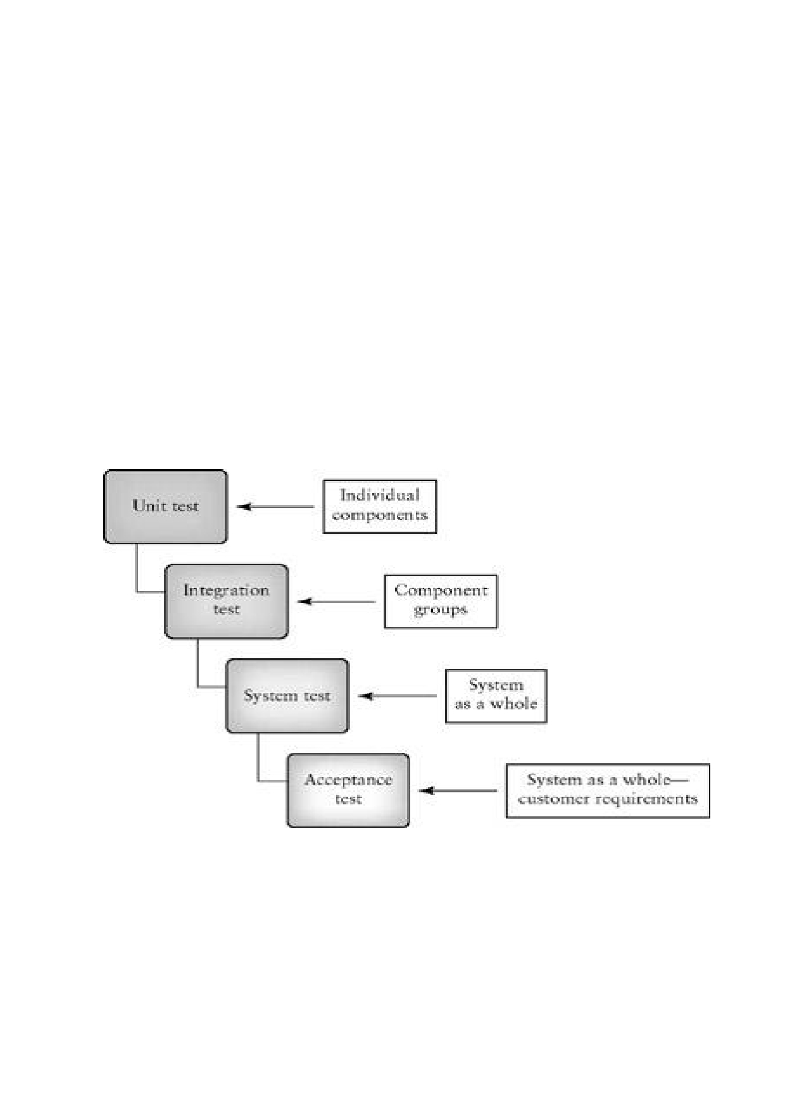**Chapter 6**

**Testing**

**6.1 Testing Plan**

* Software testing is used to establish the presence of defects in program and it is used to

Help/judge whether or not the program is usable in practice. The process of defining a test project such that it can be properly measured and controlled. The software testing is used for validation and verification, which ensures that software, conforms to its specification and meets the need of the software customer. It is used to check errors and validations.

* We have started with first testing for requirements gathering and designing. Design errors are costly to repair once the system has started operating. So it is very important to fix the designing errors first. Then we move onto implementation errors.

**Fig 7.1 Testing plan**

**6.2 Testing Strategy**

A strategy for software testing integrates software test case design method into a well-

planned series of steps that result in the successful construction of the software. The strategy provides the roadmap that describes the steps to be conducted as a part of testing, then these steps are planned and then undertaken, and how much effort, time and resource will be required.

• We have tested the whole system using bottom-up approach.

• Bottom up testing involves integrating and testing the modules to the lower levels in the

hierarchy, and then working up hierarchy of modules until the final module is tested.

• For each module testing, we have decided to test each lower level module with white box

testing strategy.

• When all modules will be tested successfully then we will integrate those modules and try

to test integrated system using black box testing strategy.

**Why Black Box Testing in our Project?**

In our project, whatever we have implemented was going to be tested by external guide

Mr Uresh Patel and our internal guide Prof.Sonali A.Virparia without knowing our code, so there was a black box testing involved directly.

**Why White Box Testing in my Project?**

During the project we were making the applications, we knew how it should proceed

Internally we needed debugging also for testing our small functionalities.

**6.3 Testing Methods**

**6.3.1 Unit Testing**

Unit Testing is the software testing process where individual units/components of a

software/system are tested. The purpose is to validate that each unit of the software performs as designed. It can be done in two ways bottom-up or top- down. In bottom-up approach, the last module is tested first and then moving upwards towards the first module. Unit Testing is normally performed by software developers themselves or their peers. In rare cases it may also be performed by independent software testers.

**6.3.2 Integration Testing**

Integration Testing is the software testing process where individual units are combined

and tested as a group. When the unit testing is over, all the modules are integrated and tested as a whole. It might be possible that all modules may work individually, but they may not work when we put them together. Data can be lost across the interface, one module can have adverse effect on other or sub functions of another, when combined may not produce desired major function, individually acceptable imprecision may be magnified to unacceptable level; global data structure can present problem. Either Developers themselves or independent Testers perform Integration Testing.

**6.3.3 System Testing**

System Testing is a level of the software testing process where a complete, integrated

system/software is tested. The purpose of this test is to evaluate the system‟s compliance with the specified requirements. Entire system is tested as per the requirements. Black-box type testing that is based on overall requirements specifications, covers all combined parts of a system.

Independent Testers perform System Testing.

**6.3.4 Acceptance Testing**

This type of testing is done to verify if system meets the customer specified requirements.

User or customers do this testing to determine whether to accept application. *User Acceptance Testing* (Also known as Beta Testing) is performed by the end users of the software.

**6.3.5 Regression testing**

Testing the application as a whole for the modification in any module or functionality.

Difficult to cover all the system in regression testing so typically automation tools are used for these testing types.

**6.3.6 Validation Testing**

After the integration testing software is completely assembled as a package, interfacing

error have been uncovered and corrected, and then validation testing may begin. Validation can be defined in many ways but a simple definition is what a validation succeeds when software

functions in a manner that can be reasonably accepted by the customer.

**6.4 Test Cases**

|  |  |
| --- | --- |
| **TEST CASE** | **NAME: Login** |
| PURPOSE: | Checking the authenticity of the user. |
| INPUT: | User name, password |
| TEST DATA: | Username, Password |
| EXPECTED O/P: | If username and password are correct then user is allowed to enter in to the system and if not then he/she is again asked to enter the username and password |
| UNBEHAVIOURABLE O/P: | N.A. |
| STEPS:   1. After user enters user name and password it is going to be verified with database and allows user to access system if both matches correctly | |

**Table 5.1 Test Case for Login Validation**

|  |  |
| --- | --- |
| **TEST CASE** | **NAME: User Type** |
| PURPOSE: | Checking the type of the user. |
| INPUT: | User name, password |
| TEST DATA: | Username, Password |
| EXPECTED O/P: | Access rights are allocated according to user group. |
| UNBEHAVIOURABLE O/P: | N.A. |
| STEPS:   1. After user enters user name and password it is going to be verified with database 2. It matches user name and password and get his user type 3. As per the type the application will open. | |

**Table 5.2 Test Case for User Type**

|  |  |
| --- | --- |
| **TEST CASE** | **NAME: Forgot Password** |
| PURPOSE: | To get the password if forgot |
| INPUT: | Email ID |
| TEST DATA: | email_id |
| EXPECTED O/P: | Email will be sent with password |
| UNBEHAVIOURABLE O/P: | N.A. |
| STEPS:   1. The user will enter their email id. The matching password will be sent to the registered mail id. | |

**Table 5.3 Test Case for forgot password**

|  |  |
| --- | --- |
| **TEST CASE** | **NAME: Email Validation**  **[asfdsg@afasg.com]** |
| PURPOSE: | Validating Email addresses and allow user to enter in a proper format |
| INPUT: | Email address |
| TEST DATA: | Email |
| EXPECTED O/P: | Validation occurs |
| UNBEHAVIOURABLE O/P: | N.A. |
| STEPS :   1. When the textbox is changed and if the validation is not correct, message box will appear. | |

**Table 5.4 Test Case for Email validation**

|  |  |
| --- | --- |
| **TEST CASE** | **NAME: Fields cannot be null Validation** |
| PURPOSE: | Validating input data in component. It should not be null. |
| INPUT: | Required field of all forms |
| TEST DATA: | All fields |
| EXPECTED O/P: | Validation occurs |
| UNBEHAVIOURABLE O/P: | N.A. |
| STEPS :  **1.** When user presses Submit or Update button then if any field is empty then message box will appear. | |

**Table 5.5 Test Case for Null validation**

|  |  |
| --- | --- |
| **TEST CASE** | **NAME: Username Validation** |
| PURPOSE: | Validating unique username of user. |
| INPUT: | User Name |
| TEST DATA: | username |
| EXPECTED O/P: | Checks database for existing username. If it is already there user has to choose new username. |
| UNBEHAVIOURABLE O/P: | N.A. |
| STEPS :   1. When the user enters username in form and clicks submit,it will check in database if the username is unique. | |

**Table 5.6 Test Case for UserName validation**

|  |  |
| --- | --- |
| **TEST CASE** | **NAME: PASSWORD VERIFICATION** |
| PURPOSE: | Validating input data in component. It should match with confirm password both password must be same |
| INPUT: | Password |
| TEST DATA: | Password |
| EXPECTED O/P: | Validation occurs |
| UNBEHAVIOURABLE O/P: | N/A |
| STEPS :   1. When the user enters password and confirm password in form and clicks submit,it will check in that both password are matching or not. | |

**Table 5.7 Test Case for Password validation**

|  |  |
| --- | --- |
| **TEST CASE** | **NAME: AFTER LOGOUT VERIFICATION** |
| PURPOSE: | Validating after logout. It should not go back to the home page after logout if the user would click the back button of the browser. |
| INPUT: | Click on back button |
| TEST DATA: | Click on back button |
| EXPECTED O/P: | Validation occurs |
| UNBEHAVIOURABLE O/P: | N/A |
| STEPS :   1. When the user logout and click on to the back button I should not go back to   home page | |

**Table 5.8 Test Case for After logout verfication**

|  |  |
| --- | --- |
| **TEST CASE** | **NAME: User Rights** |
| PURPOSE: | Checking the authenticity of the user. |
| INPUT: | User name, password |
| TEST DATA: | User name, password |
| EXPECTED O/P: | Access rights are allocated according to user  group. |
| UNBEHAVIOURABLE O/P: | N/A |
| STEPS :  **1**.After user enters user name and password it is going to be verified with  database  **2**. It matches user name and password and get his user rights  **3**. As per assigned rights the application will open. | |

**Table 5.9 Test Case for User Rights.**

**Chapter 7**

**Application Screenshot**

**User Module**

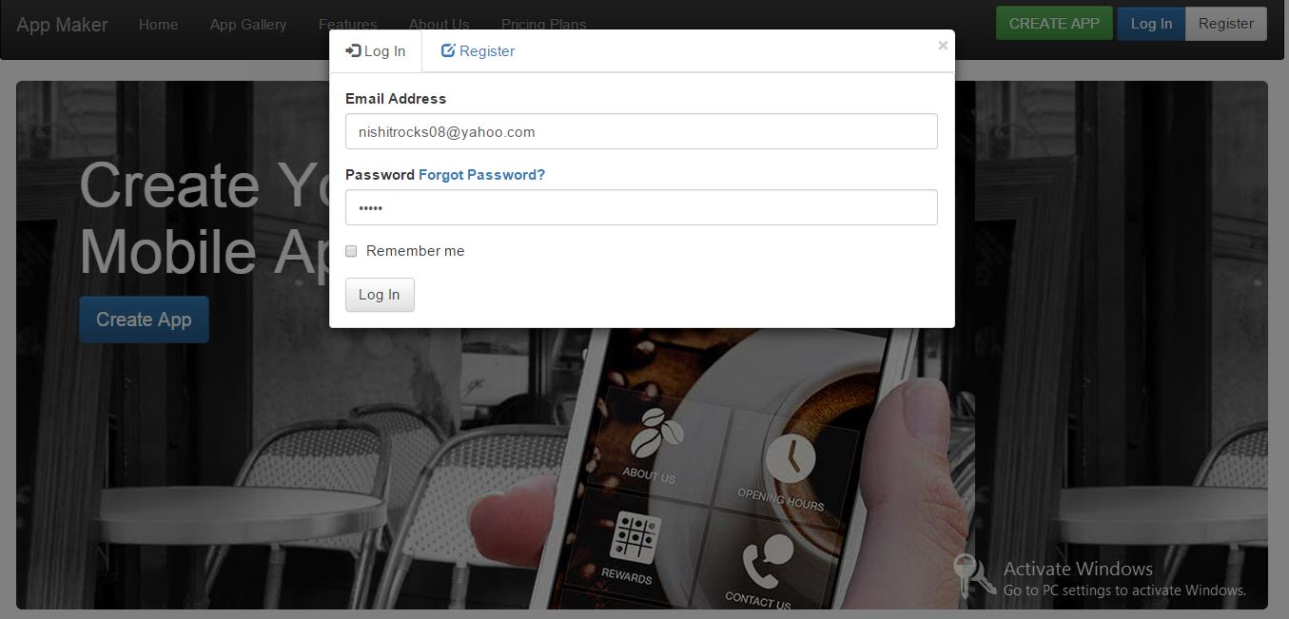

**Fig 8.1 User Login**

**Description**: When Login button is clicked a pop up modal is open as shown in above fig where Email

address and password are necessary to login

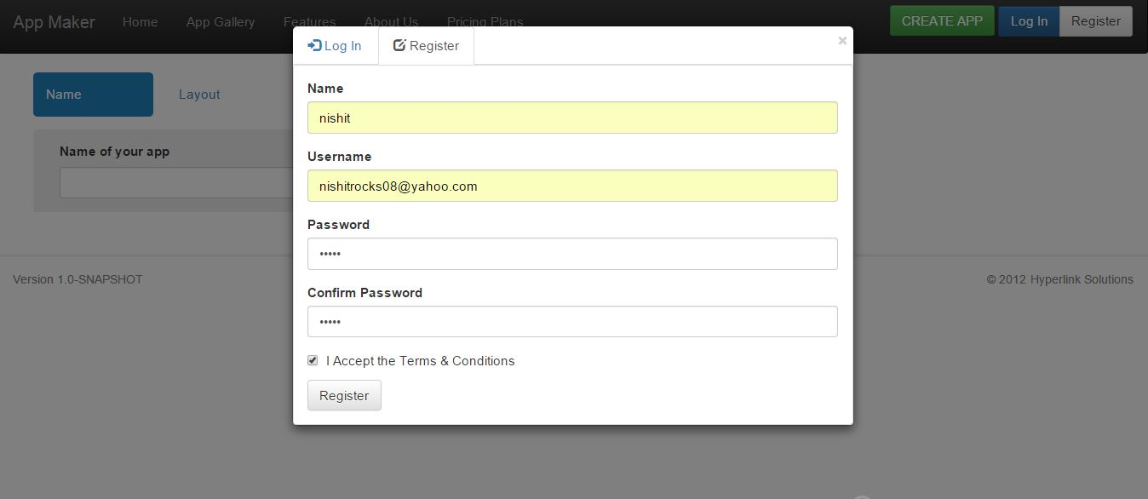

**Fig 8.2 User Registration**

**Description**: If the user is not registered user then he has to register himself by clicking on register button

pop up modal open as shown in fig

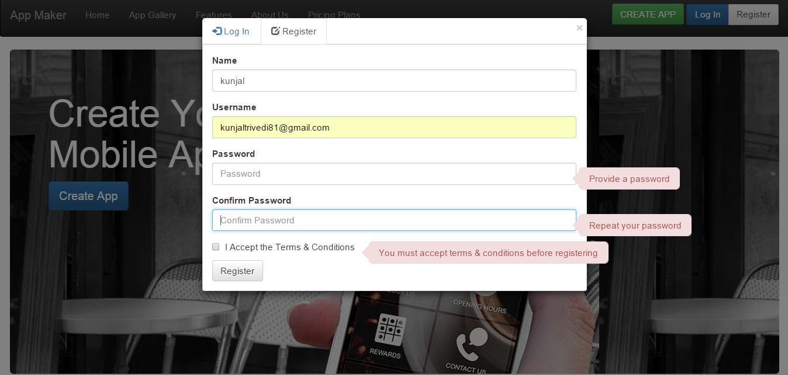

**Fig 8.3 Registration With Validation**

**Description:-** Validation with null input and wrong input.

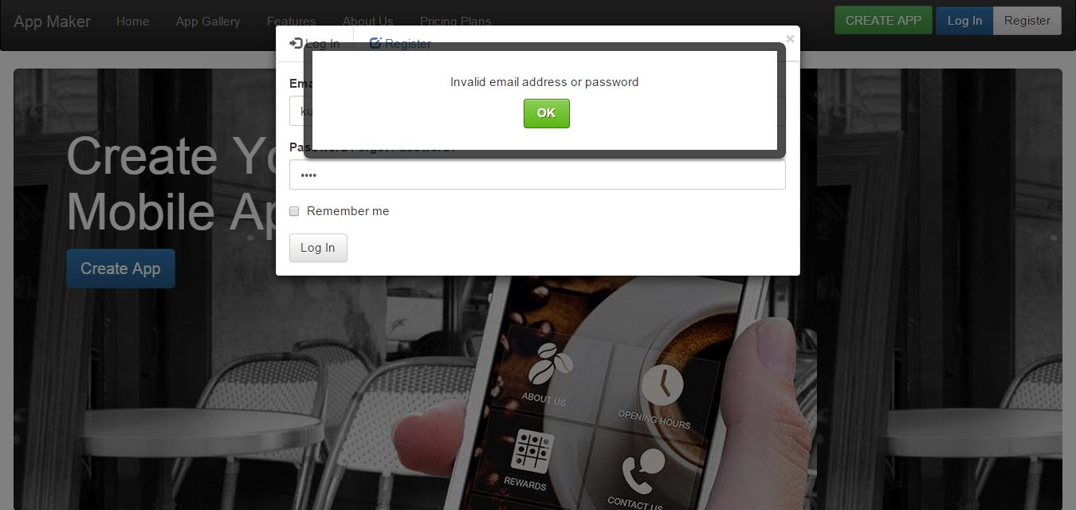

**Fig 8.4 Invalid Login**

**Description:-** Alert is popped up when there is invalid Email or password.

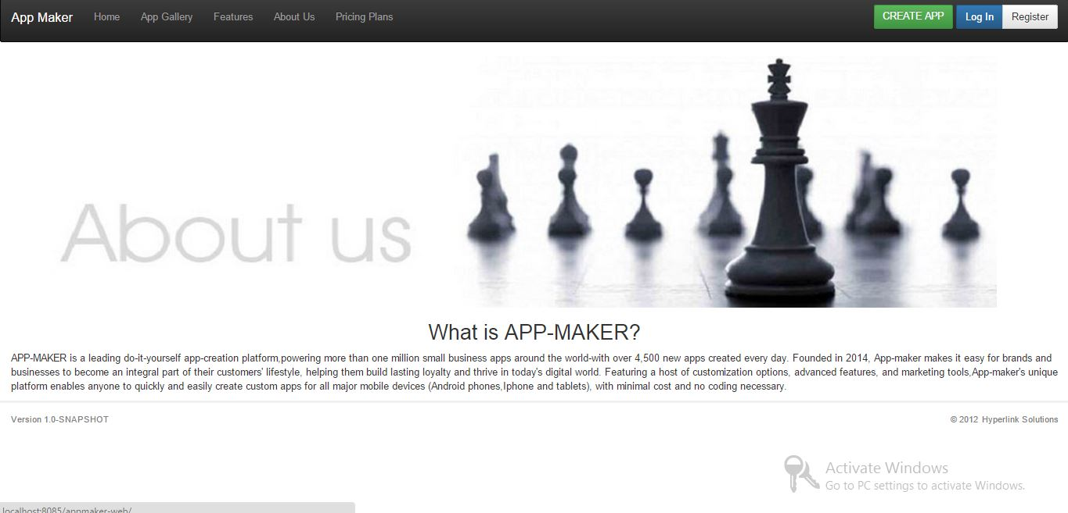

**Fig 8.5 About-us**

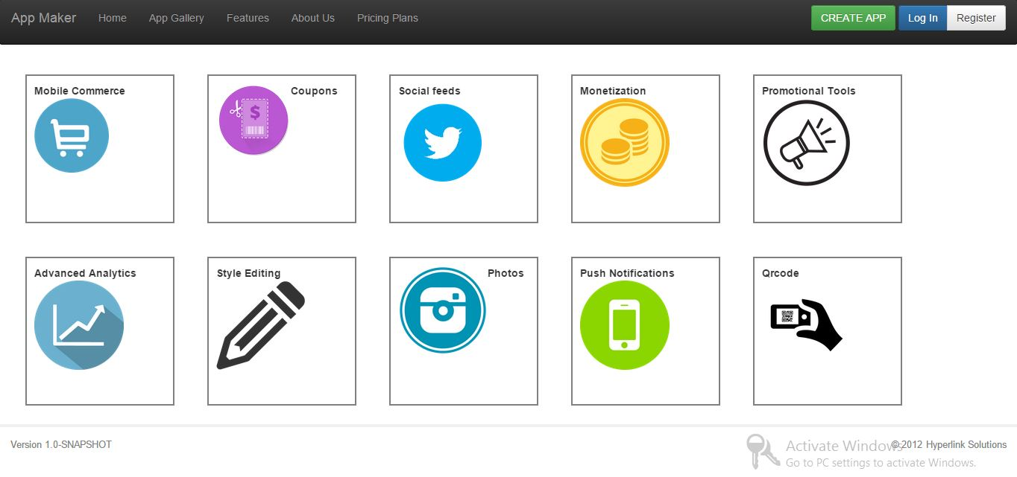

**Fig 8.6 Features**

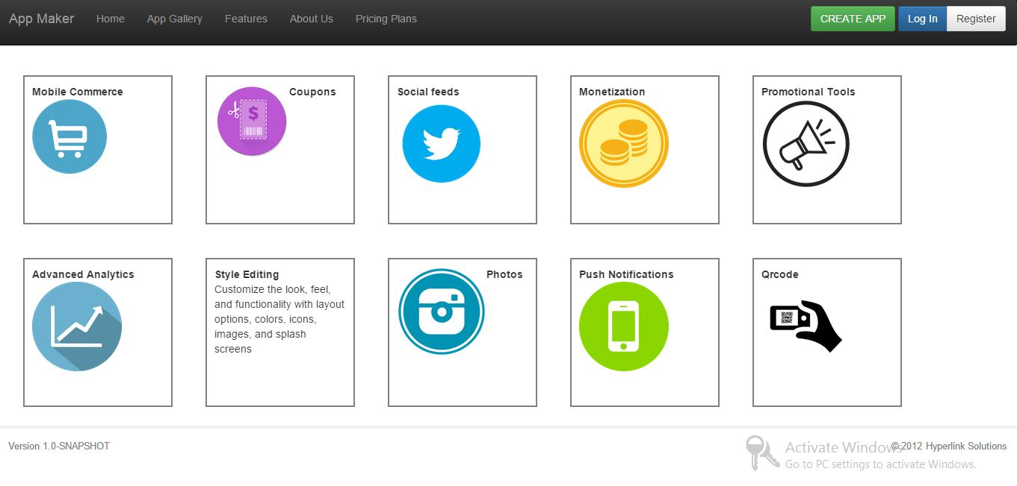

**Fig 8.7 Feature-Flip**

**Description:-**When is features is clicked or mouse over that features it will flip and info of that feature is

shown. That’s what is shown in above fig.

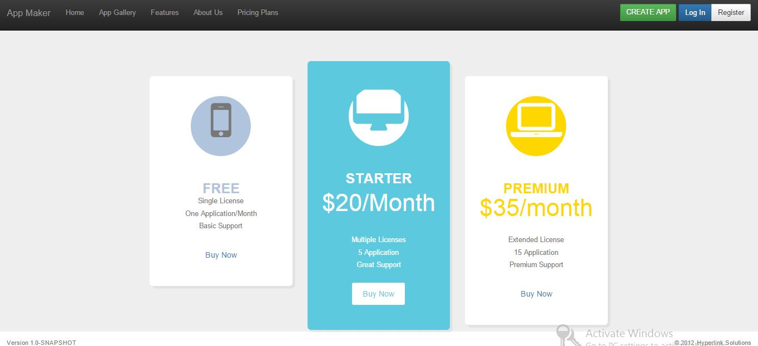

**Fig 8.8 Pricing-Plan**

**Description:-**Above fig shows the pricing plan and different functionality according to plan selection.

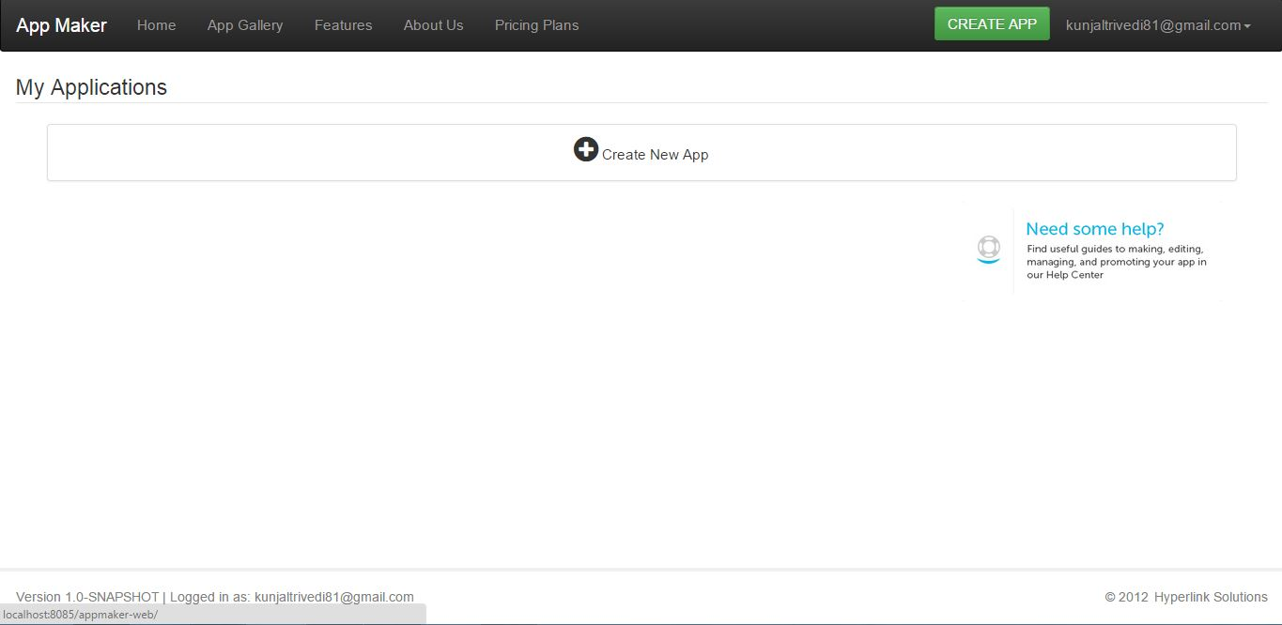

**Fig 8.9 User Screen After Login**

**Description:-**Above fig shows the User screen if user is authenticated user.

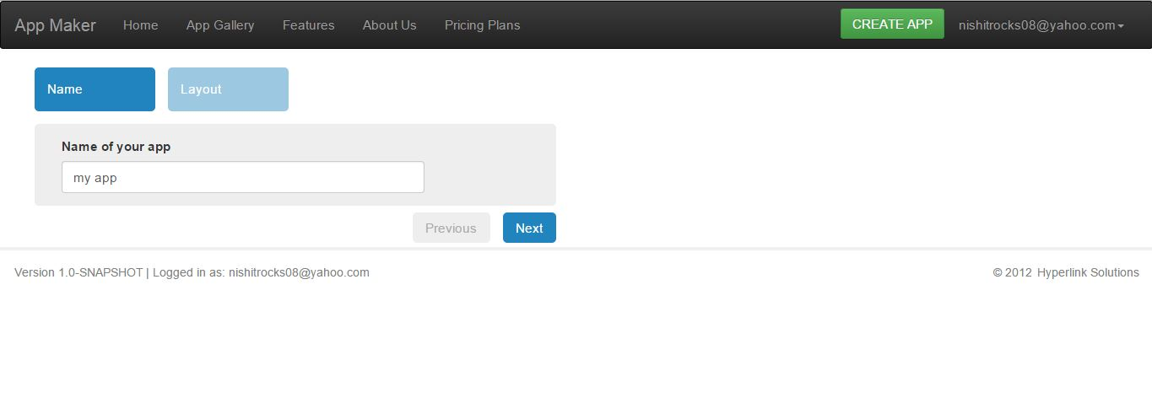

**Fig 8.10 Create App**

**Description:-**If the user click onCreate App button this type of screen is displayed where user give the

name of application which is to be created and that is shown in fig.

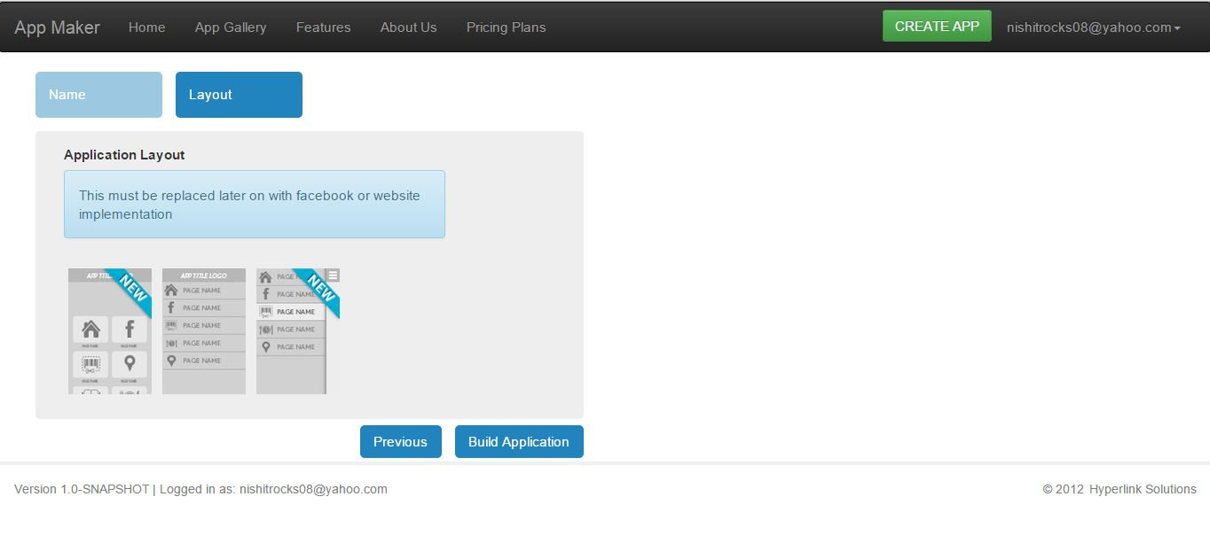

**Fig 8.11 Layout Selection**

**Description:-** Here user will select the layout from the given three layout in which layout he wants to

Build app. Three layout namely Grid, Slide and List layout.

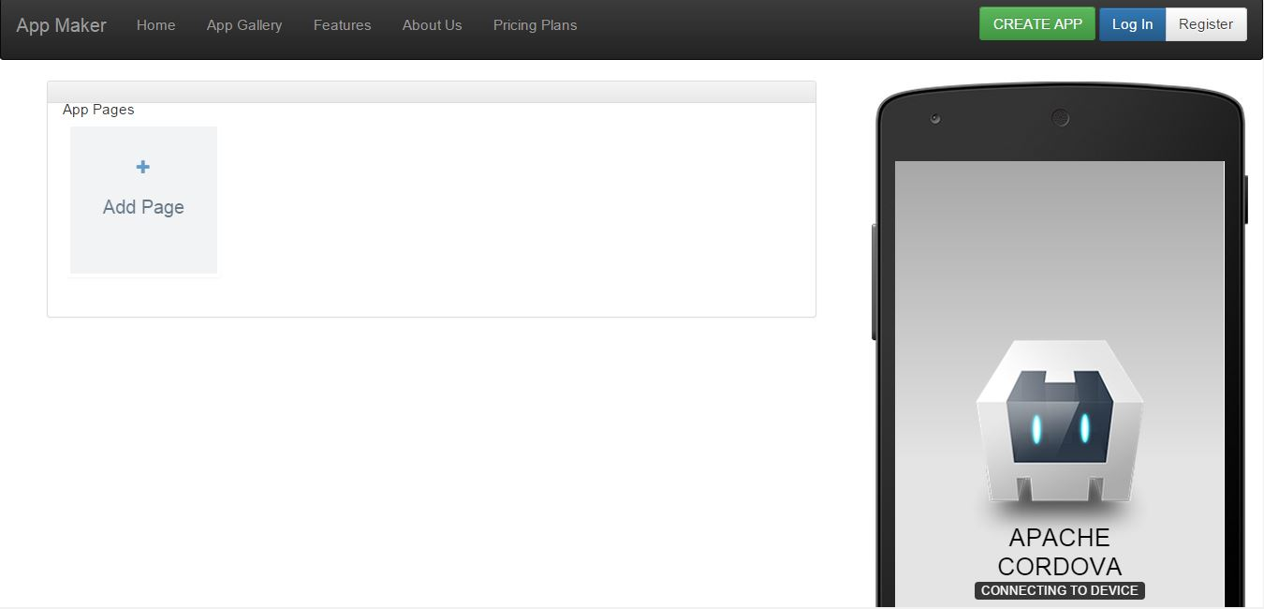

**Fig 8.12 Create application**

**Description:-** By clicking on build application button this type of screen is displayed as shown

above.

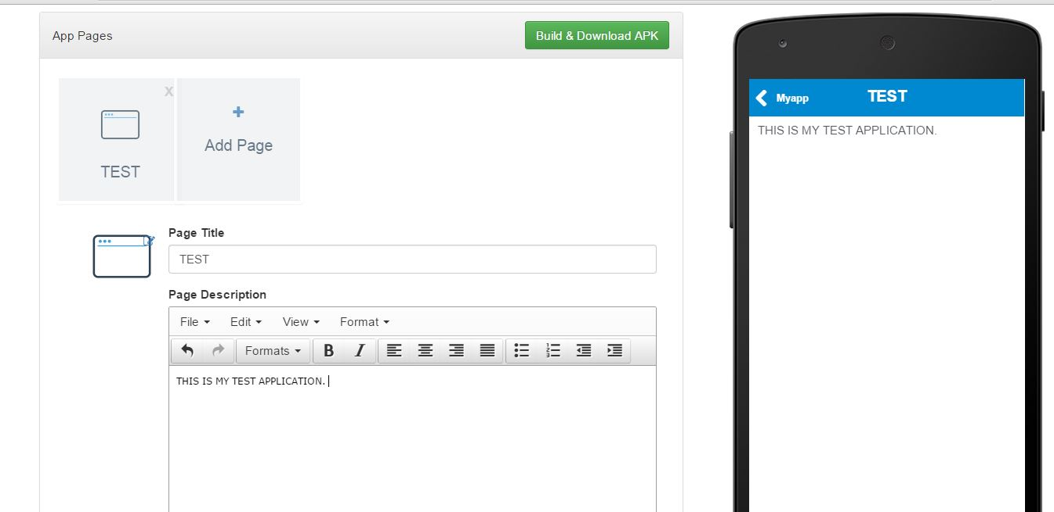

**Fig 8.13 App page 1**

**Description:-** This is the First page of Myapp name as test.

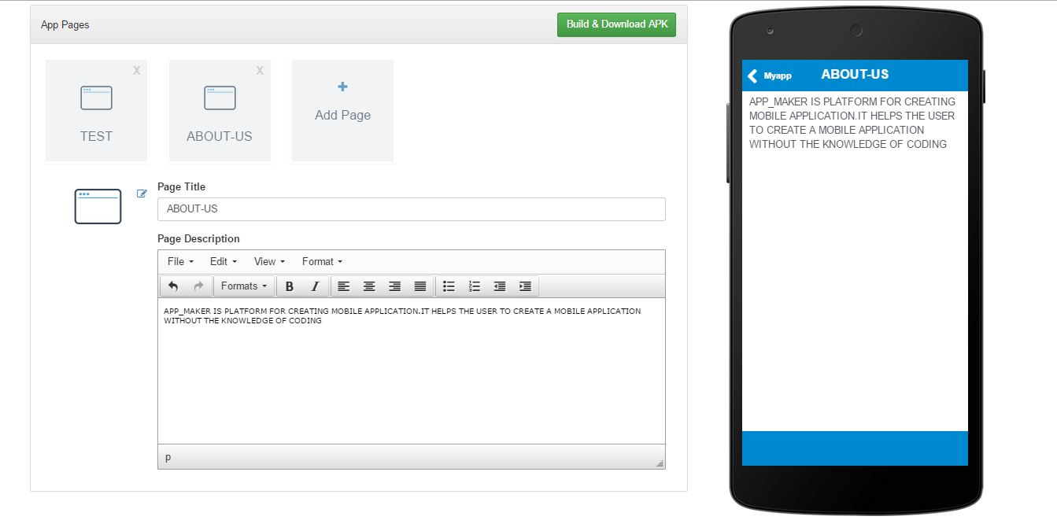

**Fig 8.14 App page 2**

**Description:-** This is the Second page of Myapp name as About-us. The text which is filled in the text

box shown above is reflected on the mobile screen.

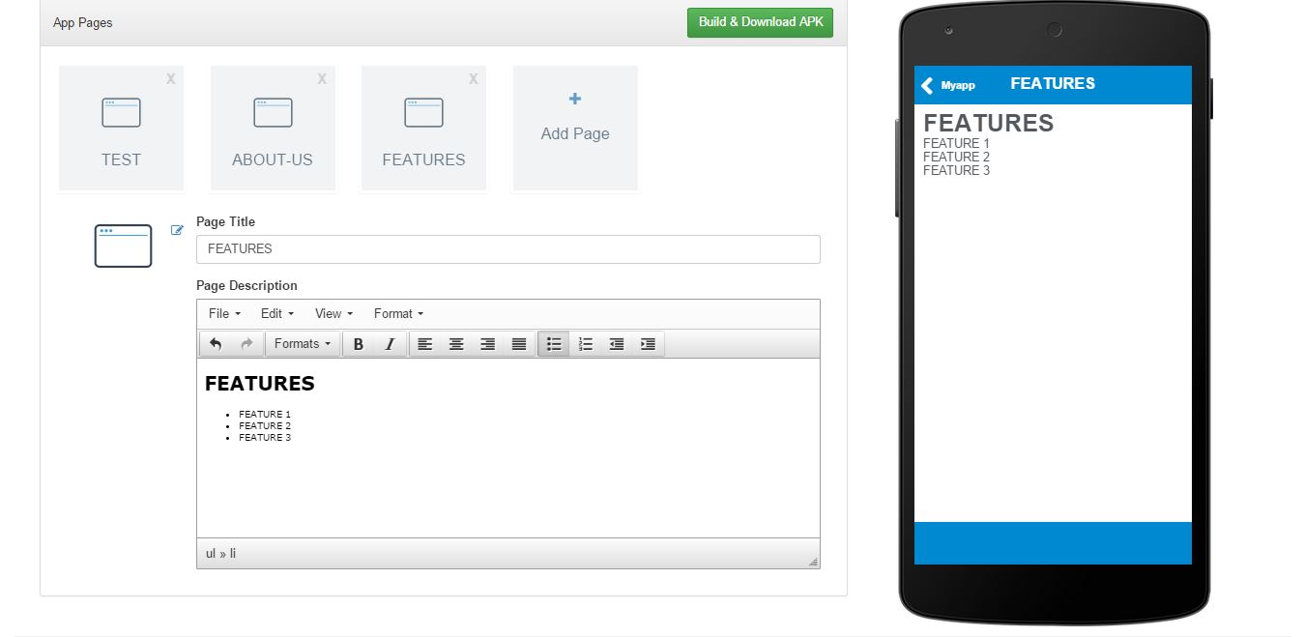

**Fi**

**Fig 8.15 App page 3**

**Description:-** This is the Third page of Myapp name as Features

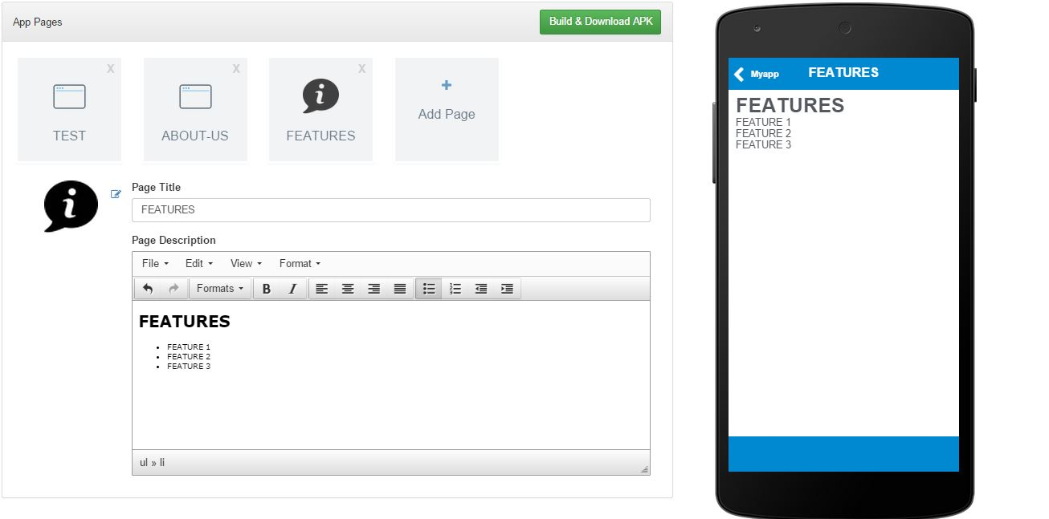

**Fig 8.16 App page 4**

D**escription:-** Adding Icon to the feature menu.

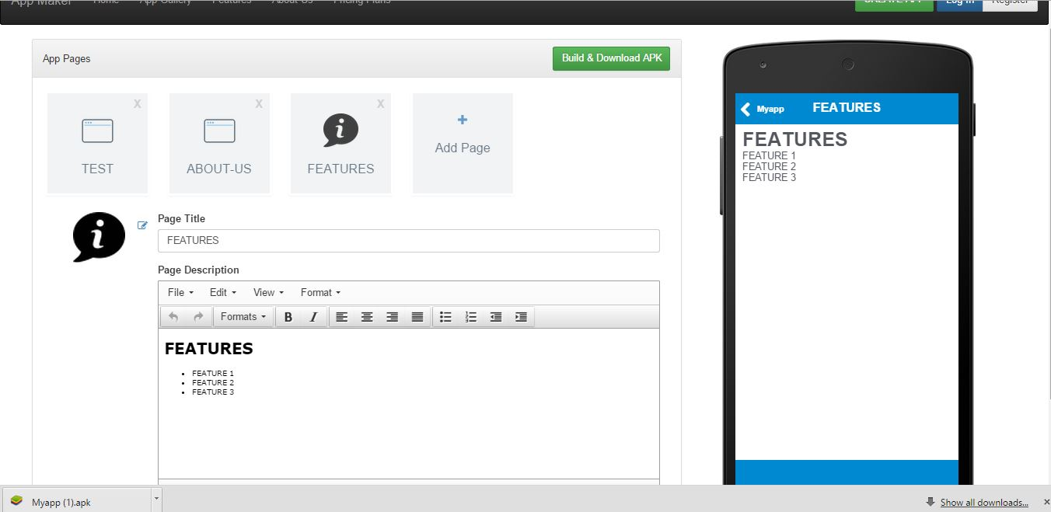

**Fig 8.17 App page 5**

D**escription:-** By clicking on build and download application is downloaded with the aap name given

as shown in fig here it will be Myapp.apk.

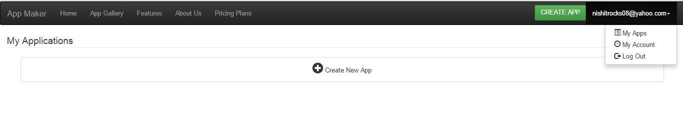

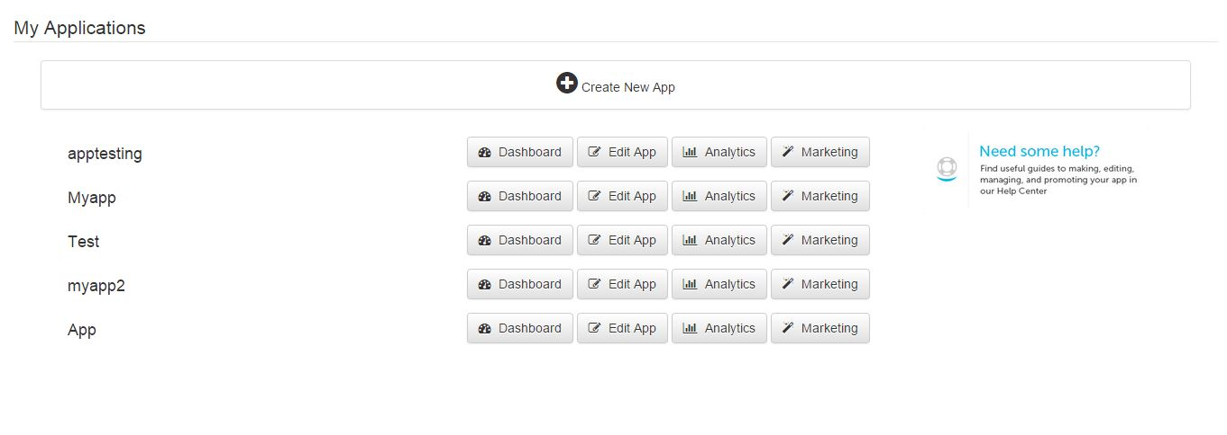After User login

**Fig 8.18 My Apps**

D**escription:-** By clicking on myapps in dropdown after login list of application created by the user is

displayed.

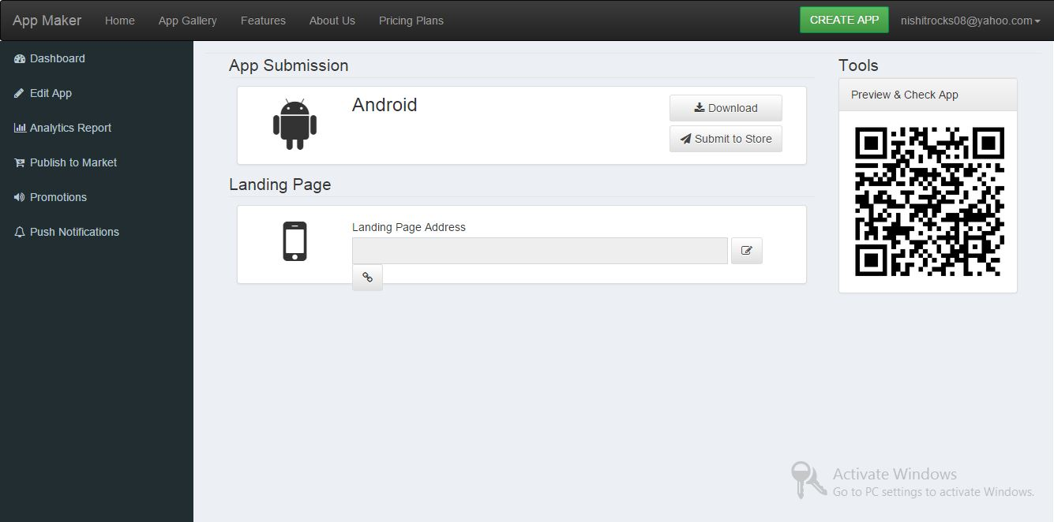

**Fig 8.19 Application dashboard**

D**escription:-** By clicking on dashboard button which was shown in previous fig application

dashboard will be open where user can edit, manage, promote, publish their application

and even they can generate reports specific to their application.

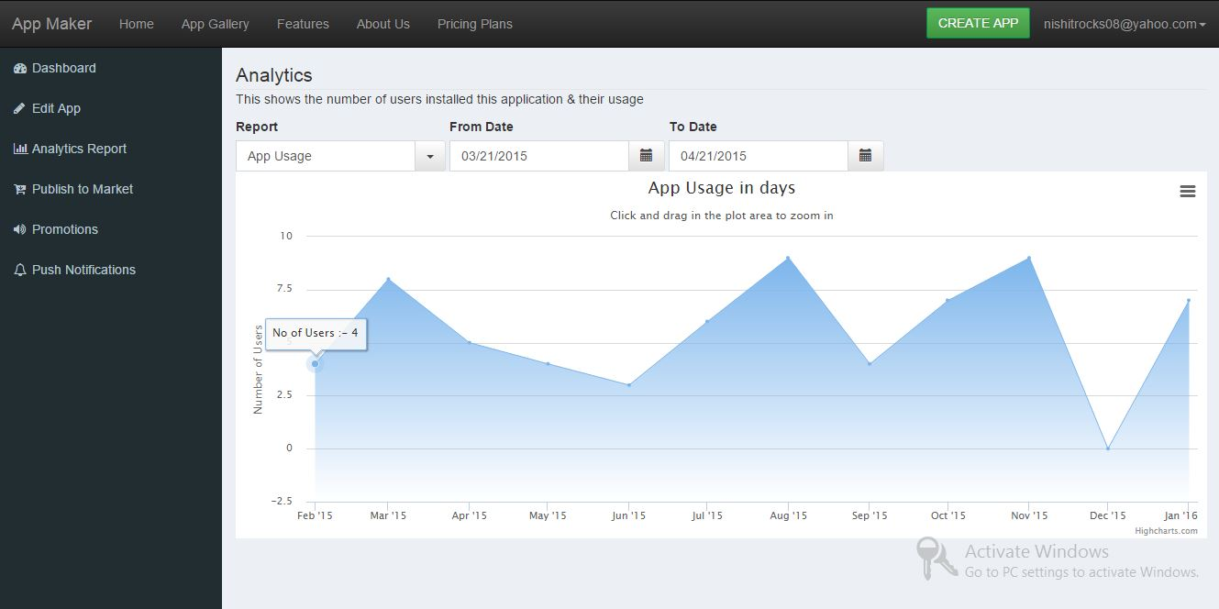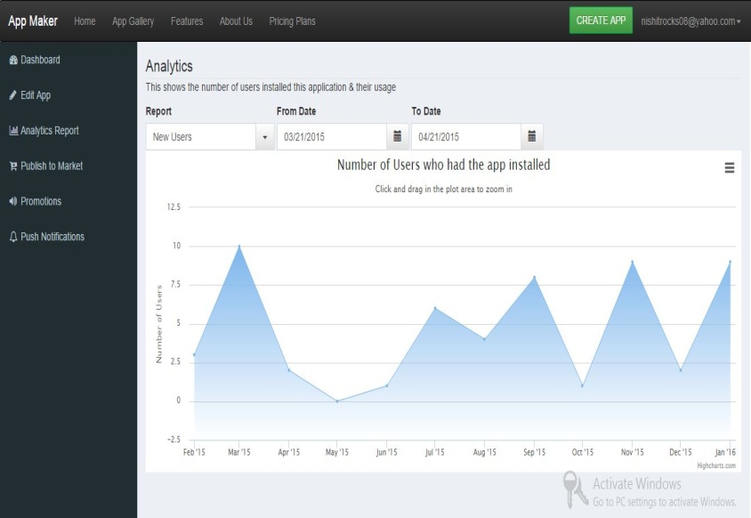

**Fig 8.20 Analytical Report**

D**escription:-** In advance analytic of application two reports are generated ie App usage in days and no

of user who installed app.

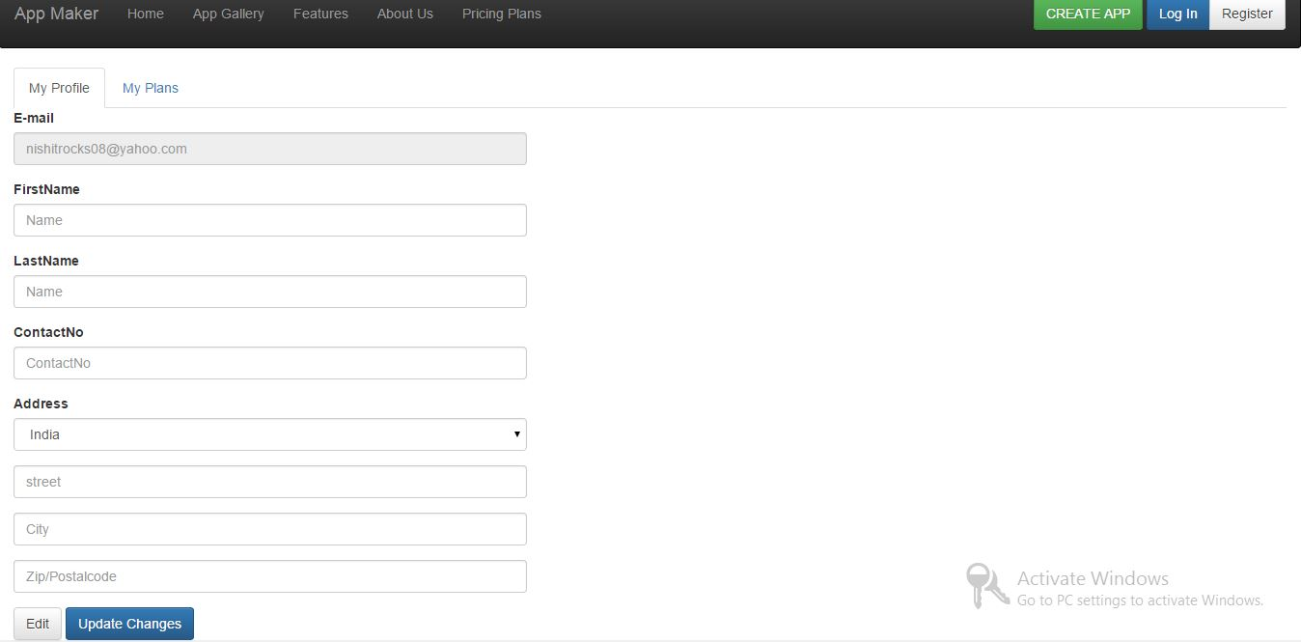

**Fig 8.21 User Profile**

D**escription:-** Display profile of user.

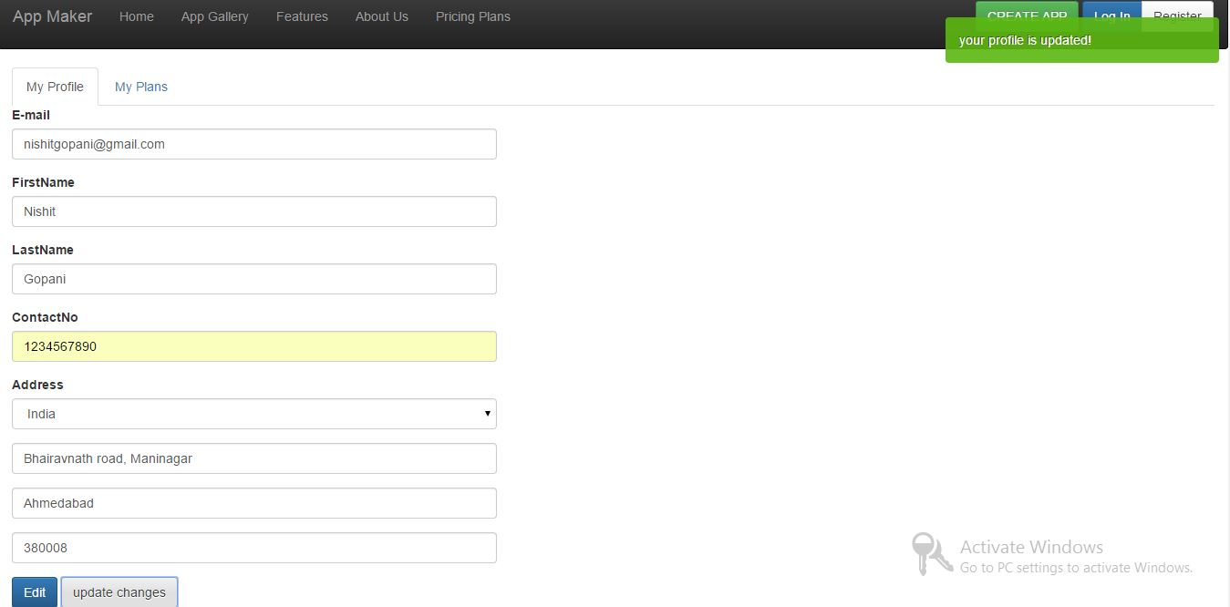

**Fig 8.22 Edit profile**

D**escription:-** By clicking on edit button it will allow user to edit the information and by clicking on

update changes changes will be updated and alert is shown as seen in above fig.

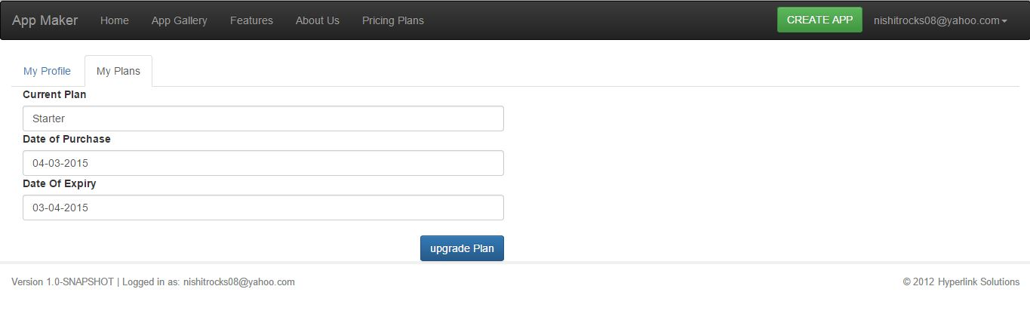

**Fig 8.23 User Plan**

D**escription:-** Display user plan.

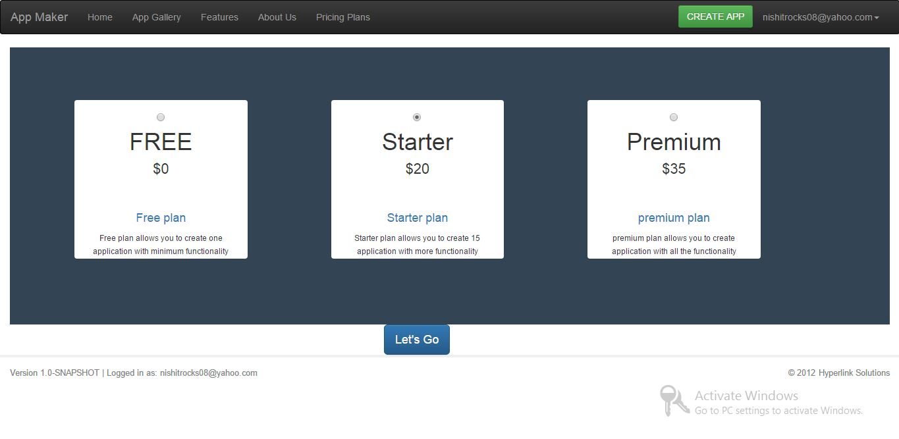

**Fig 8.24 Plan selection**

D**escription:-** By clicking on upgrade plan button user will provide with the plans option to select one

plan from them. By clicking on let’s go it will redirected to payment gateway and by

paying money alert will be shown

**Admin Module**

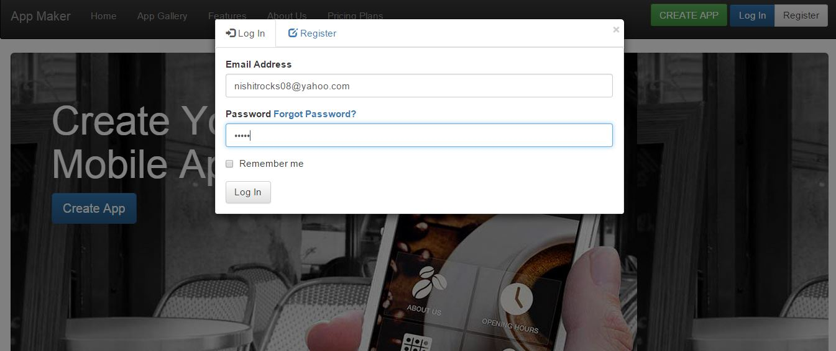

**Fig 8.25 Admin Login**

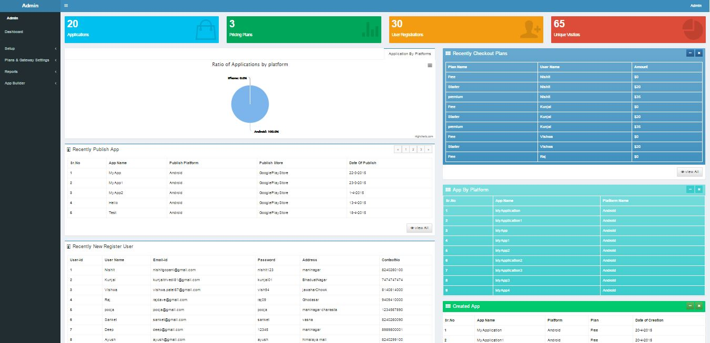

**Fig 8.26 Admin Home**

D**escription:-** If the entered email and password are correct and the user is admin then admin screen

will be open as shown above.

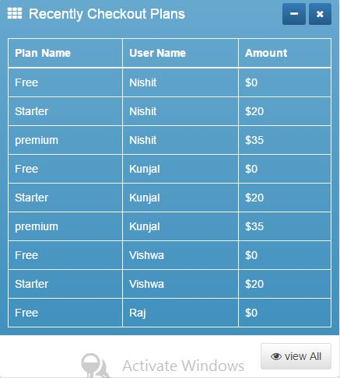

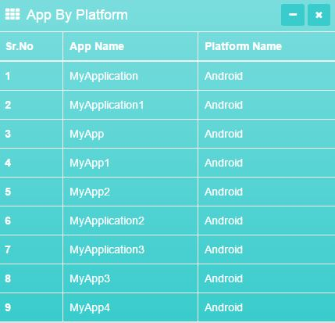

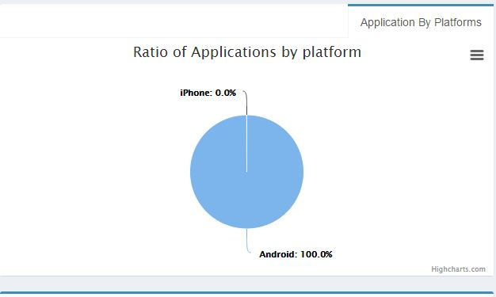

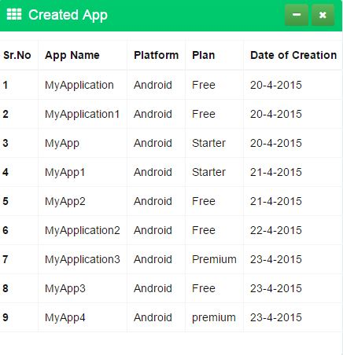

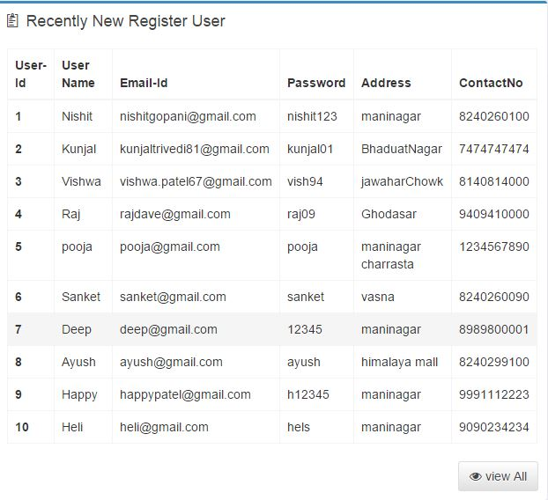

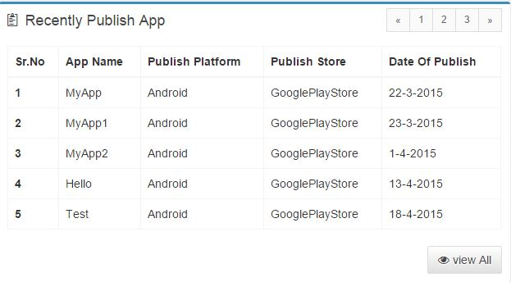

**Fig 8.27 Charts & Tables**

D**escription:-** In above display charts and table it display some information 1 table shows recently

checkout plan , 2-app by platform , 3-created app, 4-ratio of app by platform, 5-recently

publish app and 6-new register user

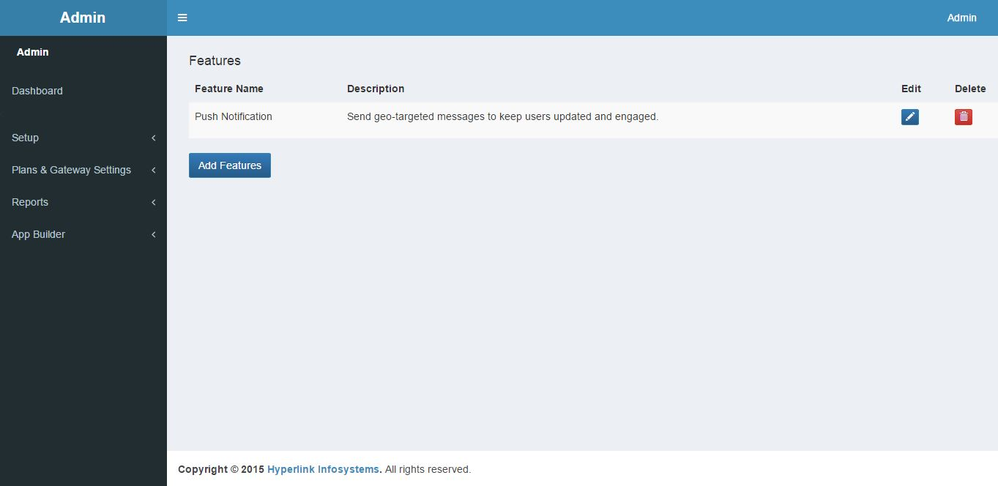

**Fig 8.28 Manage Features**

D**escription:-** By clicking on manage feature admin can add, edit and delete feature .

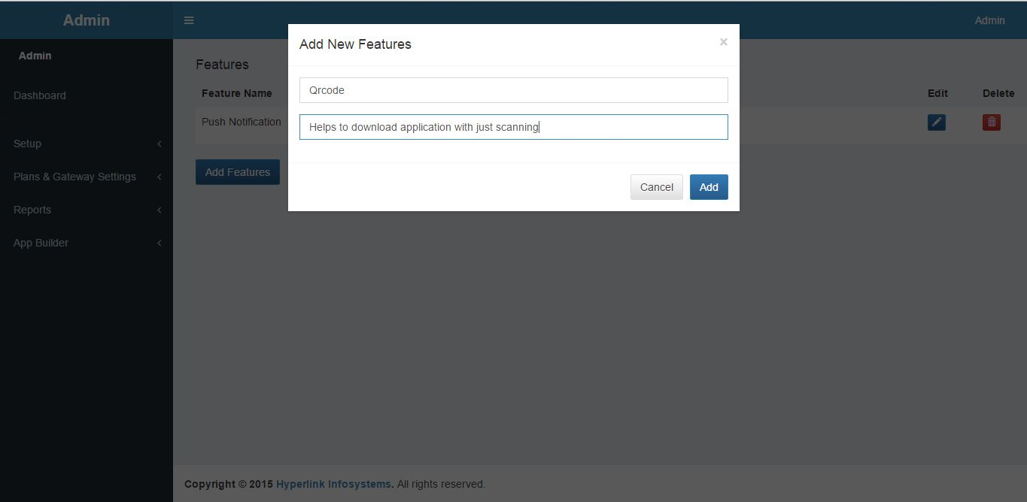

**Fig 8.29 Add new Features**

D**escription:-** By clicking on add new features pop up modal will open where administrator give

feature name and description of feature which he wants to add.

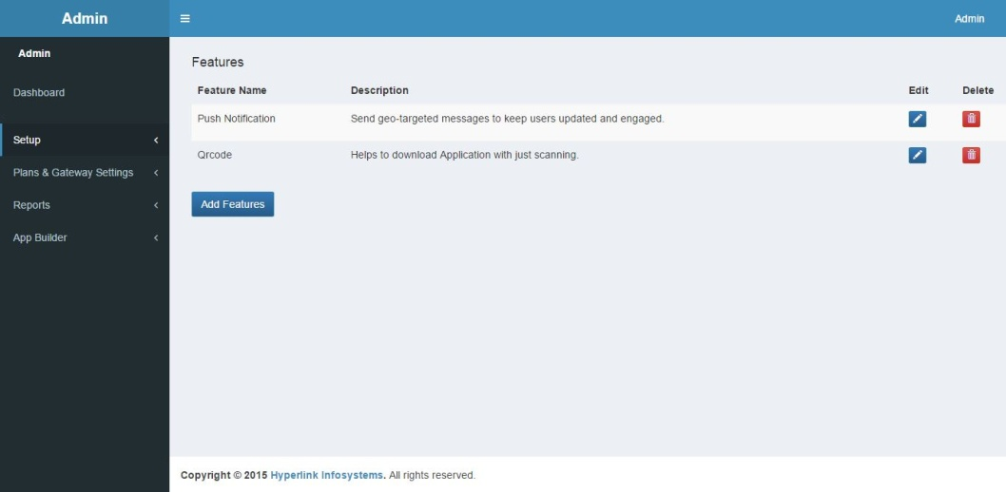

**Fig 8.30 Feature Added**

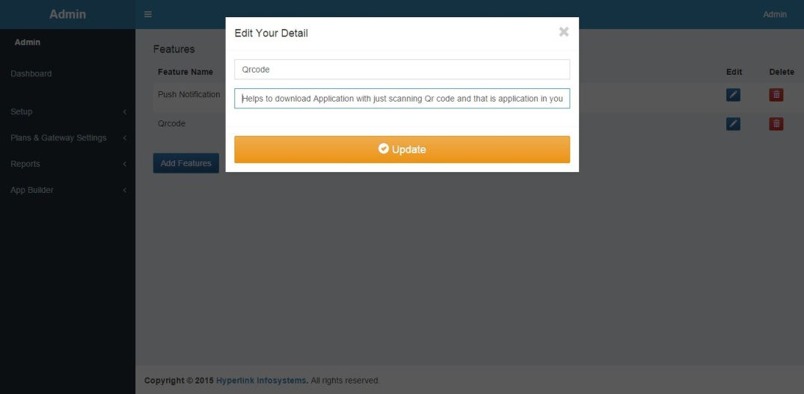

**Fig 8.31 Edit Features**

D**escription:-** By clicking on edit button a pop up modal will open and administrator will edit the

feature by clicking on update features will be edited.

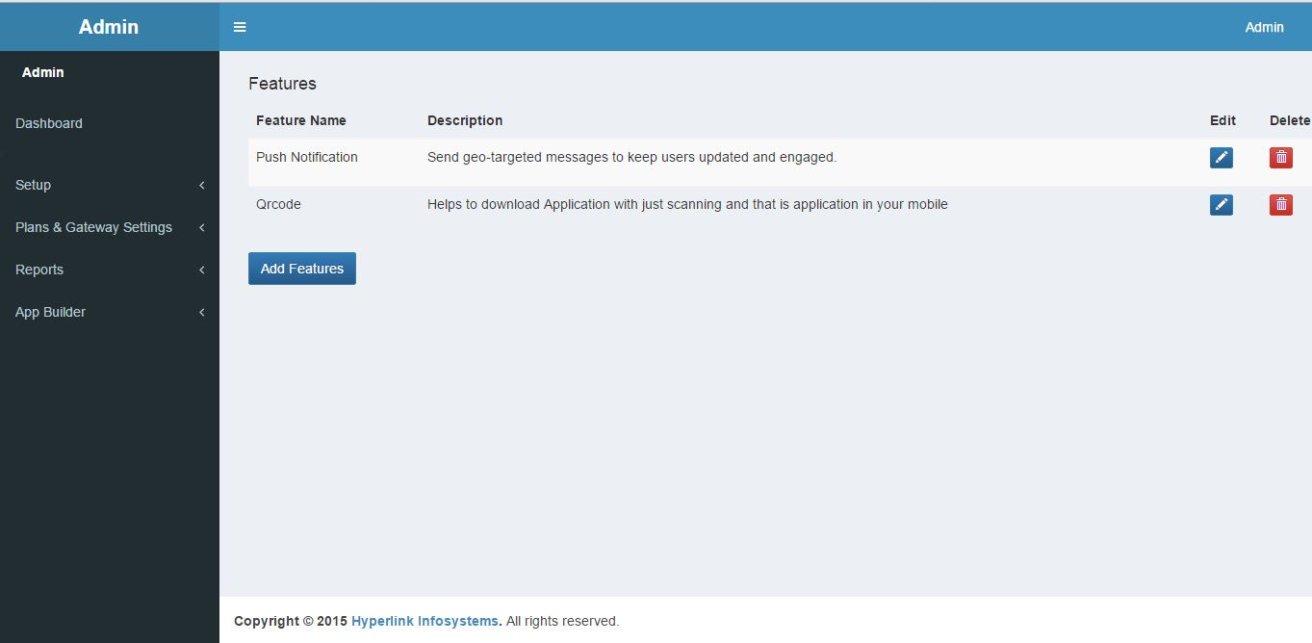

**Fig** **8.32 Updated Features**

D**escription:-** Features are Updated.

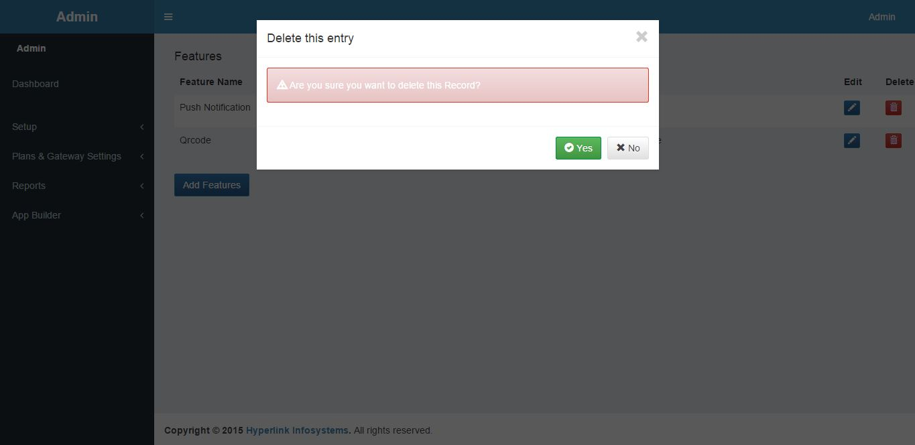

**Fig 8.33 Delete Feature**

D**escription:-** By clicking on delete button pop up modal will open asking are you sure to delete if

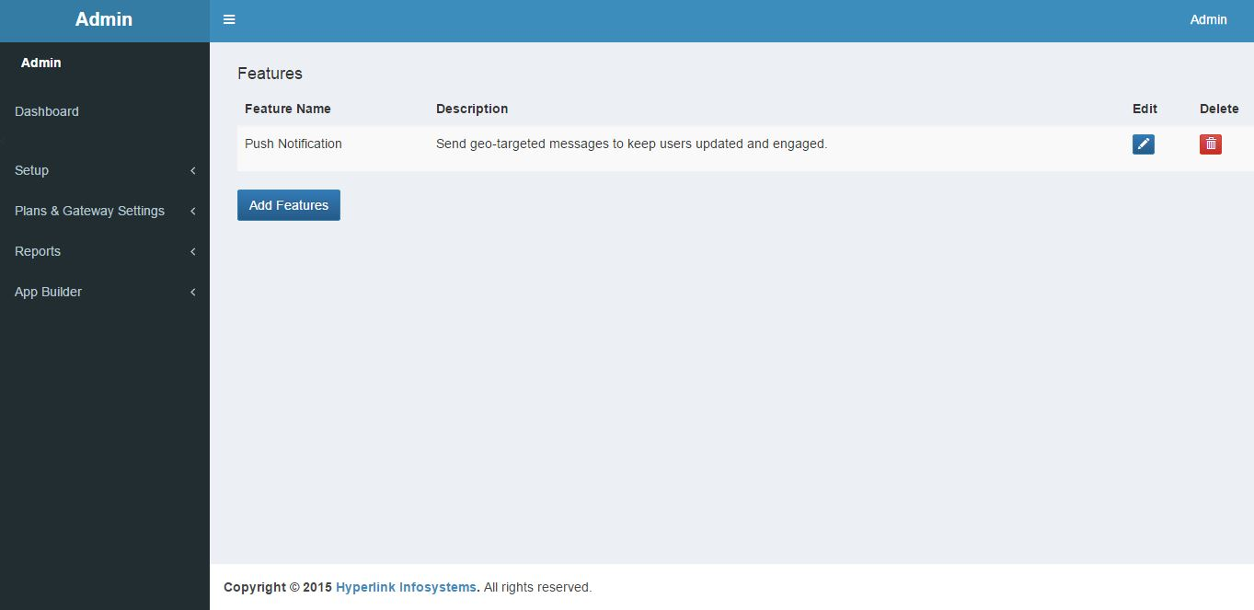 administrator click oky features will be deleted.

**Fig 8.34 Deleted Features**

D**escription:-** Feature is deleted.

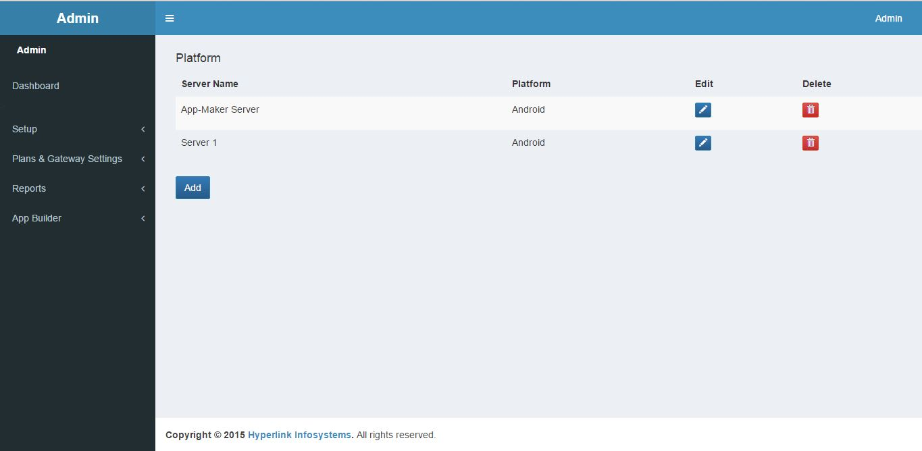

**Fig 8.35 Manage Platform**

D**escription:-** Above fig shows managing of platform and server.

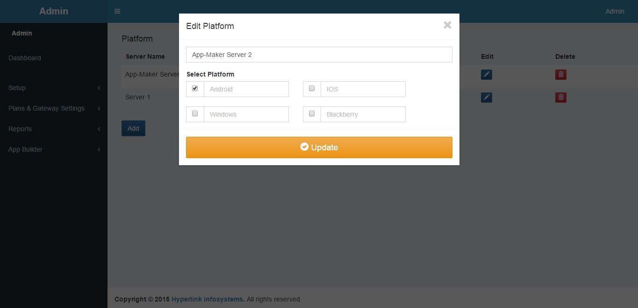

**Fig 8.36 Edit Platform**

D**escription:-** Edit platform will allows administrator to edit platform and server name as show in fig.

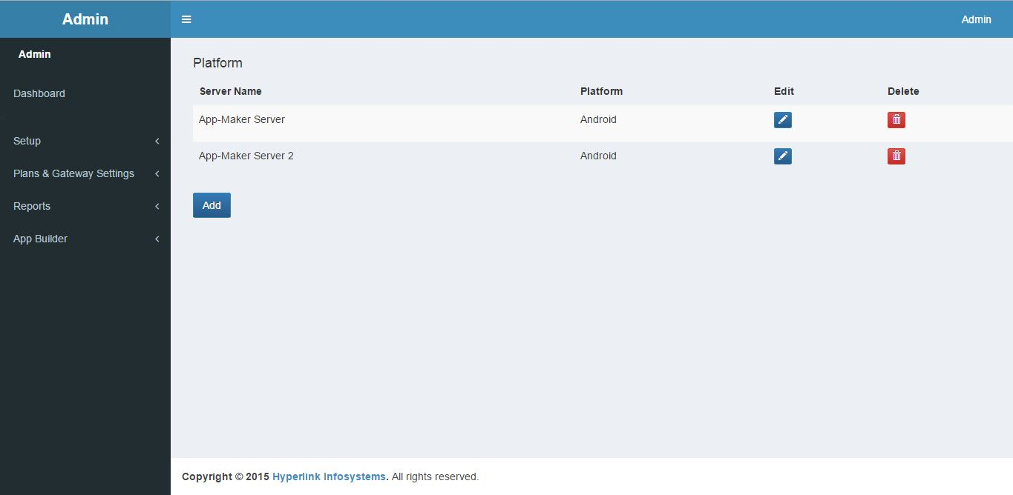

**Fig 8.37 Updated Platform**

D**escription:-** It shows the updated name of the platform after editing.

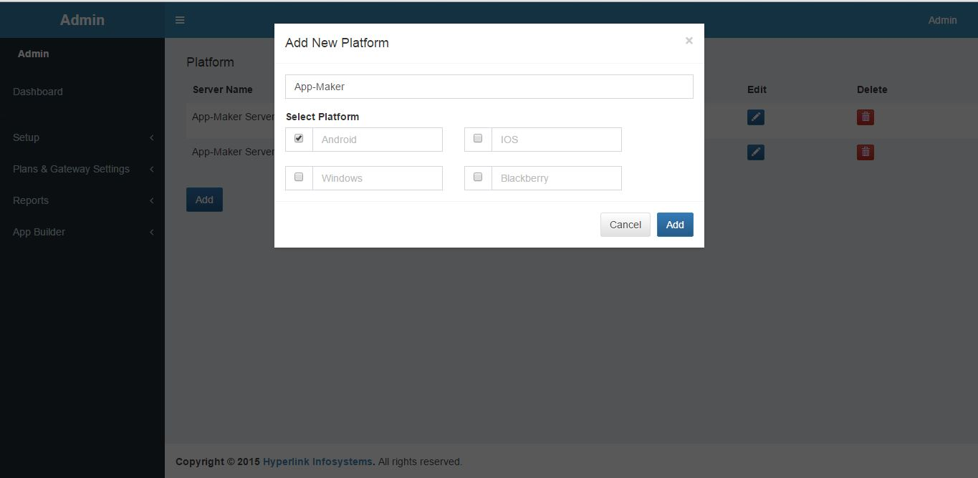

**Fig 8.38 Add Platform**

D**escription:-** Administrator can add new platform by clicking on add button pop up modal is opened

and in that modal by giving server name and selecting checkbox new platform is added.

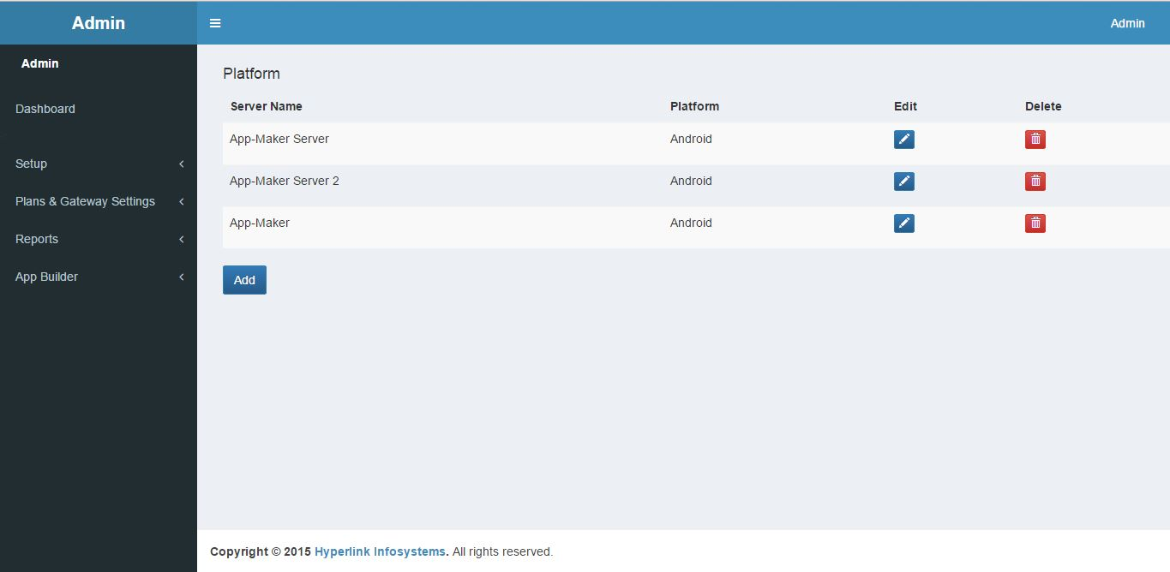

**Fig 8.39 Updated Platform**

D**escription:-** Platform with server name is added

.

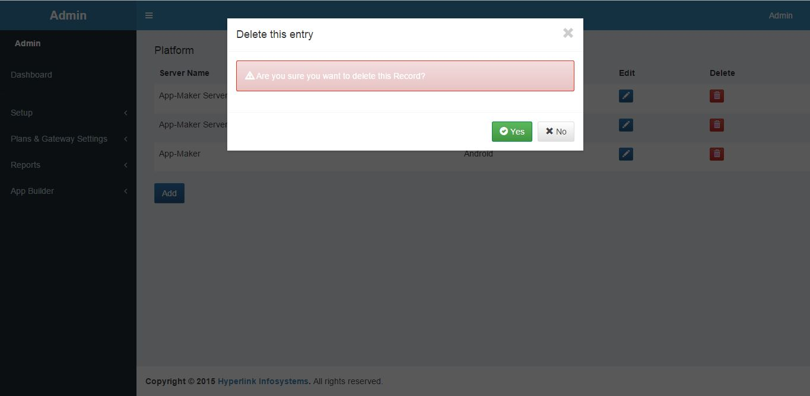

**Fig 8.40 Delete Platform**

D**escription:-** Administrator can delete the platform but clicking on delete button popup modal will

display to ask if they are sure to delete if clicked on yes platform will deleted.

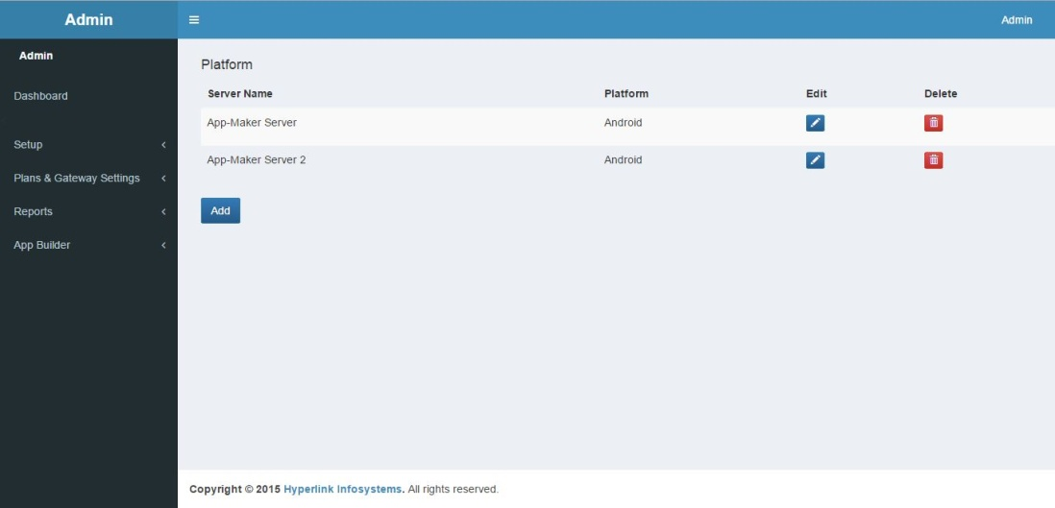

**Fig 8.41 Deleted Platform**

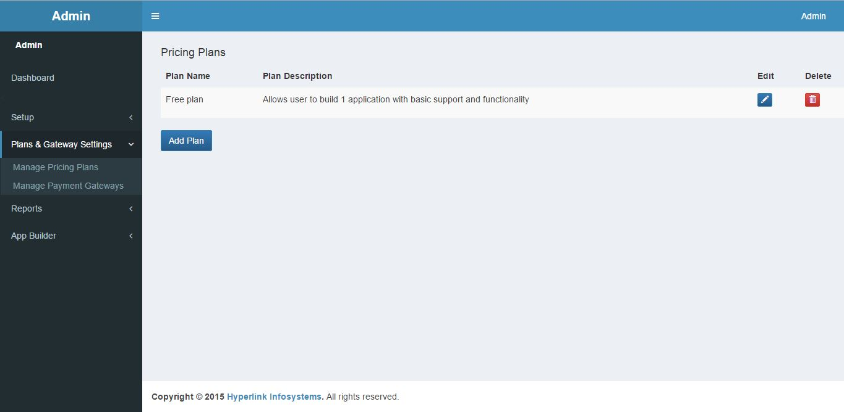

**Fig 8.42 Pricing Plan**

D**escription:-** Administrator will manage pricing plan by adding, editing and deleting.

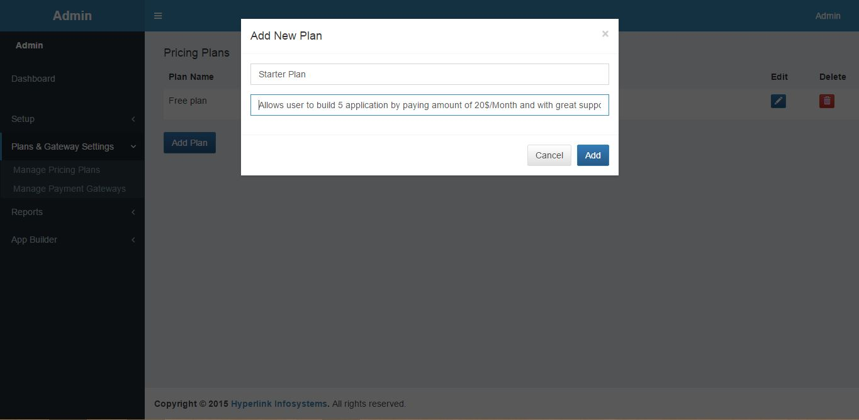

**Fig 8.43 Add New Plan**

D**escription:-** Administrator can Add new plan by clicking add plan button pop up modal will be open

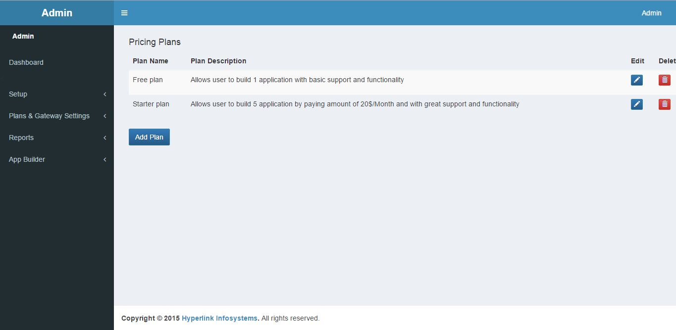 asking for plan name and plan description

**Fig 8.44 Plan Added**

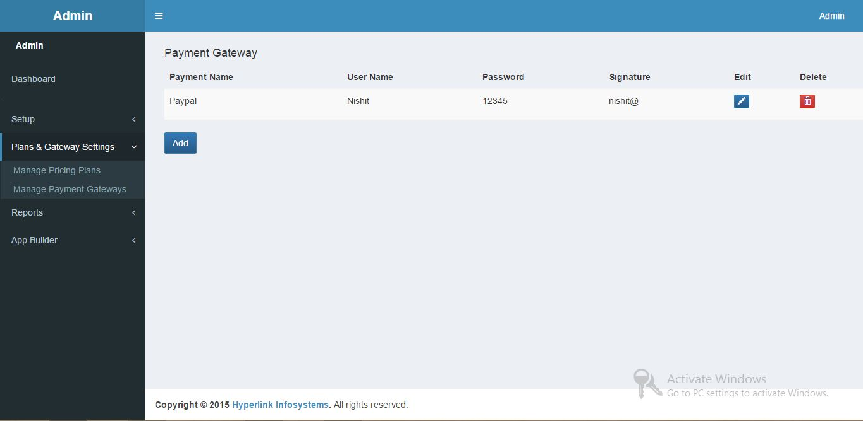

**Fig 8.45 Manage Payment Gateway**

D**escription:-** Administrator will manage Payment Gateway by adding new payment gateway,

editing existing one and deleting payment gateway.

**Reports**

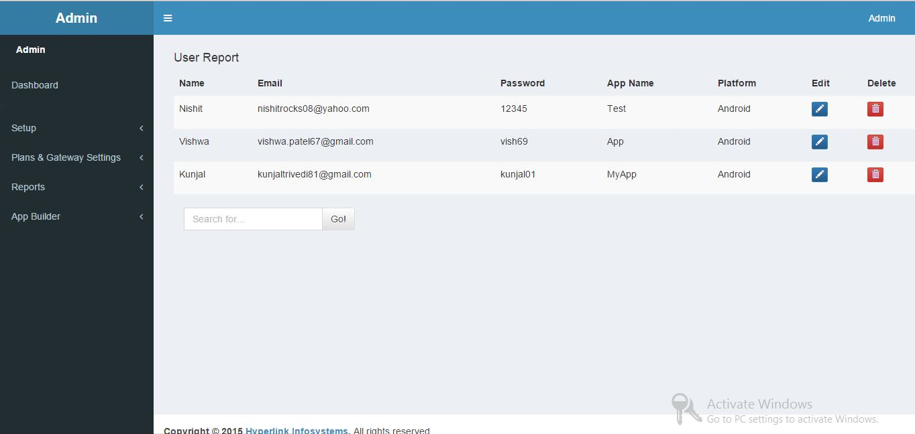

**Fig 8.46 User Report**

D**escription:-** Administrator will can view user report it shows application made by several user and

user can also search for specific user by entering into search box shown above.

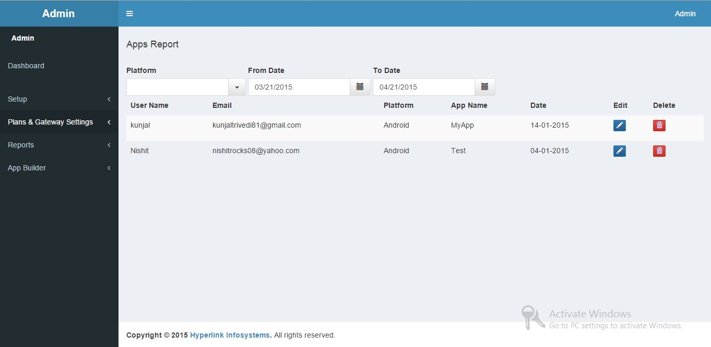

**Fig 8.47 Apps Report**

D**escription:-** Administrator can view apps report it shown the no of application create between

specified date ie From Date to To Date as shown above

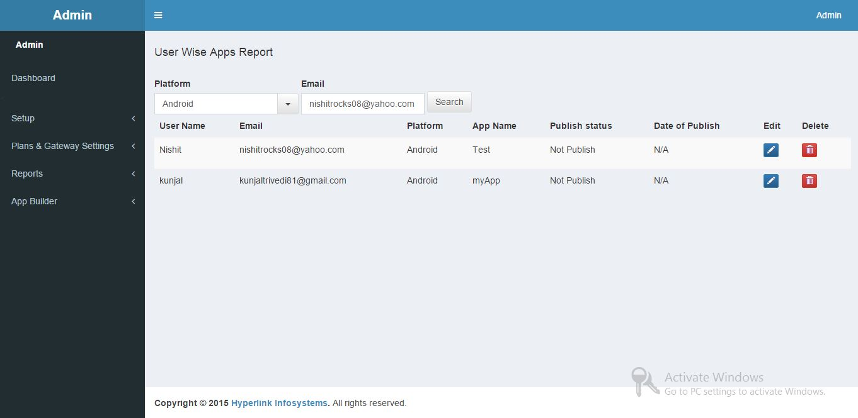

**Fig 8.48 User wise App Report**

D**escription:-** Administrator can view user wise app report. Administrator can also find for specific

user by specifying platform and emailId of that user.

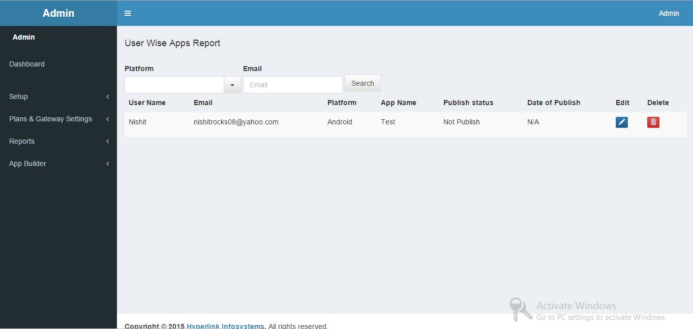

**Fig 8.49 For Specific user**

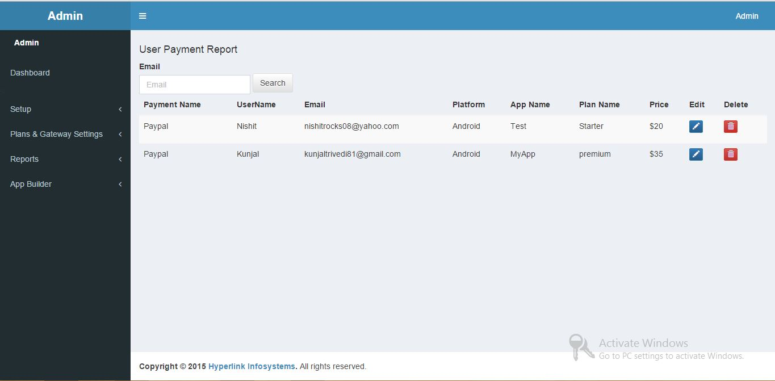 D**escription:-** Administrator can view user wise app report for specific user as shown above.

**Fig 8.50 User Payment Report**

D**escription:-** Administrator can view user payment report for specific user.

.

**Chapter 8**

**Conclusion & Future Work**

**8.1 Conclusion:-**

* The main drawbacks of existing websites led us to develop a user friendly website App-maker.
* Most problems would be solved and the expectations of the current users of these sites would be satisfied through App-maker as it will provide rich UI, Promotional tools, Multiple platform and other such exciting and new features.
* Thus, as a solution to the problems mentioned above, a website App-maker is being developed by us.

**8.2 Future Work:-**

This system will try to implement following in future:

* Providing advertisement and coupons in the mobile application.
* Changes in IOS or to implement smoothly in Macintosh.
* Try to integrate content of website/facebook by just pasting url into mobile application.
* Try to implement on windows platform.
* Will integrate paypal as our Payment Gateway.

**Patent Search and Analysis Report (PSAR) Report**

**Submitted as a part of the**

**PROJECT REPORT**

**“APP-MAKER”**

***Submitted by***

**NISHIT GOPANI (110120107039)**

**KUNJAL TRIVEDI (110120107066)**

***In partial fulfillment for the award of the degree***

***Of***

**BACHELOR OF ENGINEERING**

In

**COMPUTER ENGINEERING**



**GANDHINAGAR INSTITUTE OF TECHNOLOGY**

**Gujarat Technological University**

**Ahmedabad**

**December, 2014**

**GANDHINAGAR INSTITUTE OF TECHNOLOGY**

Khatraj-Kalol Road, At: MotiBhoyan, Tal: Kalol, Dist: Gandhinagar

Website: www.git.org.in

**DECLARATION**

We hereby declare that the PSAR Reports, submitted along with the Project Report for the project entitled ***“APP-MAKER”*** submitted in partial fulfillment for the degree of **Bachelor of Engineering** in to ***Computer E***n**gineering** Gujarat Technological University**,** Ahmedabad**,** is a bonafide record of the project work carried out at ***Gandhinagar Institute Of Technology*** under the supervision *of*

***Ast. Prof. Sonali Virparia*** and that no part of any of these PSAR reports has been directly copied from any students’ reports or taken from any other source, without providing due reference.

**Name of Students Sign of Students**

**1.** Nishit Gopani

**2.** Kunjal Trivedi

|  |  |  |
| --- | --- | --- |
| returnimagelogo.jpg | **GANDHINAGAR INSTITUTE OF TECHNOLOGY**  Khatraj-Kalol Road, At: MotiBhoyan, Tal: Kalol, Dist:Gandhinagar  Website: www.git.org.in | images.jpg |

**CERTIFICATE**

This is to certify that the PSAR reports, submitted along with the project entitled ***APP-MAKER*** has been carried out by ***Nishit Gopani(110120107039)*** under my guidance in partial fulfillment for the degree of: Bachelor of Engineeringin ***COMPUTER ENGINEERING*** 7th Semesterof Gujarat Technological University, Ahmedabad during the academic year 2014-15. These students have successfully completed PSAR activity under my guidance.

|  |  |  |
| --- | --- | --- |
| **Internal Guide,**  Prof. Sonali Virparia,  Assistant Professor ,  Computer Engineering Department |  | **Head of the Department,**  Prof. Kinjal Adhvaryu  Head of Department,  Computer Engineering,  Gandhinagar Institute of Technology |

|  |  |  |
| --- | --- | --- |
| returnimagelogo.jpg | **GANDHINAGAR INSTITUTE OF TECHNOLOGY**  Khatraj-Kalol Road, At: MotiBhoyan, Tal: Kalol, Dist:Gandhinagar  Website: www.git.org.in | images.jpg |

**CERTIFICATE**

This is to certify that the PSAR reports, submitted along with the project entitled ***APP-MAKER*** has been carried out by ***Kunjal Trivedi(110120107066)*** under my guidance in partial fulfillment for the degree of: Bachelor of Engineeringin ***COMPUTER ENGINEERING*** 7th Semesterof Gujarat Technological University, Ahmedabad during the academic year 2014-15. These students have successfully completed PSAR activity under my guidance.

|  |  |  |
| --- | --- | --- |
| **Internal Guide,**  Prof. Sonali Virparia,  Assistant Professor ,  Computer Engineering Department |  | **Head of the Department,**  Prof. Kinjal Adhvaryu  Head of Department,  Computer Engineering,  Gandhinagar Institute of Technology |

**Patent Search & Analysis Report (PSAR)**

**Team Id**

**Name**

: 1398

: GOPANI NISHIT HITESH

28-December-2014

**Part - I : PATENT SEARCH TECHNIQUE USED**

**Patent Search Database Used**

**Keywords Used for Search**

: Espacenet (EPO Patent database)

: MobileApplication,Dynamic ,adjustment

**Search String Used**

: Mobile application and dynamic adjustment

**Number of Results/Hits getting** : 10

**Part - II : BASIC DATA OF PATENTED INVENTION/BIBLIOGRAPHIC DATA**

**Category/Field of Invention** :

**Invention is Related to/Class of Invention**

**Title of Invention**

**Patent No.**

: Application

: Dynamic adjustment of mobile device based on user activity

:

**Application No.**

**Date of Filing/Application**

**Priority Date**

**Publication/Journal Number - (Issue No. of Journal in which Patent is published)**

**Publication Date**

**First Filled Country**

: US 14/253,742

: 15/04/2014

: 09/06/2013

:

: 11/12/2014

:

**Also Published as**

|  |  |
| --- | --- |
| **Country** | **Patent No** |
|  |  |

**Applicant for Patent is** : Company

**- INVENTOR DETAIL**

|  |  |
| --- | --- |
| **Name of Inventor** | **Address/City/Country of Inventor** |
| Philip StanleyMarbell | CA(US) |
| Gaurav Kapoor | CA(US) |
| Kitman Wan | CA(US) |

**- APPLICANT/ASSIGNEE DETAIL**

|  |  |
| --- | --- |
| **Name of Applicant/Assignee** | **Address/City/Country of Applicant** |
| Apple Inc | CA(US) |

**Part - III : TECHNICAL PART OF PATENTED INVENTION**

**Limitation of Prior Technology/Art :**

A method comprising receiving event data at a first process running on mobile device receiving event registration data from second process running on mobile devices, the event registration data identifying one or more events for triggering an invocation of second process, where second process is suspended or terminated after the event registration data is received.

**Specific Problem Solved/Objective of Invention :**

objective of invention is to make application which dynamically adjust as per the user requirement.This disclosure generally relates to adjusting components of computer system based user behavior.one or more components of the central processing unit, graphic processing unit, baseband processor or display of mobile device where in one or more events include a change in operating temperature of mobile device, a change in system setting, user input, turning on or off display.

**Brief about Invention :**

In some implementations, a mobile device can be configured to monitor environmental, system and user events. The occurrence of one or more events can trigger adjustments to system settings. In some implementations, the mobile device can be configured to keep frequently invoked applications up to date based on a forecast of predicted invocations by the user. In some implementations, the mobile device can receive push notifications associated with applications that indicate that new content is available for the applications to download. The mobile device can launch the applications associated with the push notifications in the background and download the new content. In some implementations, before running an application or accessing a network interface, the mobile device can be configured to check energy and data budgets and environmental conditions of the mobile device to preserve a high quality user experience.

**Key Learning Points :**

The tool for the present invention will dynamically adjust the mobile or tablet screen according to the user requirement or based on the various user request .Mobile computing devices are typically battery operated. Some mobile computing devices wirelessly access network resources over cellular data and /or wi-fi network connection. This mobile devices are often constrained by battery capacity and limits on cellular data. They automatically adjust the screen as per the user requirement.

**Summary of Invention :**

The mobile device can be configured to detect the occurrence of one or more event that can trigger adjustment to system settings. In some implementation the mobile device can be configured to keep frequently invoked application up to date. The mobile device can keep track of when applications are invoked by user. Based on the invocation information, The mobile device forecast when during the day the application are invoked.

**Number of Claims**

**Patent Status**

**How much this invention is related with your IDP/UDP?**

: 18

: Granted Patent

: 71 to 90%

**Do you have any idea to do anything around the said invention to improve it? :**

This patent can be improved by adding the second process causes the second process to adjust one or more components of mobile device.

**Patent Search & Analysis Report (PSAR)**

**Team Id**

**Name**

: 1398

: GOPANI NISHIT HITESH

28-December-2014

**Part - I : PATENT SEARCH TECHNIQUE USED**

**Patent Search Database Used**

**Keywords Used for Search**

: Google Patents

: mobile,application,generator

**Search String Used**

: Mobile application generator

**Number of Results/Hits getting** : 55

**Part - II : BASIC DATA OF PATENTED INVENTION/BIBLIOGRAPHIC DATA**

**Category/Field of Invention** :

COMPUTER ENGINEER

**Invention is Related to/Class of Invention**

**Title of Invention**

**Patent No.**

: Application

: mobile application generator

:

**Application No.**

**Date of Filing/Application**

**Priority Date**

**Publication/Journal Number - (Issue No. of Journal in which Patent is published)**

: PCT/US2013/029940

: 08/03/2013

: 09/03/2012

: WO2013134674 A1

**Publication Date**

**First Filled Country**

: 12/09/2013

:

**Also Published as**

|  |  |
| --- | --- |
| **Country** | **Patent No** |
|  |  |

**Applicant for Patent is** : -

**- INVENTOR DETAIL**

|  |  |
| --- | --- |
| **Name of Inventor** | **Address/City/Country of Inventor** |
| Marry Beth BRENDZA | US |
| Bruce C HOWARD | US |

**- APPLICANT/ASSIGNEE DETAIL**

|  |  |
| --- | --- |
| **Name of Applicant/Assignee** | **Address/City/Country of Applicant** |
| User friendly phone book LLC | US |

**Part - III : TECHNICAL PART OF PATENTED INVENTION**

**Limitation of Prior Technology/Art :**

This patent can be improved by adding selecting one or more application modules from a plurality of application modules stored in the data store in view of the selection of one or more application features specified in the application description, wherein at least one of the plurality of application modules comprises additional previously-generated base application software code for an application feature to run in connection with the base mobile application.

**Specific Problem Solved/Objective of Invention :**

A method comprising: receiving a request to create a mobile application, the request comprising provider-specific application information and provider-specific content for the mobile application generating, by a processing device, an application description based on the provider-specific application information, wherein the application description comprises a selection of one or more application features for the mobile application retrieving, by the processing device, a base mobile application stored in a data store, wherein the base mobile application comprises previously generated base application software code

**Brief about Invention :**

A system and a method are disclosed for receiving a request to create a mobile application, the request comprising provider-specific application information and provider-specific content for the mobile application, generating, by a processing device, an application description based on the provider-specific application information, wherein the application description comprises a selection of one or more application features for the mobile application, retrieving, by the processing device, a base mobile application stored in a data store, wherein the base mobile application comprises previously generated base application software code, modifying, by the processing device, the base mobile application in view of the application description; and generating, by the processing device, binary mobile application code for the mobile application in view of the modified base mobile application.

**Key Learning Points :**

The present disclosure relates to the field of mobile applications. Specifically, the examples of the present disclosure relate to automated generation of mobile applications .Mobile applications, also called mobile apps or apps, are software applications, usually designed to run on smartphones, tablet computers, and other handheld devices. They are available through application distribution platforms, which are typically operated by the owner of the mobile operating system, such as the Apple® App Store, Android® Market, and BlackBerry® AppWorld. Some mobile apps are free, and others may have a price. Usually the mobile apps are downloaded from the platform to a target device such as to one of the iPhone®, BlackBerry®, or Android® phones. Alternatively, they can be downloaded to other types of computers such as a laptops or desktops. Mobile apps were originally intended for productivity: e.g., email, calendar and contact databases, however, public demand caused rapid expansion into other areas such as mobile games, factory automation, global positioning systems (GPS) and location-based services, banking, order-tracking, and ticket purchases, and the like.

**Summary of Invention :**

The examples described herein may provide an automated mobile application generator (also referred to herein as a mobile app generator). The mobile app generator may be used to create and publish customized mobile applications (also referred to herein as mobile apps). These mobile apps may be generated for small, medium or large entities , who may be vendors of various products or services. Hereinafter these vendors may be referred to as providers. Those serviced by these providers are referred to as consumers or customers. These providers may distribute the mobile apps to their respective end-user consumers for use on mobile devices.

**Number of Claims**

: 23

**Patent Status**

**How much this invention is related with your IDP/UDP?**

: Granted Patent

: > 91 %

**Do you have any idea to do anything around the said invention to improve it? :**

Team will add one or more mobile application custom feature list in the user interface comprising one or more fields to customize the base mobile application, wherein the fields are associated with a respective application module stored in the data store

**Patent Search & Analysis Report (PSAR)**

**Team Id**

**Name**

: 1398

: GOPANI NISHIT HITESH

28-December-2014

**Part - I : PATENT SEARCH TECHNIQUE USED**

**Patent Search Database Used**

**Keywords Used for Search**

: Google Patents

: system

,method,business,mobile,application,development, deployment

**Search String Used**

: business mobile application development and deployment

**Number of Results/Hits getting** : 7,720

**Part - II : BASIC DATA OF PATENTED INVENTION/BIBLIOGRAPHIC DATA**

**Category/Field of Invention** :

mobile application

**Invention is Related to/Class of Invention**

**Title of Invention**

**Patent No.**

: Application

: system and method for mobile business application development and deployment

:

**Application No.**

**Date of Filing/Application**

**Priority Date**

**Publication/Journal Number - (Issue No. of Journal in which Patent is published)**

: PCT/IB2013/000673

: 12/04/2013

: 14/02/2012

: WO2013121293 A3

**Publication Date**

**First Filled Country**

: 22/08/2013

:

**Also Published as**

|  |  |
| --- | --- |
| **Country** | **Patent No** |
|  |  |

**Applicant for Patent is** : -

**- INVENTOR DETAIL**

|  |  |
| --- | --- |
| **Name of Inventor** | **Address/City/Country of Inventor** |
| Scott Hirsch | Boca Raton, FL (US); |
| Arsen Pereymer | Ft. Lauderdale, FL (US); |
| Sunny Rajpal | Sunrise, FL (US) |

**- APPLICANT/ASSIGNEE DETAIL**

|  |  |
| --- | --- |
| **Name of Applicant/Assignee** | **Address/City/Country of Applicant** |
| MEDIA DIRECT INC | Deerfeld Beach, FL (US) |

**Part - III : TECHNICAL PART OF PATENTED INVENTION**

**Limitation of Prior Technology/Art :**

It is understood that the various systems and methods described in connection with the foregoing figures are exemplary, and any other suitable systems or methods may be used. The foregoing is merely illustrative of the principles of this invention and various modifications can be made by those skilled in the art without departing from the scope and spirit of the invention. As an example, although certain embodiments of the mobile development platform have been described in connection with certain predefined app-types and modules associated with particular features and functions that may be included in mobile apps developed through the platform, the platform may provide any number, manner and type of predefined application components and subcomponents which may be associated with any one or more features, functionalities or content. One skilled in the art will appreciate that the present invention can be practiced in other than the described embodiments, which are presented for purposes of illustration and not limitation, and the present invention is limited only by the claims which follow.

**Specific Problem Solved/Objective of Invention :**

A system for allowing users to develop mobile business applications or portions thereof that are capable of being compiled to run on a plurality of mobile operating systems, the system comprising: a computing device having physical memory storing instructions that cause the computing device to: provide a user access to a mobile application development platform adapted to assist users with the development and customization of mobile applications; receive from a user a request to develop a mobile application through the mobile application development platform; send information associated with a plurality of customizable components to be presented to the user, the plurality of customizable components pertaining to a functionality, design, content, and database structure of a mobile application to be developed the user; receive from the user a plurality of customizable component selections pertaining to the plurality of presented customizable components; associate application data with the mobile application based, at least in part, on the plurality of customizable component selections received from the user, the application data representing user-defined functionality, design, content, and database structure for the mobile application; store the application data.

**Brief about Invention :**

Systems and methods for developing, customizing; and deploying mobile device business applications are provided through a mobile application development and deployment platform. Preferably, these systems and methods are implemented in an Internet based environment that allows non-technical users to build sophisticated, highly-customizable cross-platform mobile applications. The platform allows users to select, input, create, customize, and combine various content, design characteristics, database structure, and application components, such as modules, some of which allow an end user to store and access data in an end user database for business applications. In certain embodiments, the platform allows users to compile and generate a configuration file for the mobile application.

**Key Learning Points :**

A method for developing and customizing mobile business applications or portions thereof that are compiled to run on a plurality of mobile operating systems, the method being implemented through instructions stored in a physical memory associated with a computing device, which causes the computing device to perform the steps of: receiving at the computing device a request to access a mobile application development platform from a user through a user input device, the mobile development platform being adapted to assist users with the development and customization of mobile applications; granting the user access to the mobile application development platform .The present invention generally relates to systems and methods for developing computer software applications. More specifically, certain embodiments are directed to systems and methods for developing, deploying and updating cross -platform mobile device applications through an Internet-based mobile application development and deployment platform that allows

non-technical users and developers to build sophisticated, highly-customizable applications, including sophisticated , highly-customizable business applications (or portions of such applications).

**Summary of Invention :**

One aspect of the invention is to provide a mobile application development and deployment platform that allows developers to design, build, distribute and manage mobile software applications. Another aspect of the invention is to provide such a platform that is accessible to non -technical users and operable through an easy -to- use, intuitive user interface that does not require users to possess expertise in computer programming or mobile devices and applications. Yet another aspect of the invention is to provide such a platform that allows for a high degree of customizability and allows users to create sophisticated application through the customization and combination of various components, such as app -types, modules, content elements, and templates that can access features of various mobile devices and mobile operating systems, and can allow an end user to store and access data in an end user database for business applications. Yet another aspect of the invention is to provide such a platform that allows users to create, customize, update and deploy other types of applications, such as mobile games and web applications through the development platform.

**Number of Claims**

**Patent Status**

**How much this invention is related with your IDP/UDP?**

: 29

: Granted Patent

: < 70 %

**Do you have any idea to do anything around the said invention to improve it? :**

This patent can be improved by mobile application development platform includes a web based service accessed by the user through the Internet , the physical memory storing instructions that further cause the computing device to receive from the user one or more identifying properties for the mobile application.

**Patent Search & Analysis Report (PSAR)**

**Team Id**

**Name**

: 1398

: GOPANI NISHIT HITESH

29-December-2014

**Part - I : PATENT SEARCH TECHNIQUE USED**

**Patent Search Database Used**

**Keywords Used for Search**

: Indian Patent Office database

: manage,multiple ,operating ,system

**Search String Used**

: multiple operating system

**Number of Results/Hits getting** : 853

**Part - II : BASIC DATA OF PATENTED INVENTION/BIBLIOGRAPHIC DATA**

**Category/Field of Invention** :

COMPUTER ENGINEER

**Invention is Related to/Class of Invention**

**Title of Invention**

**Patent No.**

: Mobile Application

: System and method to manage multiple operating system

: 229602

**Application No.**

**Date of Filing/Application**

**Priority Date**

**Publication/Journal Number - (Issue No. of Journal in which Patent is published)**

**Publication Date**

**First Filled Country**

: 1493/CHE/2004

: 31/12/2004

: -

:

: 27/03/2009

:

**Also Published as**

|  |  |
| --- | --- |
| **Country** | **Patent No** |
|  |  |

**Applicant for Patent is** : Company

**- INVENTOR DETAIL**

|  |  |
| --- | --- |
| **Name of Inventor** | **Address/City/Country of Inventor** |
| PRASHANT SINGH | BAGMANE LAKEVIEW, BLOCK 'B', NO. 66/1, B |

**- APPLICANT/ASSIGNEE DETAIL**

**Name of Applicant/Assignee Address/City/Country of Applicant**

SAMSUNG INDIA SOFTWARE OPERATI BAGMANE LAKEVIEW, BLOCK 'B', NO. 66/1, BAGMANE TECH PA

**Part - III : TECHNICAL PART OF PATENTED INVENTION**

**Limitation of Prior Technology/Art :**

Although the present invention has been fully described in connection with the preferred embodiments thereof with reference to the accompanying drawings, it is to be noted that various changes and modifications are possible and are apparent to those skilled in the art. Such changes and modifications are to be understood as included within the scope of the present invention as defined by the appended claims unless they depart there from.

**Specific Problem Solved/Objective of Invention :**

This invention explains a method and a system to manage multiple operating systems wherein the said method comprises the steps of: selecting the OS to be booted from a plurality of OS by the selector component; switching to a different OS or to suspend the hardware by a switcher component; partitioning the system RAM to each of the OS instances; loading multiple operating systems into the memory without disturbing the state of the previously loaded operating systems; performing the OS sleep routine on reception of the sleep signal; and performing the resume procedure on reception of the resume signal.

**Brief about Invention :**

|  |  |  |
| --- | --- | --- |
| Systems and | methods | for developing, customizing; and deploying mobile device business applications |
| are provided | through | a mobile application development and deployment platform. Preferably, these |
| systems and | methods | are implemented in an IThe functionality of these modules are described in |

operation of the invention.

Modifications to the apparatus

The suggested modifications to the apparatus described in Structure of the related art are described below:

1. There should be support for the individual partitions of the system RAM to be put to power-saving mode, so that the part of RAM which is not being used could be put in low-power state.

2. There should be enough sleep-persistent registers available to store all the flags required in the described procedure.

Partitioning of system RAM

In software, the system RAM has to be partitioned for each of the OS instances. In partitioning, what is meant is that, the available physical RAM has to be judiciously allotted to the different OS instances. The methodology to be followed for partitioning is implementation specific. Physically the RAM could be same or it could exist in different banks accessible to the processor.

GUI / Application considerations

The provisions to switch between the various installed operating systems have to be provided by an application / GUI as required by the system. The construction of such an application / GUI is outside the scope of this invention proposal.

Operationnternet based environment that allows non-technical users to build sophisticated, highly-customizable cross-platform mobile applications. The platform allows users to select, input, create, customize, and combine various content, design characteristics, database structure, and application components, such as modules, some of which allow an end user to store and access data in an end user database for business applications. In certain embodiments, the platform allows users

to compile and generate a configuration file for the mobile application.

**Key Learning Points :**

The present invention relates to operating systems and further, to a method to multi -boot a device (utilizing a single processor for all the OS instances) and switch between the loaded operating systems dynamically. More particularly this invention relates to a system and method to manage multiple operating systems .The proposed invention overcomes the limitation of the current systems in managing multiple operating systems. It enables a device to load

multiple operating systems at the same time and to switch between the loaded operating systems on a user action or a system event.The devices having multi-boot capability can now provide a way to switch between the operating systems, which will consume less time than unloading the current operating system and loading another one and will be more user friendly as the state of running OS is saved .This is achieved with virtually no modifications to the existing hardware or the operating systems, which means that there will not be any compatibility issues with the present devices or the systems. The proposed system is also cheap in terms of resources consumed, adding only a negligible size to the system footprint and a small overhead in operation.

**Summary of Invention :**

The primary object of the present invention is therefore to load several instances of operating systems on a device , utilizing a single processor, execute them one at a time and switch between them dynamically upon user request or a system generated event.It is another object of this invention to achieve the same with limited modifications to the existing hardware and to the existing operating systems. It is another object of this invention not to include the steps and standards required for compatible working of various peripherals with different operating systems on the device . The present invention describes a method to manage multiple operating systems loaded on a device, utilizing a single processor, simultaneously. It enables a device to boot-up multiple operating systems on a device without unloading the previously loaded OS. It further describes a method to switch between the loaded operating systems dynamically on user input or otherwise.This functionality is achieved with no modifications to the hardware of the existing devices . Though some modifications are suggested in this proposal for enhanced performance, they are not mandatory.

When a device supporting power -save goes into sleep mode it saves its state in system memory and then switches off most of its devices, which on wakeup are reinitialized and restored to the previous state. Exploiting this behavior , the present invention proposes to sleep the running OS and load or wakeup another OS instead of the one previously running. This enables us to either load another OS onto the device or switch to a previously loaded OS without unloading the currently running one.

Accordingly, the present invention explains a method to manage multiple operating systems, the said method comprising the steps of:

(a) selecting the OS to be booted from a plurality of OS or switched onto the system based upon OSSelection and

OSLoaded flags by the selector component;

(b) switching to a different OS or to suspend the hardware based upon OSSwitch flag by a switcher component ; (c) partitioning the system RAM to each of the OS instances;

(d) loading multiple operating systems into the memory without disturbing the state of the previously loaded operating systems;

(e) performing the OS sleep routine on reception of the sleep signal; and

(f) performing the resume procedure on reception of the resume signal.

**Number of Claims**

**Patent Status**

**How much this invention is related with your IDP/UDP?**

: 23

: Granted Patent

: > 91 %

**Do you have any idea to do anything around the said invention to improve it? :**

This patent can be improved as follows where in the selector component is added to the Boot loader. Where in the switcher component is a Power Management component. Where in the unused RAM is put in low -power state by putting the individual partitions of the system RAM to power -saving mode. Where in sleep-persistent registers are provided to store all flags. where in partitioning the system RAM to each of the OS instances makes the available physical RAM judiciously allotted to the different OS instances. A method as claimed in claim 1 wherein physically the RAM is same or it exist in different banks accessible to the processor .

**Patent Search & Analysis Report (PSAR)**

**Team Id**

**Name**

: 1398

: GOPANI NISHIT HITESH

29-December-2014

**Part - I : PATENT SEARCH TECHNIQUE USED**

**Patent Search Database Used**

**Keywords Used for Search**

: Indian Patent Office database

: cache

,data,memory,mobile,application,management

**Search String Used**

: caching data for a mobile aaplication

**Number of Results/Hits getting** : 33

**Part - II : BASIC DATA OF PATENTED INVENTION/BIBLIOGRAPHIC DATA**

**Category/Field of Invention** :

COMPUTER ENGINEER

**Invention is Related to/Class of Invention**

**Title of Invention**

**Patent No.**

: Application for managing cache memory

: SYSTEM AND METHOD FOR CACHING DATA FOR A MOBILE APPLICATION

: 213943

**Application No.**

**Date of Filing/Application**

**Priority Date**

**Publication/Journal Number - (Issue No. of Journal in which Patent is published)**

**Publication Date**

**First Filled Country**

: 41/kolnp/2005

: 17/01/2005

: -

:

: -

:

**Also Published as**

|  |  |
| --- | --- |
| **Country** | **Patent No** |
|  |  |

**Applicant for Patent is** : Company

**- INVENTOR DETAIL**

94403

94116

|  |  |
| --- | --- |
| **Name of Inventor** | **Address/City/Country of Inventor** |
| AHAD RFIUL | 863 HUNTER LANE, FREMONT, CA 94539 |
| CHIANG JERRY | 37201, PASEO PADRE PARKWAY #107, FREMO |
| KIBIREV OLEG | 3033 LA SELVA STREET #316, SAN MATEO, CA |
| PRAKASH RAVINDRA | 1170 ALDERBROOK LANE, SAN JOSE, CA 951 |
| REHMAN SAMUELSON | 3217 SANTIAGO STREET, SAN FRANCISCO, CA |

**- APPLICANT/ASSIGNEE DETAIL**

**Name of Applicant/Assignee Address/City/Country of Applicant**

ORACLE INTERNATIONAL CORPORATIO M/S 50P7, 500 ORACLE PARKWAY REDWIID SHARES, CA

**Part - III : TECHNICAL PART OF PATENTED INVENTION**

**Limitation of Prior Technology/Art :**

The data are currently stored in a client database (e.g., in a table, cache table or snapshot) and are valid, they may be retrieved from the database during state 558. However, if any data items are not currently in the database, or if a necessary data item is stale, then the client engine may initiate a connection to a remote system to retrieve one or more data item(s). In this method of the invention, it may be noted that the connection to the remote system is minimized by retrieving just the necessary data. In particular, the client engine may avoid downloading other data (e.g., data that are locally available and not stale) and non-data components (e.g., the presentation description or format) of the requested page.The foregoing descriptions of embodiments of the invention have been presented for purposes of illustration and description only. They are not intended to be exhaustive or to limit the invention to the forms disclosed. Accordingly, the above disclosure is not intended to limit the invention

**Specific Problem Solved/Objective of Invention :**

A cache table 222 comprises a set of access parameters and a set of data columns. One or more Instances of a cache table are stored on a mobile computing device. Each instance Includes an argument (a unique set of values for the access parameters) and a result set (a set of values for the data columns). Thus, each result in a result set comprises the argument and corresponding column values. Cached result sets have specified periods of validity, and may or may not beusable after becoming invalid. Valid cached data may be used regardless of whether a connection is available to a data source (e.g. data or application server). Invalid data may be used for a period of time if no connection Is available to the data source, Data in a cache table may be selectively updated from a data source without synchronizing the entire local database.

This invention relates to the field of computer systems. More particularly, a system and methods are provided for caching data on a mobile device. Applications operated on mobile devices (e.g., laptop computers, personal digital assistants, mobile telephones) have generally been designed for either online or offline use. Both types of mobile applications tend to use some form of browser to interact with a user. Online applications enjoy continual access to an enterprise server (e.g., centraldatabase server). Offline applications, in contrast, operate with minimal or no contactwith an e n t e r p r i s e

server.

**Brief about Invention :**

The following description is presented to enable any person skilled in the art tomake and use the invention, and is provided in the context of particular applications of the

invention and their requirements. Various modifications to the disclosed embodimentswill be readily apparent to those skilled in the art and the general principles defined herein may be applied to other embodiments and applications without departing from the scope of the present invention. Thus, the present invention is not intended to be limited to the embodiments shown, but is to be accorded the widest scope consistent with the principles and features disclosed herein. The program environment in which a present embodiment of the invention is executed illustratively incorporates a general-purpose computer or a special purpose device such as a mobile computer, a PDA (Personal Digital Assistant), a telephone, etc.Details of such devices (e.g., processor, memory, data storage, display) may be omitted

for the sake of clarity. It should also be understood that the techniques of the present invention may be implemented using a variety of technologies. For example, the methods described herein may be implemented in software executing on a computer system, or implemented in hardware utilizing either a combination of microprocessors or other specially designed application specific integrated circuits, programmable logic devices, or various combinations thereof. In particular, the methods described herein may be implemented by a series of computer-executable instructions residing on a suitable

|  |  |  |
| --- | --- | --- |
| computer-readable medium. Suitable computer-readable media may include volatile | (e.g.. | RAM) and/or |
| non-volatile (e.g., ROM, disk) memory, carrier waves and transmission media | (e.g., | copper wire, |
| coaxial cable, fiber optic media). Exemplary earner waves may take the | form | of electrical, |

electromagnetic or optical signals conveying digital data streams along a local network, a publicly

accessible network such as the Internet or some other communication link.

**Key Learning Points :**

In one embodiment of the invention, a system and methods are provided for fine -grained caching of data for use with an application executing on a mobile (e.g., wireless)

device configured for use in a third generation wireless network or other enterprise network. In this embodiment, the device need not always access a central or master source of the data (e.g., a data, web or application server) and can use the cached data in an online or offline mode. Traditional synchronization operations between the device and the data source are unnecessary, as data cached on the mobile device may be selectively refreshed when needed. Thus, benefits of both modes of operation (e.g., fresh data,acceptable connection costs) are obtained. Existing mobile applications and client databases typically are not configured to recognize or consider the longevity of downloaded data. Further, mobile client applications that attempt to provide significant functionality to users tend to require robust software and/or hardware configurations (e.g., a Java Virtual Machine, an HTTP listener, a servlet engine). Such requirements prevent the use of smaller, more restrained client devices, such as Personal Digital Assistants (PDA) or smart telephones, and also add overhead to client operations. In another embodiment of the invention, an algorithm is provided to define the data and transactional semantics of cache tables, in a manner that is consistent with theACID (Atomicity, Consistency, Isolation, and Durability) properties of database transactions. In particular, data stored in a cache table have associated periods of validity, which may be specified by a data source from which the data were

obtained

**Summary of Invention :**

In an embodiment of the invention, data are cached in cache tables implementedas part of a local DBMS (Database

Management System) of a mobile device. In this

embodiment, a cache table is a table whose content (e.g., rows) are retrieved from a server, on demand, and cached locally according to cache control instructions associated with the content. A subset of the columns (or attributes) of a cache table is designated as the "access parameters" for the cache table. To retrieve data from a cache table, a value is provided for each of the access parameters. These values constitute an argument for one instance of the cache table. If the row(s) with those argument values are not in the local database, or have expired, the DBMS will contact the corresponding server to retrieve and cache the rows .A cache table comprises a set of access parameters and a set of data columns. One or more Instances of a cache table are stored on a mobile computing device. Each instance Includes an argument (a unique set of values for the access parameters) and a result set (a set of values for the data columns). Thus, each result in a result set comprises the argument and corresponding column values . Cached result sets have specified periods of validity, and may or may not be usable after becoming invalid. Valid cached data may be used regardless of whether a connection is available to a data source (e.g. data or application server). Invalid data may be used for a period of time if no connection is available to the data source, Data in a cache table may be selectively updated from a data source without synchronizing the entire local database.

**Number of Claims**

**Patent Status**

**How much this invention is related with your IDP/UDP?**

: 24

: Granted Patent

: 71 to 90%

**Do you have any idea to do anything around the said invention to improve it? :**

A method of facilitating the caching of data from a data source on a mobile computing device coupled to the data source with a discontinuously available communication link, comprising: configuring a cache table within a database on the mobile computing device, wherein said cache table includes: access parameters comprising a first set of columns of a dataset on a data source; and result columns comprising a second set of columns of the dataset distinct from the first set of columns of the dataset.

**Patent Search & Analysis Report (PSAR)**

**Team Id**

**Name**

: 1398

: TRIVEDI KUNJAL HIKSHU

29-December-2014

**Part - I : PATENT SEARCH TECHNIQUE USED**

**Patent Search Database Used**

**Keywords Used for Search**

: Google Patents

: Mobile application ,Business application,music mobile application,publishing application,Mobile application for barcode identification and method

**Search String Used**

: Mobile application creation system

**Number of Results/Hits getting** : 77,900

**Part - II : BASIC DATA OF PATENTED INVENTION/BIBLIOGRAPHIC DATA**

**Category/Field of Invention** :

**Invention is Related to/Class of Invention**

**Title of Invention**

**Patent No.**

: Mobile Application

: Mobile application creation system

: 1

**Application No.**

**Date of Filing/Application**

**Priority Date**

**Publication/Journal Number - (Issue No. of Journal in which Patent is published)**

: US 13/946,325

: 19/07/2013

: 19/07/2012

: US8813028 B2

**Publication Date**

**First Filled Country**

: 19/08/2014

:

**Also Published as**

|  |  |
| --- | --- |
| **Country** | **Patent No** |
|  |  |

**Applicant for Patent is** : -

**- INVENTOR DETAIL**

|  |  |
| --- | --- |
| **Name of Inventor** | **Address/City/Country of Inventor** |
| Arshad Farooqi | Potomac falls VA(US) |

**- APPLICANT/ASSIGNEE DETAIL**

|  |  |
| --- | --- |
| **Name of Applicant/Assignee** | **Address/City/Country of Applicant** |
| Arshad Farooqi | Potomac falls VA(US) |

**Part - III : TECHNICAL PART OF PATENTED INVENTION**

**Limitation of Prior Technology/Art :**

limitation is providing a mobile application development software executable by at least one processor configured to create said mobile application, wherein said mobile application development software is accessible by said user device via a network.

**Specific Problem Solved/Objective of Invention :**

Using mobile devices for different forms of communication, for example, voice communication, messaging, etc., thesemobile devices also allow consumers and business entities to perform other functions such as accessing and displaying websites, sending and receiving electronic mails, capturing and displaying images, playing videos, music and other forms of audio, social networking, etc. These functions are typically performed by software applications that are either built into the mobile devices or that are run on top of operating systems of the mobile devices.Consumers and business entities are increasingly using mobile devices such as smart phones, tablet computing devices, personal digital assistants, other handheld devices, etc., for performing various personal, work, and business or enterprise related tasks.

**Brief about Invention :**

A computer implemented method and system for creating a mobile application provides a mobile application development software (MADS) and pre-coded software components (PCSCs) encapsulated in a mobile application creation interface (MACI). The MADS dynamically maps data to be rendered in the mobile application with one or more data sources and launches the MACI. The MADS creates one or more composite software components (CSCs) by combining more than one of distinct software components selected from component sources and/or the PCSCs. The MADS inserts one or more PCSCs and/or CSCs into the MACI. The MADS generates one or more recommendations for adding one or more characteristic objects associated with the mobileapplication. The MADS creates the mobile application using the inserted PCSCs, the created composite software components, the recommendations, the dynamically mapped data, and/or an adaptively configured application programming interfaces that facilitate backend integration of the mobile application with the user device.

**Key Learning Points :**

Providing a plurality of pre-coded software components executable by said at least one processor and encapsulated in a mobile applicationcreation interface, wherein said pre -coded software components are fully developed applications that can be assembled to build apps in the mobileapplication creation interface, wherein said mobile application creation interface is accessible at the user device via the network to download and deploy mobile apps in any mobile interface, device or wearables, wherein said pre -coded software components are adaptable based on context and behavioral elements, wherein said pre -coded software components comprise hierarchical layers of data, interactive elements configured to enable interactions with said data, and predetermined criteria, and wherein said pre -coded software components dynamically create multiple pages within said pre -coded software components based on data and mapping defined by a user.

**Summary of Invention :**

This summary is provided to introduce a selection of concepts in a simplified form that are further disclosed in the detailed description of the invention. This summary is not intended to identify key or essential inventive concepts of the claimed subject matter, nor is it intended for determining the scope of the claimed subject matter .The computer implemented method and system disclosed herein address the above stated needs for providing encapsulated pre-coded software components to perform multiple functions in the form of a software package and enterprise grade mobile applications that are connected with backend databases, enabling creation of enhanced software components or widgets without coding, providing support for native, web and cross platform mobileapplications, providing an

interface to dynamically map backend data sources and add new fields on the fly, providing connection of data from multiple data sources, enabling creation of complex business to business (B2B) mobileapplications that require complex business rules and data validation, allowing development of machine to machine (M2M) applications or sensor specific applications that combine sensor data with business processes and creation of process and sensor composite or mashup applications, and implementing application programming interfaces for backend integration of the developed mobile application with a user device and with backend databases.

**Number of Claims**

**Patent Status**

**How much this invention is related with your IDP/UDP?**

: 25

: Granted Patent

: < 70 %

**Do you have any idea to do anything around the said invention to improve it? :**

Adaptively configuring one or more application programming interfaces for a backend integration of said mobile application with said user device by said mobile application development software for operating said mobile application on said user device.

**Patent Search & Analysis Report (PSAR)**

**Team Id**

**Name**

: 1398

: TRIVEDI KUNJAL HIKSHU

29-December-2014

**Part - I : PATENT SEARCH TECHNIQUE USED**

**Patent Search Database Used**

**Keywords Used for Search**

: Google Patents

: publishing mobile application,publish application,Mobile application

**Search String Used**

: Publishing Mobile Application

**Number of Results/Hits getting** : 107,000

**Part - II : BASIC DATA OF PATENTED INVENTION/BIBLIOGRAPHIC DATA**

**Category/Field of Invention** :

**Invention is Related to/Class of Invention**

**Title of Invention**

**Patent No.**

: Publishing Application

: Publishing Mobile application

: 2

**Application No.**

**Date of Filing/Application**

**Priority Date**

**Publication/Journal Number - (Issue No. of Journal in which Patent is published)**

**Publication Date**

**First Filled Country**

: EP20120007772

: 16/11/2012

: -

:

: -

:

**Also Published as**

|  |  |
| --- | --- |
| **Country** | **Patent No** |
|  |  |

**Applicant for Patent is** : -

**- INVENTOR DETAIL**

|  |  |
| --- | --- |
| **Name of Inventor** | **Address/City/Country of Inventor** |
| T S Sabarish | India |

**- APPLICANT/ASSIGNEE DETAIL**

|  |  |
| --- | --- |
| **Name of Applicant/Assignee** | **Address/City/Country of Applicant** |
| Sap Ag | US |

**Part - III : TECHNICAL PART OF PATENTED INVENTION**

**Limitation of Prior Technology/Art :**

[0001] The present disclosure relates to publishing mobile applications.

[0002]Application software, also known as "application" or "app," is designed to help software users to perform a variety of tasks. Example application software may include enterprise software, accounting software, office suites, graphics-related software, and media players. Some applications may be developed to create, edit, or manage documents. In some cases, application software may be bundled with a computer and its system software. In some other cases, application software may be published separately. Application software may be designed for a particular computing platform or system software for a particular purpose. Some applications (e.g., Microsoft Office®) are available with versions for several different operating system platforms. Some other applications may have narrower requirements and are thus called, for example, a Geography application for Windows or an Android application for education or Linux gaming. Application software developed for mobile devices may sometimes be called mobile applications. Example mobile devices may include personal digital assistants, enterprise digital assistants, or mobile phones. Mobile applications may be pre-installed on mobile devices during manufacture, or downloaded by mobile device users from various mobile software distribution platforms. Example mobile software distribution platforms may include Android™, i OS, BlackBerry®, HP web OS, Symbian OS, and WINDOWS MOBILE®

**Specific Problem Solved/Objective of Invention :**

Systems, methods and techniques relating to publishing mobile applications are described. A described technique includes instantiating an application for one or more mobile devices, associating one or more templates with the instantiated application, where each of the one or more templates configurable to provide a functionality to the application, mapping data from a back end system to each of the associated one or more templates, and publishing the application to the one or more mobile devices.

**Brief about Invention :**

This disclosure provides details and examples of publishing mobile applications. In some aspects, enterprise resource planning (ERP) vendors may allow creation of mobile applications and their publication using a mobile business application publishing platform (MBAPP). The MBAPP may act as an interface between the ERP vendors, ERP customers and end-users of the mobile applications. In some instances, the MBAPP can be a hosted solution provided by the ERP vendors to which the ERP customers can subscribe, in order to create mobile applications for their end-users/customers. In some instances, the MBAPP can be a part of the ERP instance provided by the ERP vendors which the ERP customers can use in order to create and publish mobile applications for their end-users and/or customers. To publish a mobile application, an ERP customer may first choose an existing template based on its specific implementation. The template may be, e.g., in a format of Extensible Markup Language (XML), including static data content that the mobile application can understand. The ERP customer can create and support a mobile application by populating the template with corresponding dynamic data content from the ERP back end based on mapping of one or more web services. The created mobile application may then be published by the ERP customer to their end-users.

**Key Learning Points :**

A computer-implemented method performed by one or more processors for publishing mobile applications, the method comprising: instantiating an application for one or more mobile devices; associating one or more templates with the instantiated application, each of the one or more templates configurable to provide a functionality to the application ; mapping data from a backend system to each of the associated one or more templates .publishing the requested data on the application of the one or more mobile devices when the one or more mobile devices are authenticated, and

sending the data to the application of the one or more mobile devices based on an event triggered in the backend system when the application is configured for alert and the one or more mobile devices are authenticated.

**Summary of Invention :**

This disclosure provides various implementations of systems, computer program products, and methods for publishing mobile applications. An application is instantiated for one or more mobile devices. One or more templates are associated with the instantiated application, each of the one or more templates configurable to provide a functionality to the application. Data is mapped from a back end system to each of the associated one or more templates, and the application is published to the one or more mobile devices.

While generally described as computer program product that processes and transforms the respective data, some or all of the aspects may be computer -implemented methods or further included in respective systems or other devices for performing this described functionality. The details of these and other aspects and embodiments of the present disclosure are set forth in the accompanying drawings and the description below. Other features, objects, and advantages of the disclosure will be apparent from the description and drawings, and from the claims.

**Number of Claims**

**Patent Status**

**How much this invention is related with your IDP/UDP?**

: 12

: Published Application

: > 91 %

**Do you have any idea to do anything around the said invention to improve it? :**

Authenticating the one or more mobile devices, requesting data to be published to the one or more mobile devices when the one or more mobile devices are authenticated, publishing the requested data on the application of the one or more mobile devices when the one or more mobile devices are authenticated, and sending the data to the application of the one or more mobile devices based on an event triggered in the backend system when the application is

configured for alert and the one or more mobile devices are authenticated.

**Patent Search & Analysis Report (PSAR)**

**Team Id**

**Name**

: 1398

: TRIVEDI KUNJAL HIKSHU

29-December-2014

**Part - I : PATENT SEARCH TECHNIQUE USED**

**Patent Search Database Used**

**Keywords Used for Search**

: Google Patents

: Mobile Application Testing,Testing of

Application,Mobile application

**Search String Used**

: Mobile application testing platform

**Number of Results/Hits getting** : 92,100

**Part - II : BASIC DATA OF PATENTED INVENTION/BIBLIOGRAPHIC DATA**

**Category/Field of Invention** :

COMPUTER SCIENCE &

**Invention is Related to/Class of Invention**

**Title of Invention**

**Patent No.**

: Testing of Mobile Application

: Mobile application testing platform

: 3

**Application No.**

**Date of Filing/Application**

**Priority Date**

**Publication/Journal Number - (Issue No. of Journal in which Patent is published)**

**Publication Date**

**First Filled Country**

: US 14/029,631

: 17/09/2013

: -

:

: -

:

**Also Published as**

|  |  |
| --- | --- |
| **Country** | **Patent No** |
|  |  |

**Applicant for Patent is** : -

**- INVENTOR DETAIL**

|  |  |
| --- | --- |
| **Name of Inventor** | **Address/City/Country of Inventor** |
| Jonas Maturana Larsen | Denmark |

**- APPLICANT/ASSIGNEE DETAIL**

|  |  |
| --- | --- |
| **Name of Applicant/Assignee** | **Address/City/Country of Applicant** |
| Xamarin Inc | US |

**Part - III : TECHNICAL PART OF PATENTED INVENTION**

**Limitation of Prior Technology/Art :**

A method for testing mobile applications over a network using a computer that is operative to perform actions, comprising: providing a mobile application, at least one test script, and at least one mobile computer criteria to the computer, wherein the mobile computer criteria includes at least a type of operating system for the mobile application; determining at least one of a plurality of mobile computers based on at least the mobile computer criteria, wherein each determined mobile computer is in communication with the computer; employing the computer to install the mobile application on each determined mobile computer;

performing each portion of the at least one test script for the mobile application on each determined mobile computer, wherein a result for each performed portion is stored by the computer; generating at least one screenshot on each determined mobile computer based on at least one performed portion of the at least one test script, wherein the at least one screenshot is stored by the computer; concurrently displaying a plurality of screenshots for each determined mobile computer in a user interface, wherein each screenshot corresponds to execution of at least one portion of the at least one test script.

**Specific Problem Solved/Objective of Invention :**

Embodiments are directed towards testing mobile applications for a plurality of mobile computers. A server computer may be provided a mobile application, a test script, and mobile computer criteria. One or more mobile computers may be filtered from a larger set on the mobile computer criteria. The server computer may install the mobile application on each determined mobile computer. Next, each portion of the test script for the mobile application may be performed and/or executed on each determined mobile computer, wherein a result for each performed portion may be stored. During the test run at least one screenshot may be generated based on at least one performed portion of the test script, wherein the screenshots may be stored. The server computer may generate a displayable report that may include each screenshot and a result for each performed portion of the test script.

**Brief about Invention :**

A highly competitive mobile application marketplace and the consumerization of information technology have put tremendous pressure on mobileapplication developers to deliver high quality mobile user experiences for both consumers and employees. In this competitive environment, a small defect or failure may lead to permanent application abandonment or poor reviews. Moreover, device fragmentation, with hundreds of mobile computers on the market for a variety of different mobile operating systems, multiplies quality assurance efforts resulting in a time-consuming and costly development process. The difficulties associated with providing sufficient quality a s s u r a n c e ma y be further aggravated by faster release cycles for mobile applications, which

may necessitate more stringent and efficient regression testing.

**Key Learning Points :**

providing a mobile application, at least one test script, and at least one mobile computer criteria to the computer , wherein the mobile computer criteria includes at least a type of operating system for the mobile application : determining at least one of a plurality of mobile computers based on at least the mobile computer criteria, wherein each determined mobile computer is in communication with the computer. Performing each portion of the at least one test script for the mobile application on each

determined mobile computer, wherein a result for each performed portion is stored by the computer. Generating at least one screenshot on each determined mobile computer based on at least one performed portion of the at least one test script, wherein the at least one screenshot is stored by the computer.

**Summary of Invention :**

Since user-interfaces for mobile applications may also change often, traditional user- interface testing tools that often may require significant investment to configure and set up may rely on fragile methods for defining correct user-interface behavior. Accordingly, failure to keep these user- interface testing tools in sync with the faster -release cycles for mobileapplications may often lead to broken or ineffective test cases. In addition, many traditional user-interface test tools do not provide cross -platform support and may be difficult to integrate into mobile application developer tools and workflow. Thus, it is with respect to these and other considerations that these innovations are made.

**Number of Claims**

**Patent Status**

**How much this invention is related with your IDP/UDP?**

: 26

: Published Application

: > 91 %

**Do you have any idea to do anything around the said invention to improve it? :**

Determining the at least one mobile computer, further comprises, determining at least one of a screen size, a screen resolution, an operating system, an input method, a processor speed, a memory capacity, a manufacturer, a storage media capacity, or a market share for sales in at least one country.

**Patent Search & Analysis Report (PSAR)**

**Team Id**

**Name**

: 1398

: TRIVEDI KUNJAL HIKSHU

29-December-2014

**Part - I : PATENT SEARCH TECHNIQUE USED**

**Patent Search Database Used**

**Keywords Used for Search**

: Google Patents

: Mobile Application for Restaurant,Activities of Restaurant provide by mobile Application,REstaurant Application

**Search String Used**

: Mobile application facilitating restaurant activities

**Number of Results/Hits getting** : 741,000

**Part - II : BASIC DATA OF PATENTED INVENTION/BIBLIOGRAPHIC DATA**

**Category/Field of Invention** :

COMPUTER ENGINEER

**Invention is Related to/Class of Invention**

**Title of Invention**

**Patent No.**

: Activity of REstaurant Mobile Application

: Mobile application facilitating restaurant activities

: 4

**Application No.**

**Date of Filing/Application**

**Priority Date**

**Publication/Journal Number - (Issue No. of Journal in which Patent is published)**

**Publication Date**

**First Filled Country**

: US 13/339,652

: 29/12/2011

: -

:

: -

:

**Also Published as**

|  |  |
| --- | --- |
| **Country** | **Patent No** |
|  |  |

**Applicant for Patent is** : -

**- INVENTOR DETAIL**

|  |  |
| --- | --- |
| **Name of Inventor** | **Address/City/Country of Inventor** |
| Doug Robson | US |

**- APPLICANT/ASSIGNEE DETAIL**

|  |  |
| --- | --- |
| **Name of Applicant/Assignee** | **Address/City/Country of Applicant** |
| Doug Robson | US |

**Part - III : TECHNICAL PART OF PATENTED INVENTION**

**Limitation of Prior Technology/Art :**

A mobile device having a display screen, a graphical user interface (GUI) provided on said display screen and an interactive menu displayed on said GUI, said device comprising: at least one processor; and a memory operatively coupled to said processor, said memory storing program instructions that when executed by said processor, causes said processor to: display said interactive menu through said GUI on said display screen. The mobile device of wherein displaying said interactive menu comprises providing at least one category, at least one item associated with said at least one category and a description for said at least one item on said GUI.

**Specific Problem Solved/Objective of Invention :**

|  |  |  |  |  |  |
| --- | --- | --- | --- | --- | --- |
| The present disclosure relates to a | client application and | system |  | for | f a c i l i t a t i n g |
| restaurant activities between a hostess, | attendant and others | involved | in | a | restaurant. In one |

customers for order. The attendant in turn can take orders from the customers and provide them wirelessly to a point-of-sale. In the kitchen, the order can be received from the point-of-sale and processed. Thereafter, payment can be calculated for the orders. The calculated payment can be processed directly on the application or at the point-of-sale. When processed on the application, the payment is then displayed to the customer. The attendant can receive payment from the customers. The attendant can then close the session for the customers of the table.

|  |  |  |  |  |  |
| --- | --- | --- | --- | --- | --- |
| illustrative | embodiment, an | attendant | for | customers logs into the application. Through | the |
| application, | the attendant can | assign a | table | to the customers. Menu items can be displayed to | the |

**Brief about Invention :**

In a restaurant, customers are often greeted and asked to take a seat by a hostess. The hostess, in turn, provides a menu listing available items for order and their prices. The customer then places an order with an attendant. The attendant walks over to a point-of-sale system and records the order by the customers. The order is relayed to employees who fill the order. In a restaurant establishment, the order is sent to the grill area where kitchen employees cook and plate the food. Restaurants have been using this process with little variation throughout the years. Disadvantages of this system include inaccuracies associated with filling orders. A main contributor to the problem of mistakes in orders is communication between the attendant and the customers. Furthermore, and adding to the complexity, attendants often take "mental notes" leading to botched orders.

**Key Learning Points :**

Provide said at least one order to a point -of-sale whereat said at least one order is processed receive payment for said at least one order; provide said payment to say point-of-sale where said payment is processed.

**Summary of Invention :**

This summary is provided to introduce a selection of concepts in a simplified form that are

further described below in the DESCRIPTION OF THE DISCLOSURE. This summary is not intended to identify key features of the claimed subject matter, nor is it intended to be used as an aid in determining the scope of the claimed subject matter. In accordance with one aspect of the present disclosure, a mobile device having a display screen, a GUI provided for on the display screen, and an interactive menu displayed on the GUI is provided. The mobile device can include at least one processor and a memory operatively coupled to the processor, the memory storing program instructions that when executed by the processor, causes the processor to perform processes. The processes can include displaying the interactive menu through the GUI on the display screen and receiving at least one order entered through the interactive menu. In addition, the processes can include providing the at least one order to a point -of-sale whereat the at least one order is processed and receiving payment for the at least one order. The processes can also include providing the payment to the point-of-sale where the payment is processed.

**Number of Claims**

: 20

**Patent Status**

**How much this invention is related with your IDP/UDP?**

: Published Application

: > 91 %

**Do you have any idea to do anything around the said invention to improve it? :**

This disclosure generally relates to a wireless device, and more particularly, to an application operating on the wireless device for the ordering and payment of services provided by a restaurant. A mobile device having a display screen, a graphical user interface (GUI) provided on said display screen and an interactive menu displayed on said GUI, said device comprising: at least one processor; and a memory operatively coupled to said processor, said memory storing program instructions that when executed by said processor, causes said processor to: display said interactive menu through said GUI on said display screen.

**Patent Search & Analysis Report (PSAR)**

**Team Id**

**Name**

: 1398

: TRIVEDI KUNJAL HIKSHU

29-December-2014

**Part - I : PATENT SEARCH TECHNIQUE USED**

**Patent Search Database Used**

**Keywords Used for Search**

: Google Patents

: Barcode Scanner for Mobile Application,Mobile Application Scanner,Mobile application identification

**Search String Used**

: Mobile application for barcode identification and method

**Number of Results/Hits getting** : 112,000

**Part - II : BASIC DATA OF PATENTED INVENTION/BIBLIOGRAPHIC DATA**

**Category/Field of Invention** :

COMPUTER ENGINEER

**Invention is Related to/Class of Invention**

**Title of Invention**

**Patent No.**

: Scanning of Mobile Application

: Mobile application for barcode identification and method

: 5

**Application No.**

**Date of Filing/Application**

**Priority Date**

**Publication/Journal Number - (Issue No. of Journal in which Patent is published)**

**Publication Date**

**First Filled Country**

: US 13/340,200

: 29/12/2011

: -

:

: -

:

**Also Published as**

|  |  |
| --- | --- |
| **Country** | **Patent No** |
|  |  |

**Applicant for Patent is** : -

**- INVENTOR DETAIL**

|  |  |
| --- | --- |
| **Name of Inventor** | **Address/City/Country of Inventor** |
| Andrew Michael | France |

**- APPLICANT/ASSIGNEE DETAIL**

|  |  |
| --- | --- |
| **Name of Applicant/Assignee** | **Address/City/Country of Applicant** |
| Flash Seats | France |

**Part - III : TECHNICAL PART OF PATENTED INVENTION**

**Limitation of Prior Technology/Art :**

A computer-implemented method of electronically authenticating a person at a venue or event entry, comprising: in a database, electronically storing an indication of a mobile device user, including indicating a certain mobile device for that user, the database being operatively coupled to a venue or event entry subsystem. wherein the comparing resulting in a match of the first indicator portion to the database stored indication of the mobile device user and a match of the second indicator portion to the database stored indication of the certain mobile device.

**Specific Problem Solved/Objective of Invention :**

Applicant's Smartphone application provides ticket-holding patrons an alternative, digital means of verifying personal identification at entry to a venue or event.The Smartphone application periodically generates a unique QR code (barcode) that contains a unique identifier (i.e., mobile device ID) which prompts the venue/event entry system to recognize the patron. No barcode(serving as a ticket, or authentication/verification, or otherwise) is downloaded from the system server to the Smartphone/mobile device client in contrast to prior art systems.

**Brief about Invention :**

|  |  |  |  |  |  |
| --- | --- | --- | --- | --- | --- |
| U.S. Patent Application Publication | No. | 2003/0047613 by | Funamoto, | et al. | for "Identification |
| Barcode Assigning Method, | Identity | Verifying Method, | Identification | Barcode | Assigning Device, |

Identity Verifying Device and Portable Terminal Device" which generates an identification barcode of a

customer per store or event. In some embodiments, the database also stores user account information. Foreach user account,the database stores an indication of one mobile device of (associated with) the person (user) holding the account. Restated, per user account, an indication of the mobile device user (person holding the account) is associated with an indication of his certain mobile device in the database. Also in embodiments, the database per user account, stores ticket information of one or more tickets owned by the mobile device user (person who holds account). However, the venue or event entry subsystem authenticates identity of the mobile device user as an individual at thevenue or event entry separate from and independent of authenticating him as a specific ticket holder (having tickets to a specific event).

**Key Learning Points :**

In embodiments, the present invention locally creates, i.e., generates anew, at the mobile device a barcode display uniquely identifying a person (the holder/bearer of the mobile device). The mobile device may be any of a personal digital assistant (PDA), mobile phone, or other hand held digital processing and /or communications device. In a preferred embodiment, the mobile device is a so called smart phone by way of example and not limitation. Also in embodiments, the database per user account, stores ticket information of one or more tickets owned by the mobile device user (person who holds account). However, the venue or event entry subsystem authenticates identity of the mobile device user as an individual at thevenue or event entry separate from and independent of authenticating him as a specific ticket holder (having tickets to a specific event).

**Summary of Invention :**

With the present invention, Applicant's provide improvements and advantages over the prior art. In embodiments, the present invention locally creates, i.e., generates anew, at the mobile device a barcode display uniquely identifying a person (the holder/bearer of the mobile device). The mobile device may be any of a personal digital assistant (PDA), mobile phone, or other hand held digital processing and /or communications device. In a preferred embodiment, the mobile device is a so called smart phone by way of example and not limitation.

Applicant's smart phone application provides ticket-holding patrons an alternative, digital means

of verifying personal identification at entry to a venue or event. The smart

phone application periodically generates a unique QR code (barcode) that contains a unique identifier (i.e., mobile device ID) which prompts the venue /event entry system to recognize the patron. No barcode (serving as a ticket, or otherwise) is downloaded from the system server to the smart phone /mobile device client in contrast to prior art systems.

**Number of Claims**

**Patent Status**

**How much this invention is related with your IDP/UDP?**

: 15

: Published Application

: > 91 %

**Do you have any idea to do anything around the said invention to improve it? :**

At the venue or event entry subsystem, with the mobile device user displaying the locally created bar code on the certain mobile device: electronically reading the bar code from the certain mobile device, electronically decoding the bar code into a first indicator portion indicating mobile device user and a second indicator portion indicating mobile device.

The comparing resulting in a match of the first indicator portion to the database stored indication of the mobile device user and a match of the second indicator portion to the database stored indication of the certain mobile device.

Document

On

**Hands on Exercise on Business Model Canvas**

For project

“APP-MAKER”

**Prepared By**

Group ID: GIT_CE_14_12

Nishit Gopani (110120107039)

Kunjal Trivedi (110120107066)

**Guided By**

Prof. Sonali Virparia

Asst. Prof. Computer Engineering

**Submitted to**

**Department of Computer Engineering**

**GANDHINAGAR INSTITUTE OF TECHNOLOGY**

**Index**

|  |  |  |
| --- | --- | --- |
| **Sr. No** | **Content** | **Page No** |
| **1** | **Customer Segments** | **76** |
| **2** | **Value Propositions** | **76** |
| **3** | **Channels** | **77** |
| **4** | **Customer Relationship** | **77** |
| **5** | **Revenue Streams** | **78** |
| **6** | **Key Activities** | **78** |
| **7** | **Key Resources** | **79** |
| **8** | **Key Partnerships** | **79** |
| **9** | **Cost Structure** | **80** |
| **10** | **Scanned copy of Business Model Canvas** | **80** |

1. **Customer Segment**

* 1. **Businessman**

* Anyone who started small business and they cannot afford to hire android developer for creating their mobile application. It is very helpful to them for creating mobile application without hiring the developers or without knowledge of coding.

* 1. **Educational Institute**
* Small institute who want to promote their institute. Now a days mobile application is primary requirement of any institute who allow their student or keep them up to date with information. It is very helpful to them.
  1. **Blog Lover**
* Helpful to blog lover who wants their own mobile application for sharing their blog.
  1. **Photographer**
* It is helpful for photographer to create their mobile application and share their creative work on them .
  1. **Restaurant**
* Now a days food-mania is very popular it is necessary for restaurant to provide all round services to their customer it is helpful for them too .

1. **Value Prepositions** 
   1. **Mobile Application Creation**

* Creating mobile application without hiring the developer. User can create their application even if they does not have knowledge of coding. So App-maker is a platform for them to create their own application easily.
  1. **Beautiful User Interface**
* App-Maker comes with the beautiful UI with attractive design which is user friendly and helps the user to thrill in world of mobile application.
  1. **One App Multiple platform**
* It comes with the concepts of one app multiple solution(platform mainly android and ios)
  1. **QR code Generation**
* It helps user to download their application by scanning QR code. So they can easily download their application.

1. **Channels**
   1. **Google Play Store**

* We can publish our mobile application on Google store for sharing our application to more number of user.
  1. **Advertisement**
* By the advertisement we can increase our user.
  1. **Notification**
* It will notify the user when any updation is required regarding this application.

1. **Customer Relationship**

* 1. **Quick, Easy signup**
* User can easily signup in it and create their own mobile application.
  1. **Features**
* Provides flexible and reliable features to user. User could save the time and getting the result within very low amount of time.
  1. **App-Gallery**
* App-gallery shows the created application which are made by users.
  1. **Advanced Analytics**
* Provide advanced analytics to user for their development.

1. **Revenue Streams**
   1. **Plans**

* Three types of plans free, Starter and premium which will help to generate revenue on basis of price of plans.

* 1. **Marketing**
* By Marketing App-Maker we will increase our revenue.

* 1. **Click per cost**
* By clicking the advertisement provided in mobile application revenue will be generated.

1. **Key Activities**
   1. **Mobile application creation**

* Creating mobile application without hiring the developer. User can create their application even if they does not have knowledge of coding. So App-maker is a platform for them to create their own application easily.
  1. **Report Generation**
* Report generation on various categories, various platforms, total number of application created by user etc. for created application

1. **Key Resources**
   1. **Apache Cordova**

* Apache Cordova is a set of device APIs that allow a mobile app developer to access native device from JavaScript. Combined with a UI framework such as jQuery Mobile, this allows a smartphone app to be developed with just HTML, CSS, and JavaScript.
  1. **Bootstrap**

* Bootstrap is open source. We are using bootstrap for creating beautiful UI .

1. **Key Partners**
   1. **Pay-Pal Services**

* We are using paypal service as payment gateway for payment of plans.
  1. **Storage Provider**
* For storing the data , storage provider is required.
  1. **Google Play Store**
* Google Play store is used to publishing the created mobile application.

1. **Cost Structure**
   1. **Domain purchasing**

* Cost for purchasing the domain.
  1. **Software Development**
* Cost for developing the software.
  1. **Storage Cost**
* Cost for storage.
  1. **Web Maintenance Cost**
* Cost for maintenance of application.

1. **Scanned Copy of Business Model Canvas**

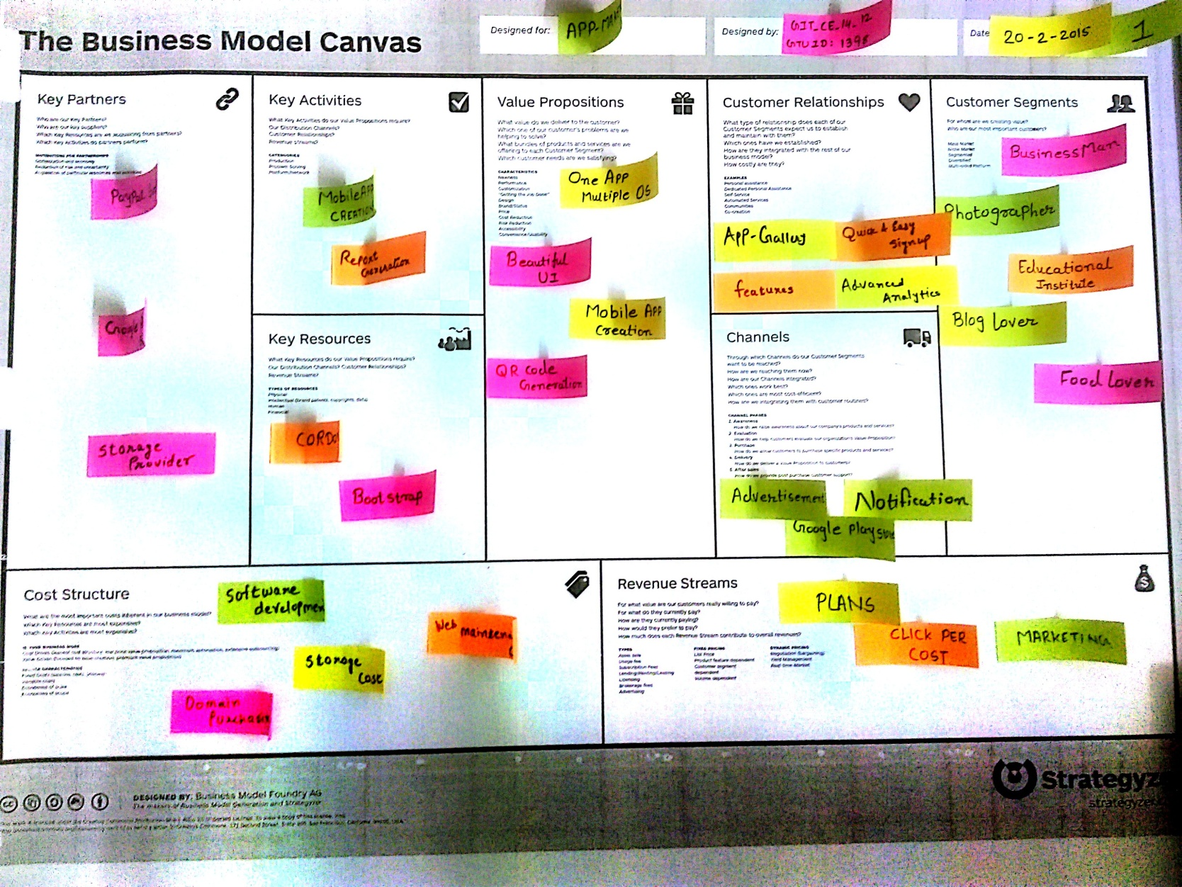

.***REFERENCES***

[1] Michael R Blaha, James R Rumbaugh, Object Oriented Modelling and Design with UML, 2nd

Edition, Pearson Publication, 2011.

[2] Roger S. Pressman, Software engineering, McGraw-Hill, 2001

[3] M.T Savaliya and Kogent Learning Solutions, Advance Java Technology, Dreamtech

press, 2012

[4] (2013) The GOOGLE website. [Online]. Available: http://www.google.com

[5] (2009-2012) The JAVA website. [Online]. Available: http://www.java2s.com

[6] (2011) The Java Tutorial website. [Online]. Available: http://www.roseindia.net

[7] (1999-2013) The Online Tutorial website. [Online]. Available: http://www.w3schools.com

[8]App-Builder. [Online]. Available: http://www.App-builder.com

**[**9**]** Como. [Online]. Available: http://www.como.com

[10] Appery.io.com website. [Online]. Available: http://www. Appery.io.com.com

[11] Rajib Mall, Fundamentals of Software engineering, 3rd Edition, PHI Learning Pvt. Ltd